Moma Program Creative Brief | Proposal Submission Deadline: August 1st, 2016

Contact name & email Vish Mazumder | vish.mazumder@suominencorp.com
Role @ Business name Product Development Manager | Suominen Corporation
Describe your business Suominen manufactures nonwovens, i.e. ‘roll goods’ or raw materials that end up in wipes and other disposable products.
What makes us unique? Unlike our competitors who have myriad interests – Suominen is focused solely in being a global nonwoven roll goods manufacturer. Our product is sold in B2B scenarios and used by customers in manufacturing wipes, layers within feminine care products, personal care and medical applications.
Existing brand guidelines in place? Our purpose is to make nonwovens continuously better for people – patterns that deliver the perception of premium is a key driver in delighting our end users and help drive our mission.
Any colors that you like/dislike? Patterns will be created on a white background – in the future we expect to make products having a blue background
__________________________________________________________________________________________________________________
Scope of project Suominen intends to be a market driven product leader, a core component of which is delivering consumer preferred patterns across all five key categories: Household (including Baby), Work Place (e.g. Hospital care and food service), Personal Care (e.g. facial cleansing), Hygiene (incontinence and feminine care) and Medical (including wound care). This project brings in key external perspective from design experts who are empowered to be inspired by examples beyond nonwovens (e.g. pumice stone cleans body cleansing, a Scotch Brite scrubber pad for tough stains) and incorporate them into their pattern submissions.
Deliverable of project Two Patterns communicating the key 'Clean' attribute i.e. “looks like
Pattern (material) will clean effectively” – distinctly differentiated vs industry status quo (see Appendix). Our expectation is for designers to incorporate inspirations from products besides nonwovens (e.g. diapers, foam) and bring in a fresh perspective that will stand out to an evaluative audience well versed with ‘status quo’ of where we play.
What problem is it solving? Deliver differentiation versus our competition and disrupt the market as measured by consumer preference studies (panels, focus groups). This is a key step in Suominen’s journey in becoming a ‘market driven product leader’.
Who is your audience? The patterns will be evaluated for execution by a technically proficient team – who will also place patterns in front of end users/ consumers. The profile of consumer is as follows:

Product Application Category | Age | Main User Group
Facial wipes | 15-55. Specifically:  - 25-35  - 55+ | Women
Anti blemish | 10-35 | Male & Female
Moist Toilet Wipes (incl. Baby) | 3-65+ | Everyone
Intimate Care Wipes | 15-55  25-35 | Female  Male
Who is your competition? The chief competition from an ‘at use’ perspective is in the wipes arena. Consumers can use the following instead of wipes –
- Paper towels
- Actual linen towels
- Shay cloth
What’s the tone/feeling? The patterns will need to deliver the perception that they:
- ‘clean’ effectively
- Technologically advanced
- differentiated vs status quo (appendix)
- differentiated vs current Suominen offering (appendix)
How will you measure success? 1. Primarily, consumer feedback using Suominen’s proprietary pool of end users
2. Judgement from the cross functional team (senior engineers, product managers and customer-facing sales managers)

Key Action Steps / Milestones | Deadline
Procure design from open innovation sources  Conduct initial assessment of ~ 50 designs for each attribute (‘Soft’ & ‘Clean’) | 2016-08-31
Consumer Feedback using patterns on paper, to go down from 50 designs to 20 designs per attribute for further development | 2016-10-30
Consumer Feedback using actual nonwovens (hand sheets) to showcase preference vs status quo that delivers 20 high resolution prototypes per attribute (‘Soft’ & ’Clean’) | 2016-12-30

APPENDIX

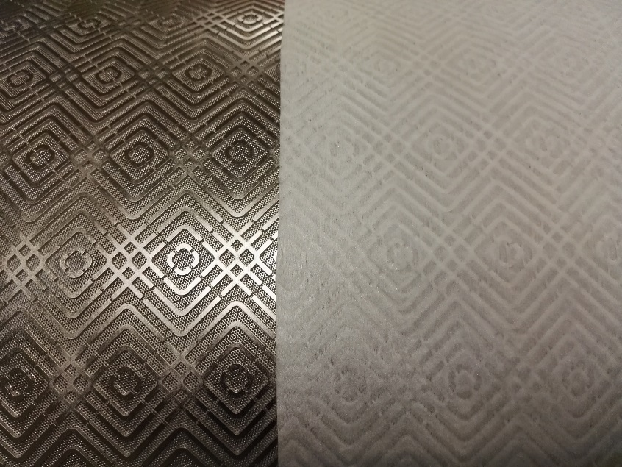

Example of: how does patterns translate into finished product

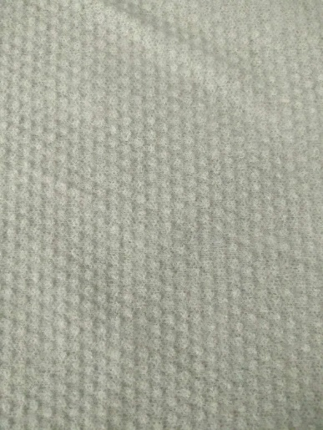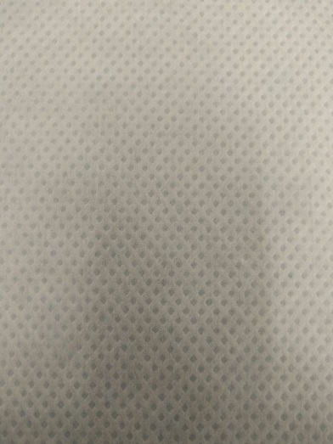

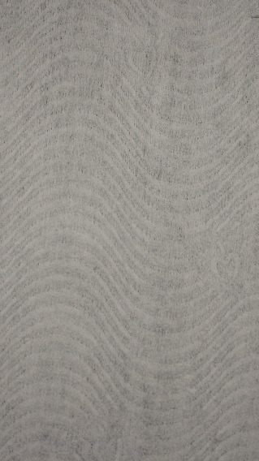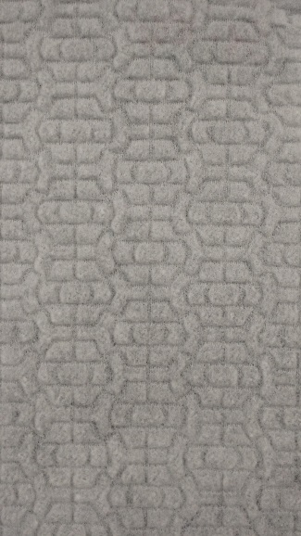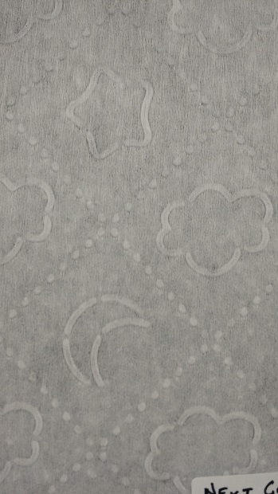

Examples of what Suominen delivers to customers and consumers TODAY

`

Examples of differentiated patterns in the marketplace

