Non Alcoholic Beverages

Sodas
Jarritos Limon $6.5
Jarritos Mandarin $6.5
Jarritos Guava $6.5
Jarritos Pineapple $6.5
Bundaberg Ginger Beer $5
Bundaberg Passionfruit Soda $5
Tonic Water $4
Ginger Ale $4
Lemon Lime & Bitters $4.5
Juices
Orange Juice $4
Apple Juice $4

Mocktails
INNOCENT MOJITO $10
fresh lime, mint, sprite, agave nectar
PASSIONFRUIT DREAMING $10
passionfruit pulp, fresh lime, soda and agave nectar
PIÑA COLADA $10
pineapple, coconut & fresh lime
NIÑOS PALOMA $10
pink grapefruit, lime agave nectar & s

Wine, Sangria, Mimosa

Sangrias
Bitter Orange Sangria
Aperol*White wine*Orange*Simple Syrup

Sparkling Passionfruit Mimosa
Sparkling Wine*Passionfruit Pulp*Lime*Simple

Ruby Rojo Sangria
Fruity Red wine, Cointreau, Orange, Lime

White Sangria with Citrus & Ginger

Strawberry Rose
Rośe*Lemon*Agave

Sparkling Wine G B
Seppelt Fleur de Lys, South Eastern Australia $7 $32

White Wine
T'Gallant Juliet, Moscato, Mornington Peninsula, VIC $9 $38
Secret Stone, Pinot Gris, Marlborough, NZ $9 $38
Black Cottage, Sauvignon Blanc, Marlborough, NZ $9 $38
Shaw and Smith, Sauvignon Blanc, Adelaide Hills, SA $11 $45
Stella Bella, Semillon Sauvignon Blanc, WA $9 $40
Gemstone, Organic Chardonnay, McLaren Vale, SA $7.5 $33

Red Wine
Riposte, Pinot Noir, Adelaide Hills, SA $9 $38
Ad Hoc, Mix Master Red, Great Southern, WA $7 $33
Littleberry, Shiraz, McLaren Vale, SA $9 $38
Brand's Laira, Barrelman Cabernet Sauvignon, CoonawarrA

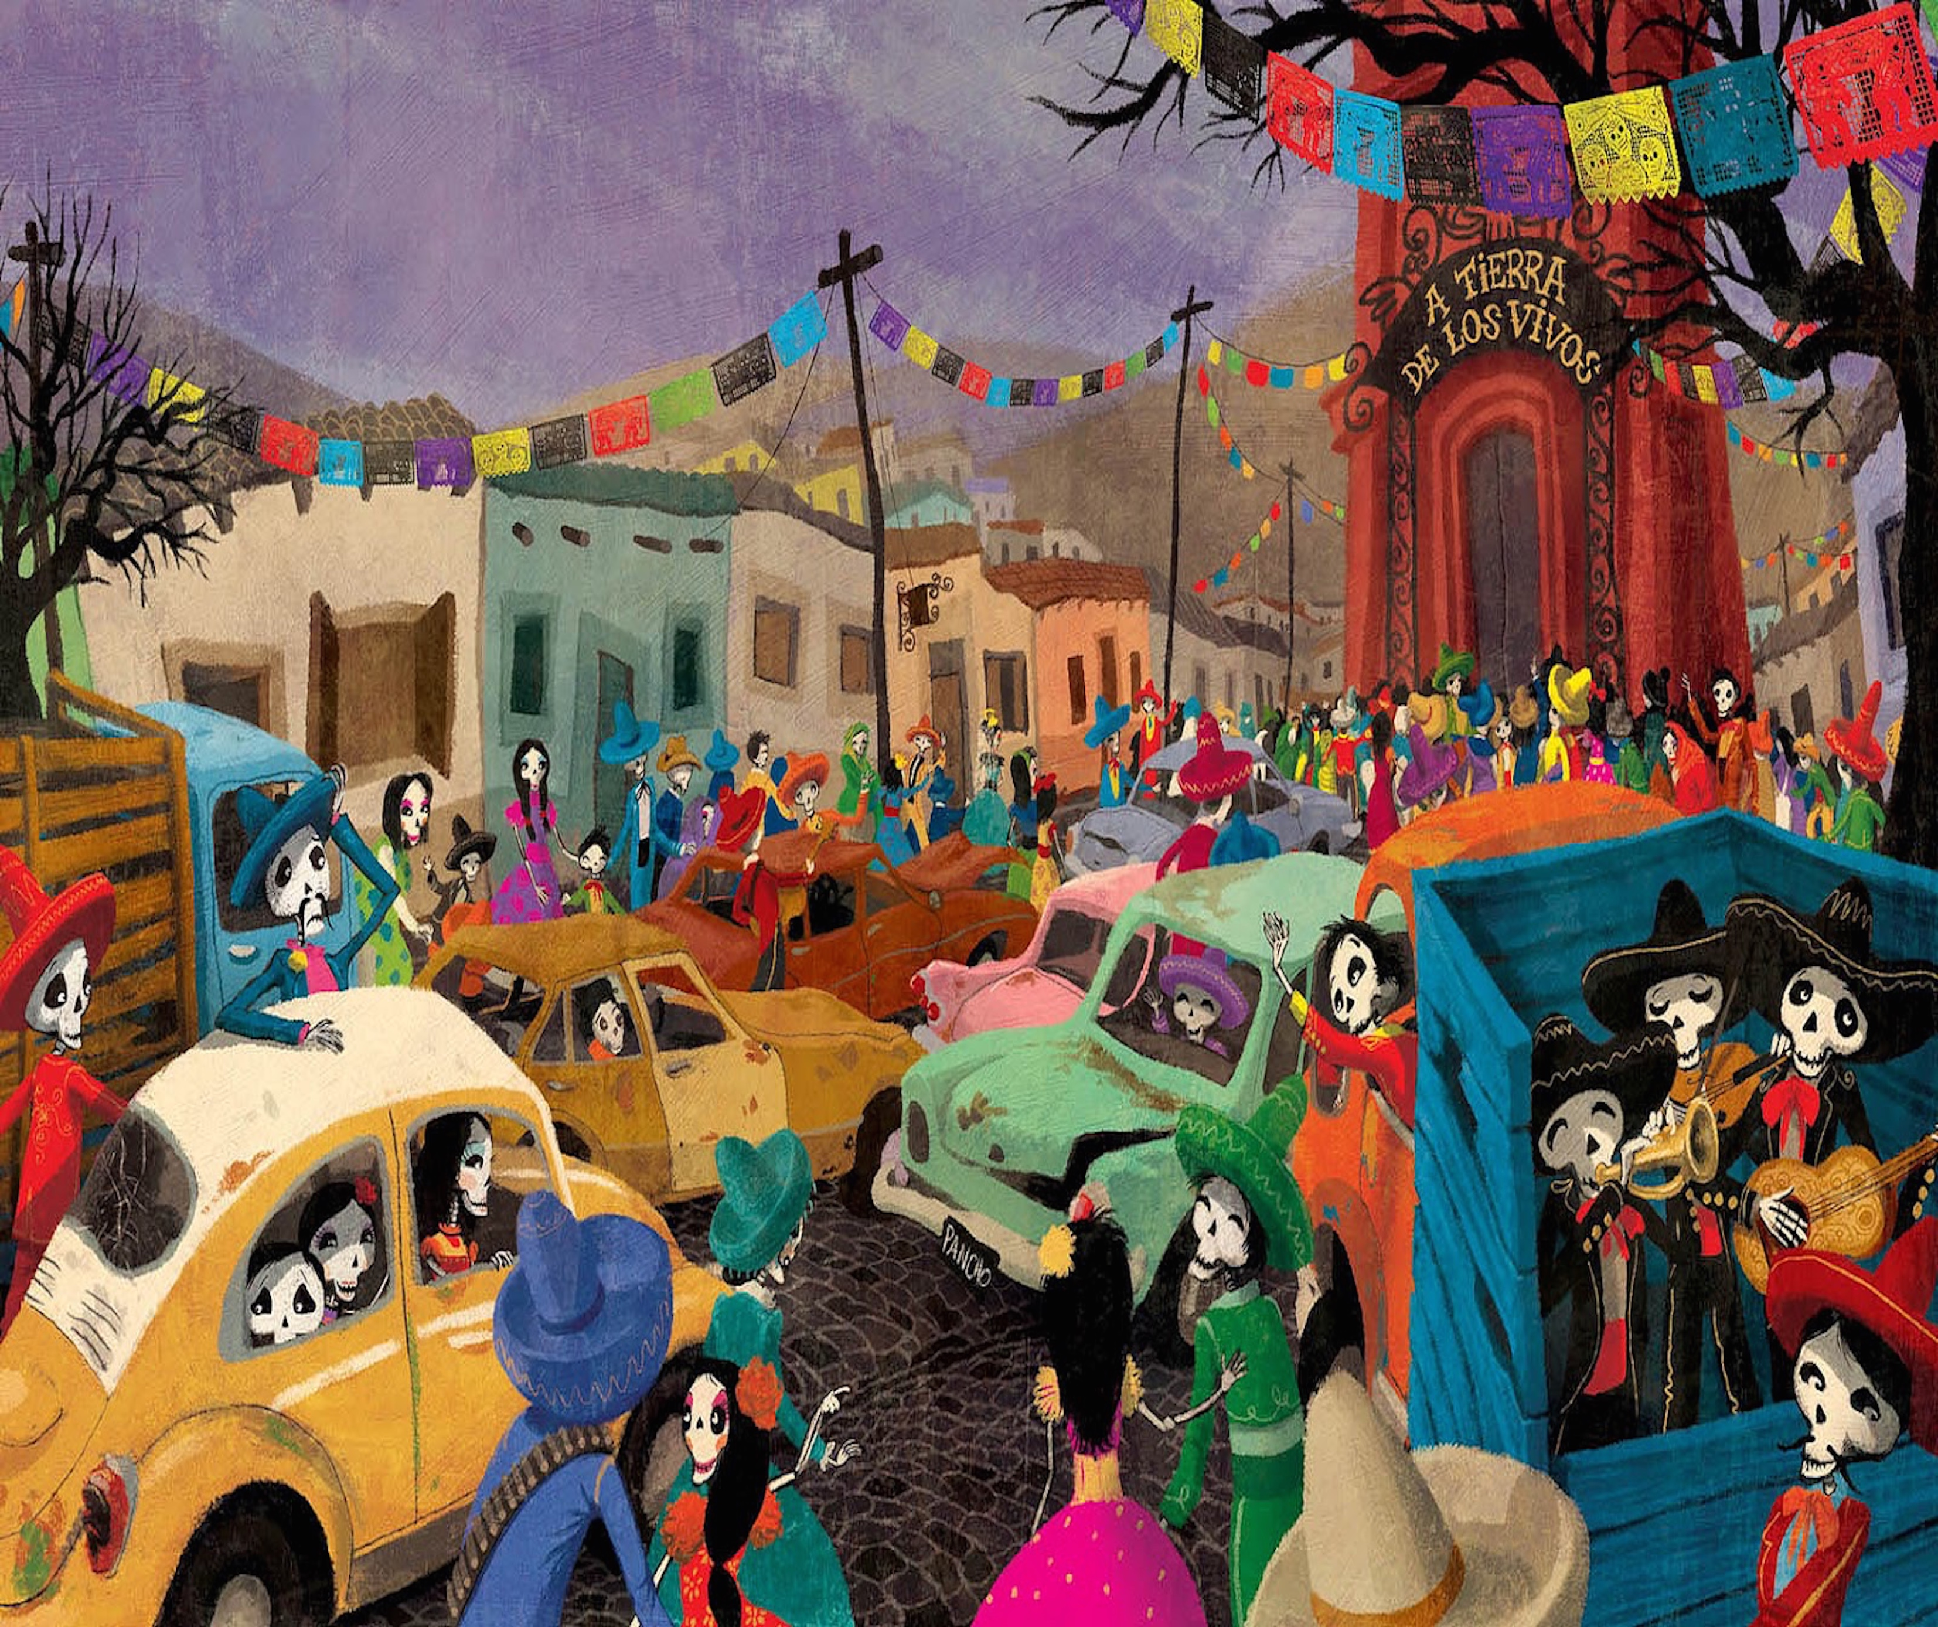

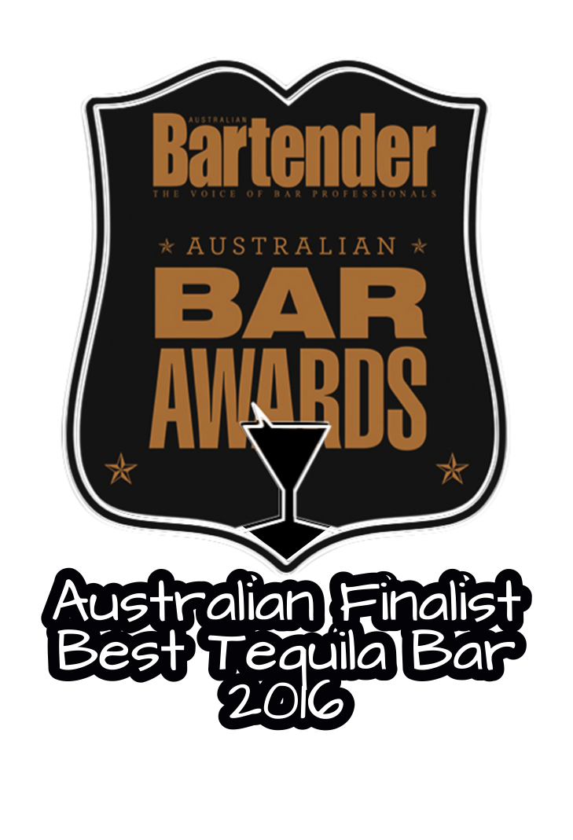

Cocktails
Being Australia’s largest Tequila & Agave bar, we have created our lastest cocktail list to showcase the amazing versatility of tequila and the wider agave spirits. We have recreated numerous classic cocktails and put a Hot Tamale spin on them, creating syrups & shrubs, squeezing fresh citrus, infusing spirits and barrel aging cocktails.

Margarita & Variations
Tommy’s Margarita
Tequila*Agave Nectar*Lime

Frozen Tommy’s Margarita
Tequila*Lemon*Sugar Syrup

Mango Tommy’s
Tequila*Mango*Lime*Sugar Syrup

Jalapeno Tommy’s
Jalapeño infused Tequila*Agave Nectar*Sugar Syrup

Ginger Tommy’s
Tequila*Ginger Syrup* Lime

Smokey Margarita
Mezcal*Tequila*Agave*Lime

Chipotle Margarita
Tequila*Chipotle Simple Syrup*Lime

Old School Margarita
Tequila*Cointreau*Fresh Lime*Agave Nectar

Beers
International
Michelada $11

Day of the Dead Blonde Ale Mexico $ 9

Dos Equis Mexico $ 8

Aguila Columbia $ 7.5

Corona Mexico $ 8

Pacifico Mexico $ 8

Negra Modelo Mexico $ 8

Tecate Cans Mexico $ 7

Rio Bravo Cans Mexico $ 7

Sol Mexico $ 7.5

Local
XXXX GOLD $ 6
Carlton Dry $ 6.5

Draught Beer/Cider
Carlton Draught $ 7.5

Fat Yak $ 8

Bulmer $ 8

Spirits
Whisky/Whiskey

Jamieson Irish Whisky $ 8
Canadian Club $ 8
Bullet Bourbon $ 7.5
Jack Daniels $ 8
Michters Cour Mash $ 9.5
Starwards $ 9
Johnnie Walker Red $ 7.5
Glenmorangie Original $ 9
Balvenie 14Y Carribean Cask $11
Nikka Whisky from the barrel $ 9.5
Tequila – see Agave List for the other 240 Tequilas and Mezcals
Hot Tamale T1 Blanco $11
Hot Tamale T1 Reposado $12
Hot Tamale T1 Anejo $13
Mezcal
Del Maguey Crème de Mezcal $11
Del Maguey Vida $11
Vodka
Smirnoff $ 7.5
666 Pure Tasmanian $ 8.5
Gin
Tanqueray $ 7.5
Four Pillars $ 9
Rum
Bacardi $ 7.5
Bundaberg Rum $ 7.5
Kraken Spiced Rum $ 9
Bundaberg Small Batch $ 8.5
Havana Club De Maestros $1

