RABJTERAX ® ft
TRUCl<& BUS TYRE 



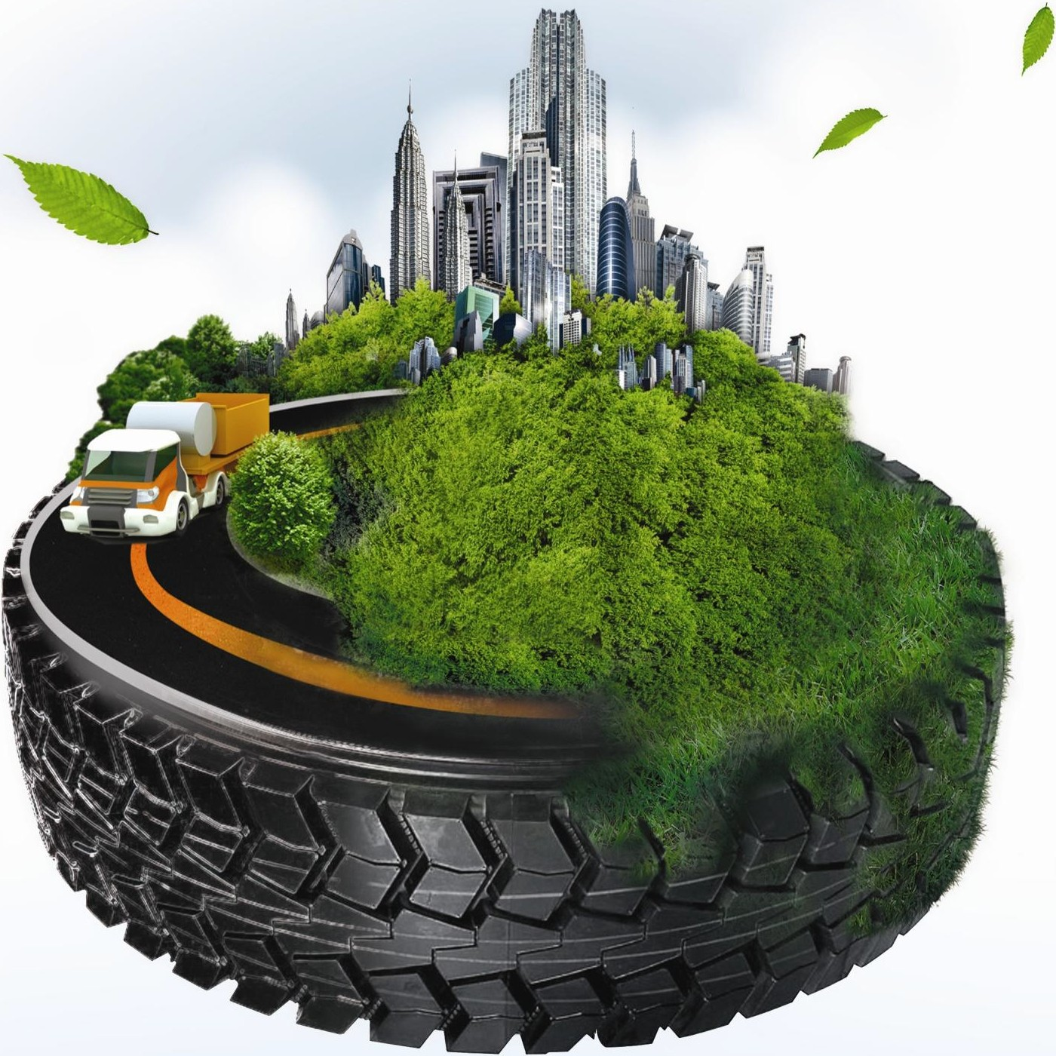

SHANDONG HAWK INTERNATIONAL RUBBER INDUSTRY CO.,LTD

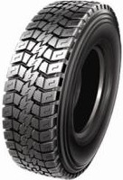
HAR VEHAX ®

TRUCl<&BUS TYR E

Introduction
Established in 2004,Shandong Hawk International Rubber Industry Co.,Ltd is currently council member of Shandong Rubber Industry Association.
Located in Phoenix Industry Park, Laizhou Economy Developing Zone of Shandong Province, the com­ pany covers over 500,000 square meters with capital asset of 1.2 billion RMB. The company has more than 2300 staff including 260 senior technicians and 11 nationalpatents. Among these years, our prod­ ucts are qualified with certificates including CCC,IS09001 Standard, DOT, SMARTWAY, ECE,GCC and tire laboratory recognized by IS017025 standard. Business scope of the company covers all steel and bias heavy duty truck tire,giant mining tire, off road tire,industrial tire, and agricultural tire,the annual pro­ duction capacity over 2,200,000 sets. Our workshop are equipped with advanced tire manufacture and test machines mainly imported from USA, Italy, Germany, Netherlands, all our products are guaranteed in top quality.We own rich technical force and perfect warranty system to solve the problems and protect the benefit for our customers.
The company is formerly Laizhou Xiongying Tire Co.,Ltd, which was established in 1975. Among 40 years of development, the company insisted on the belief that integrity is the foundation of an enterprise. Oriented by the market demand, value combined with quality products, through constant innovations of corporate culture, management team together with technical progress, we grow from a small company into a well-established one till today. In 2010, the company was voted as the key enterprise and high and new technology enterprise of Shandong Province; in 2011, the company ranked in the Top 50 Enter­ prises in the Rubber Industry by Shandong Rubber Industry Association.
With brands "ti" , "D" , "5'l-HAWK" for domestic sales and brands "SUPERHAWK" and
"MARVEMAX" for international sales, our tires enjoy great reputation home and abroad. We support tires for many famous automobile manufacturers such as Shanan Xi Automobile Group Co.,Ltd and Sanny Heavy Industry Co.Ltd, the quality is trusted by domestic users. SUPERHAWK and MARVEMAX brand tires are fully recognized and trusted by our clients from over 50 countries including USA, Mexico, Australia, Russia, Vietnam, Malaysia, Indonesia, Thailand etc.
In the future, Hawk Tire company will strengthen innovation, introduce advanced technology and man­ agement discipline. With accurate market prospective, continuing to explore new models of business development, we will built HAWK as the leading tire manufacturer in China and well-known brand in worldwide.

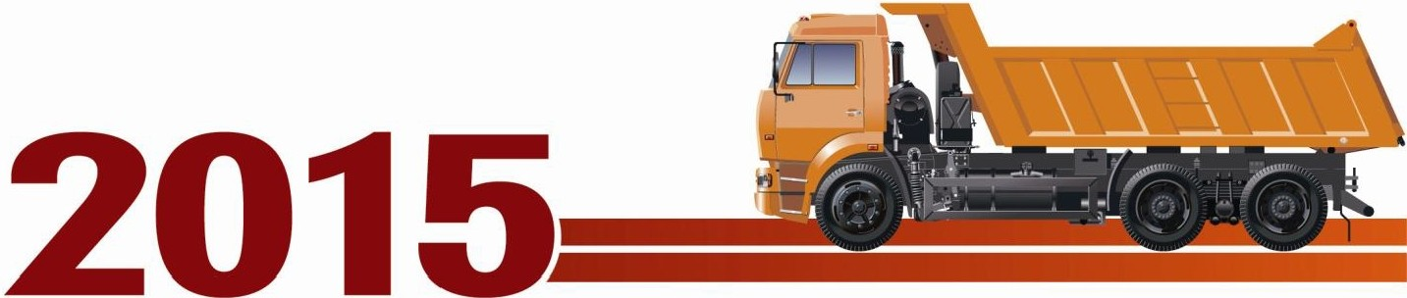

TYRE MANUFACTURER WITH 40 YEAR'S EXPERIENCE

- • I I •
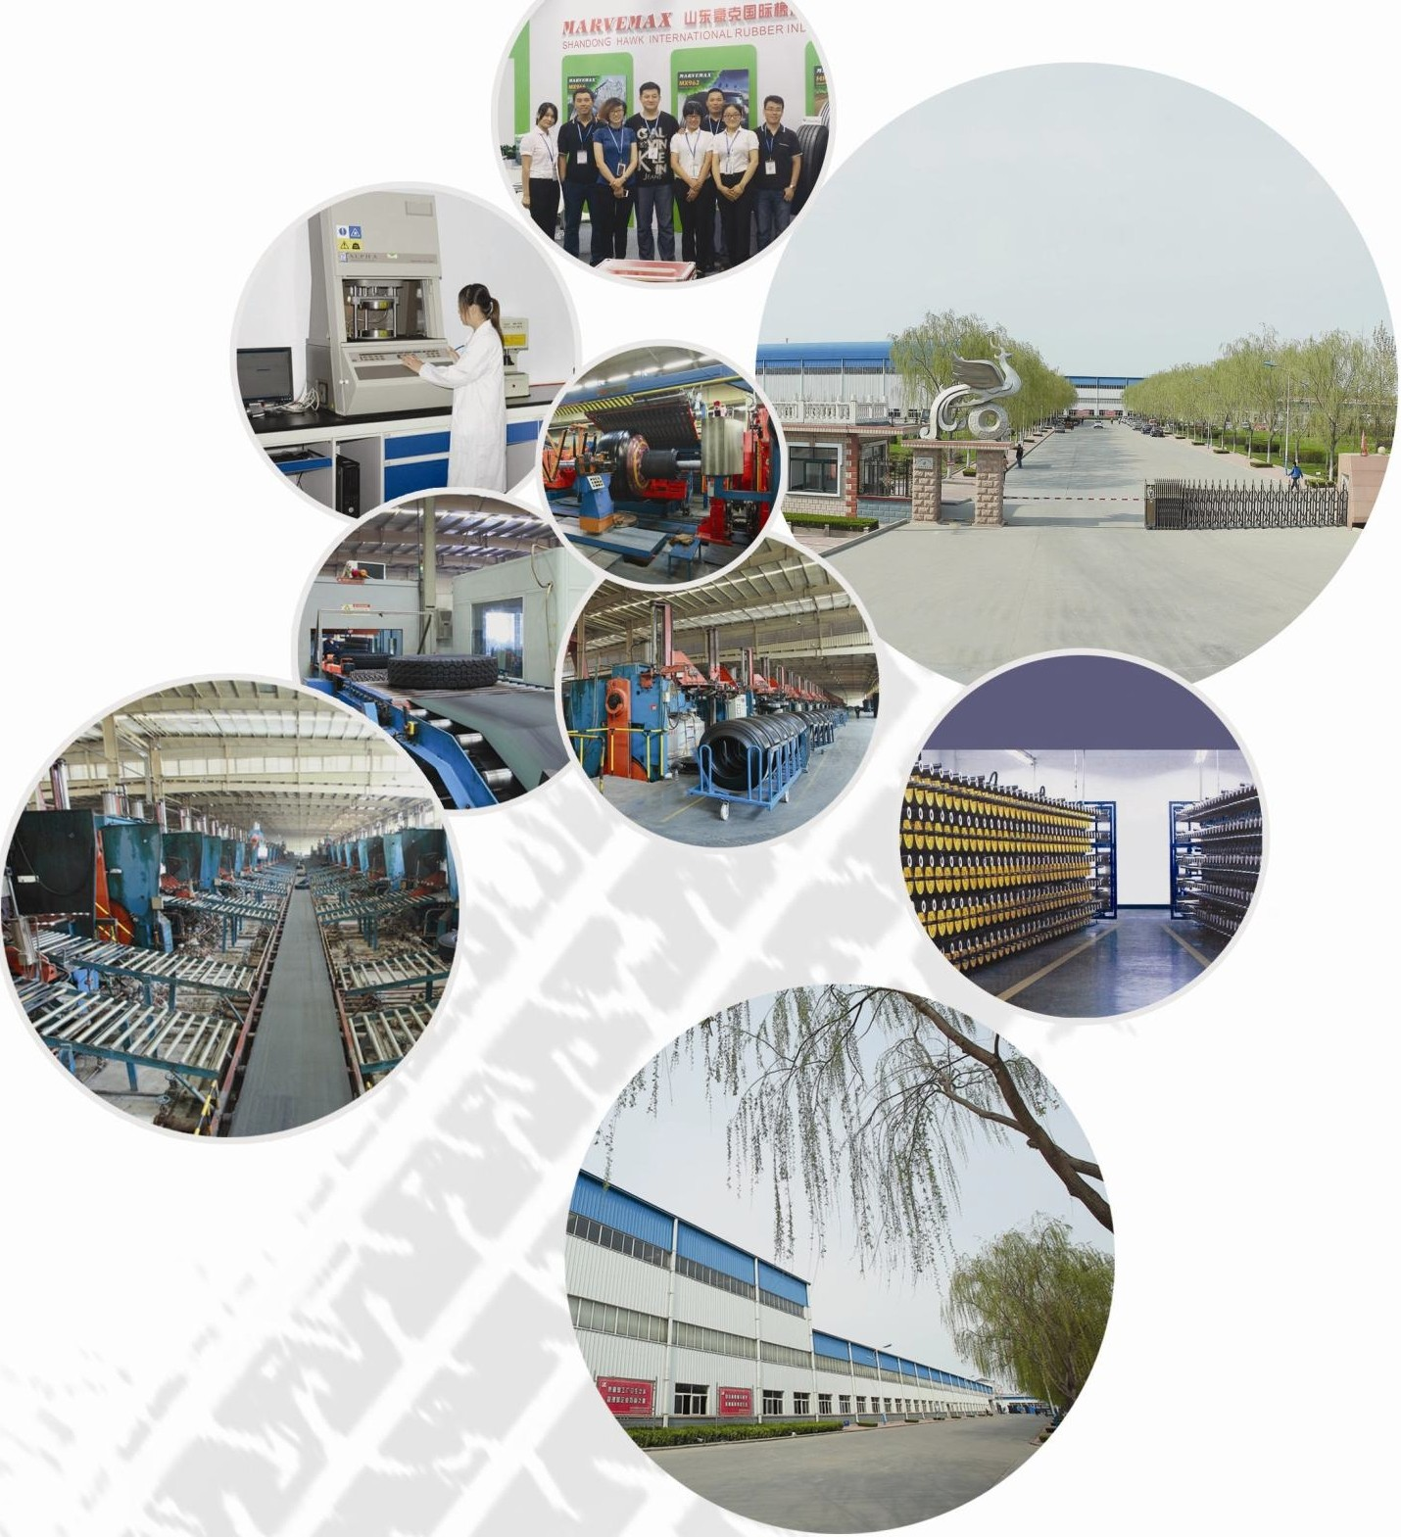

RAB VERAX ®

TRUCl<&BUS TYRE

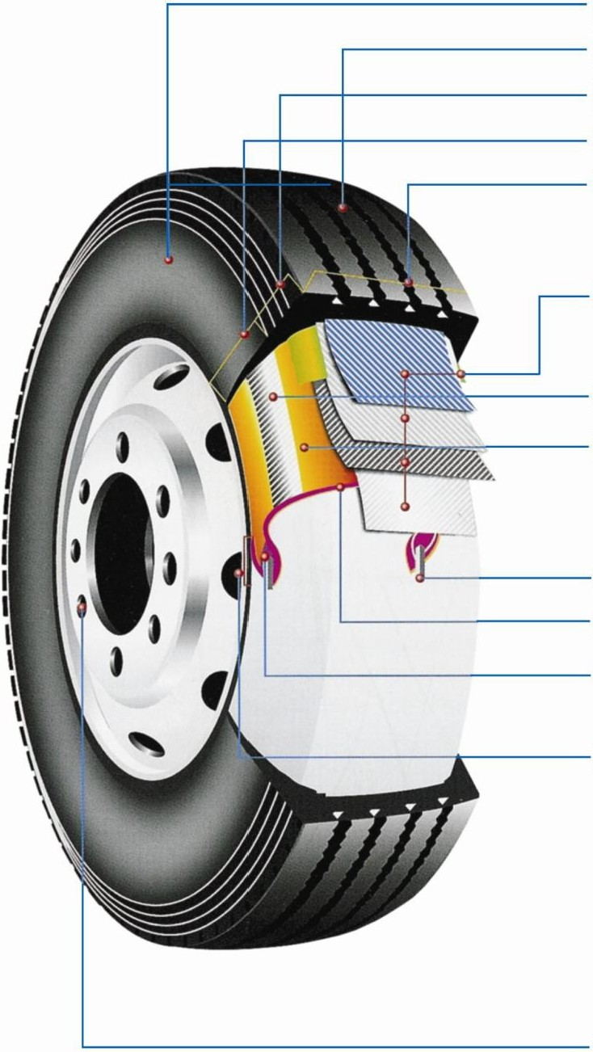
Sidewall Rubber Tread Rubber Shoulder Area Sidewall Area Tread Area

Steel Belt

Carcass

Shoulder Rubber

Bead Wire

Inner Liner Bead Filler

Bead Area

Rim

Series on well paved road.

r.:.1 Excellent wear resistance, application of polymolecularity compound economic but longer service lif e.

r.1 Optimizing belt structure combination reduce the interminable shear force good ride comfort feeling
----1..:.1 and excellent durability.

-----[!I Use the low beat building primer and the most suitable shape.
Resistance to heat build-up and avoiding separation.

Series for general pavement and combination pavement

-----[!] Application of brand new tyre compound resistance to cutting and abrasion.

r:11 Application of low heat-building rubber and f igure optimization.
-----1=i1 Anti-tread accident under load.

-----+-----IJ Reinforced tyres bead and application of high dens ity cord fabrico Anti-tread accident under load.

Series on mine road and unpaved road.

Mixed material of both organic and inorganic.
1-----(ii Excellent tear propagation resistance
Excellent anti-cutting

Reinforced tyre bead and application of high density cord fabric
-----Cl Anti-raw edge inside accident under heavy load

RAB VEIIAX ®

TRUCK&B US TYRE

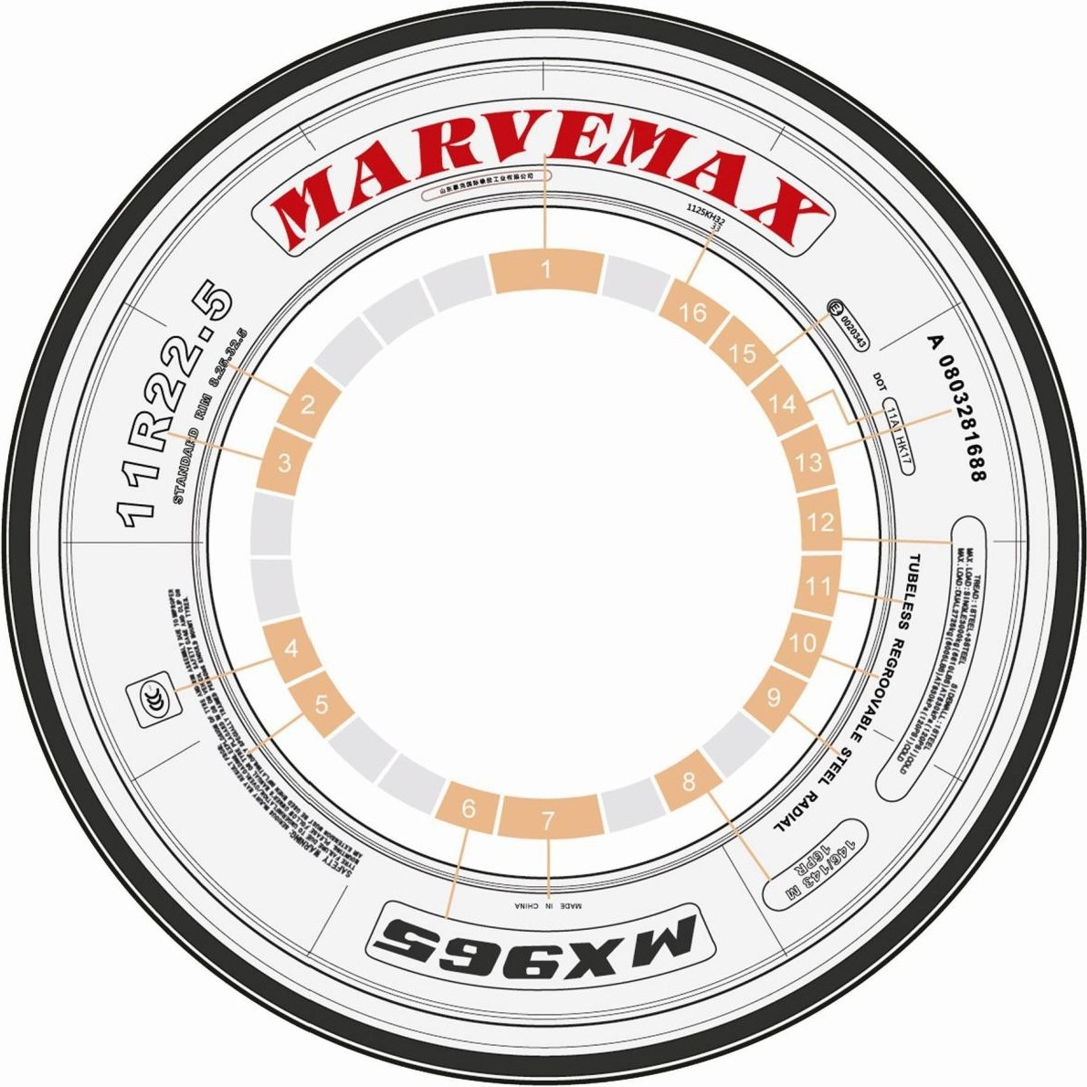

1.MARVEMAX | BRAND NAM E | 9.STEEL RADIAL | STRUCTURE OF CARCASS
2.STA NDARD RIM 8.25 | TYRE SIZE | 10.REGROOVABLE | REGROOVABLE TREAD DESIGN
3. 11 R22.5 | RECOMMENDED R IM SIZE | 11.TUBELESS | TUBE TYPE
4.CCC | CCC MARK SYMBOL | 12.MAX.LOAD ETC. | DATA OF PRESSURE.LOAD AND CARCASS CORD
5.SAFETY WAR NING | TYR E SPECIAL SAFETY WARNING | 13.A0803281688 | SERIES NO. OF PRODUCTION
6. MX969 | MARVEMAX TREAD PATIERN CODE | 14.DOT ETC | CODE OF DOT CERTIFICATE
7.MADE INCHINA | ORIGIN OF MANUFACTURING | 15.E40020363 | CODE OF EMARK CERTIFICATE
8. 146/143 M 16PR | LOAD INDEX&SPEED SYMBOL&PLY RATING | 16. 1125HK32 | NO. OF MOULD

SERIAL NUMBER EXPLANATION

-A 130328 16 88

Shift NO.(NB/C) ._I I
Production Date(YY/MM/DD) J
I LProduction Tyre NO.
L_Curing Press NO.

TYRE ASPECT RATIO EXPLANATION CTyre Section Height/Tyre Section Widthl
Micro,Light truck tyres

8. 25 | R | 16 | LT | PR | 126/122 | L
31 10. 50 | R | 15 | LT | 6PR | 109 | Q

Nomioal oat dliam,tec : I I
Norminal section width(inch)
I LSpeed symbol
L_Load index(single/dual)

Radialstructure---------' '--------Ply rating

Nominal rim diameter(inch)-------- ._ .... LT-light truck ULT-ultra light truck

TRUCK AND BUS TYRES

Norminal section width(mm) ... -- I
Normianlaspect ratio •--------'I

Radialstructure----------'
LSpeed symbol
Load index(single/dual)
12 .00 | R | 24 | 20PR | 160/ 157 B
!;!_ | R | 22. 5 | lOPR | 124/ 122 .§.
315 I 80 | R | 22.5 | 18PR | 154/ 151 !:._

Nominal rim diameter(inch)------------' '--------Ply rating

TYRE PATTERN

ALL POSITION

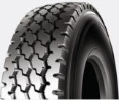
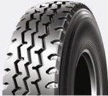
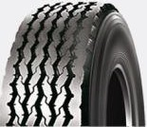
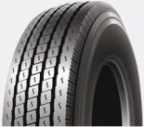
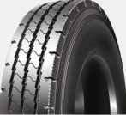
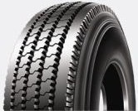
MX 901 MX902 MX906 MX967 MX968 MX900

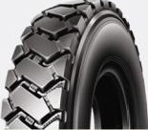
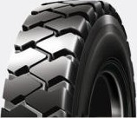
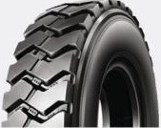
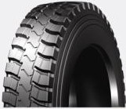
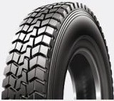
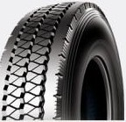
MX789 MX908 MX909 MX928 MX929 MX937
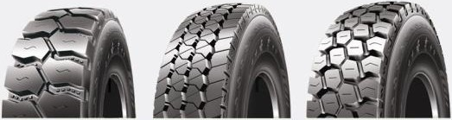
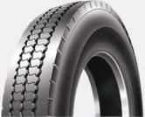
MX907 MX930 MX950 MX970 MX990 MX926
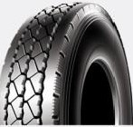
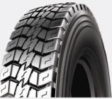
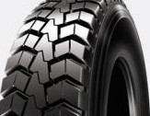
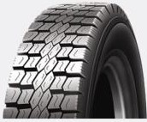
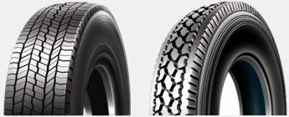
MX938 MX958 MX959 MX960 MX966 MX969
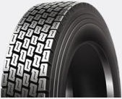
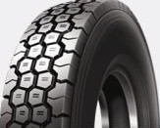
MX975 MX977 MX978 MX979 MX980 MX998

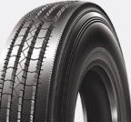
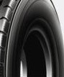
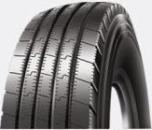
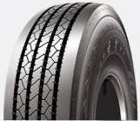
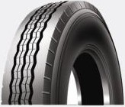
•MX962 MX965

STEER

DRIVE

TRAILER
MX988
MX936
MX920
MX961
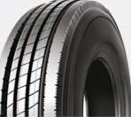
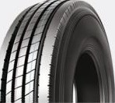
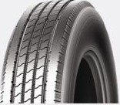
MX963 HK863T HK876T

SIZE |  |  |  |  |  | PATTER N
6.50R 16 | MX900 | MX901
7.00R 16  7. 50R 16 | MX902 MX902 | MX928 MX909 | MX928
B. 25R 16 | MX902 | MX908 | MX909 | MX928 | MX958
8. 25R20  9.00R20 | MX902 MX902 | MX908 MX958
10.00R20 1 1 .OOR20 | MX789 MX902 | MX902 MX908 | MX958 MX909 | MX928 | MX936 | MX958 | MX978
1 2.00R20  1 2 .00R24 | MX789 MX086 | MX902 MX088 | MX908 MX902 | MX909 MX908 | MX928 | MX958 | MX950
21 5/75R 1 7.5 | MX961 | MX967
225/70R 1 9.5  235/75R 1 7.5 | MX967 MX967
255/70R22.5  265/70R 1 9 . 5 | MX967 MX967
275/70R22.5 | MX926 | MX967
295/80R22 .5 | MX789 | MX908 | MX959 | MX962 | MX966 | MX975
31 5/80R22 .5 | MX902 | MX928 | MX929 | MX959 | MX962 | MX966
1 1 R22.5 | MX902 | MX928 | MX959 | MX960 | MX961 | MX963 | MX965 | MX967 | MX969 | MX978 | HK863T | HK876T
1 1R24.5 | MX902 | MX965 | MX969 | HK863T | HK876T
285/75R24. 5  295/75R22 .5 | MX965 MX965 | MX969 MX969 | HK863T HK863T | HK876T HK876T
1 2R22.5 | MX902 | MX937 | MX938 | MX962 | MX963 | MX965 | MX966 | MX977 | MX978 | MX980 | MX990 | MX920
 | MX930 | MX970
385/65R22.5 | MX906
205/85R 16LT | MX902 | MX928
235/85R 16LT | MX902 | MX959
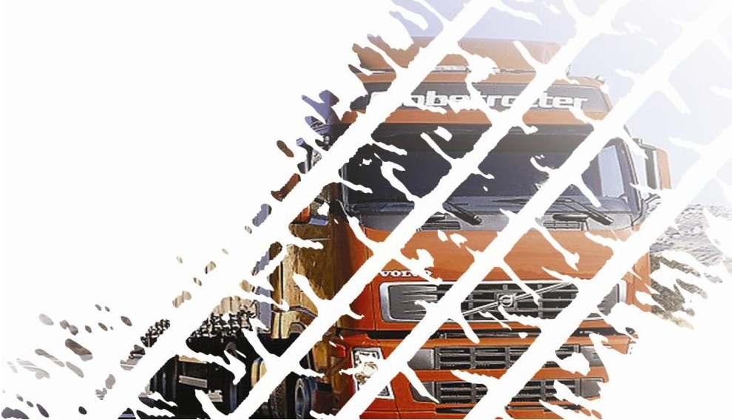


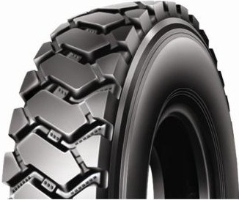
MX 789 ..////// .! ..
'///j
/J!
!f
_..
-
Applied for short-haulwithin 200kms,low speed,and heavy loaded dumping trucks.
Specialtread compound with high wear-resistant, suitable for mining application and construction sites.
Aggressive lug pattern design provides excellent grip and traction performanc e

295/ 80R22 .5

TYRE SIZE
TREAD DEPTH
lLATION PRESSUlE (kPa )

16
--·

LOAD CAPACITY (kg)

18.5
18
16
150/ 147
23 .3 9 .00 TT B 1050
152/ 149
146/ 143
298
830
900
830
830
900
830
3350
3550
3000
3075
3250
2725

10. OOR 20
23 .5 29. 6 7 .50 TT B
18 149/ 146
1061
275

930

930

3250

3000

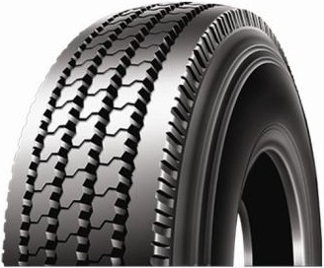
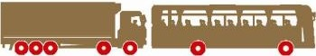
MX 9DD
Applied for express way and urban road, all position of the light trucks and bus.
Rib pattern, extra sideslip resistance, pitch pattern designed.Low noise.By four staight main slots and it delivers superior stability and drainage of driving.
Super steel belt carcass construction enhances casing strength and maximizes tire load capacity
TREAD DEPTH
IM'I.ATION PRESSUlE (kPa)

-TYRE si_z_E_I
••••• •
.., ...

I • I •

6 .50R 16LT
16
10.5
18

13.2 5.50F TT
107/ 102
110/ 105
L 750
185
560 560 975
670 670 1060
850
925

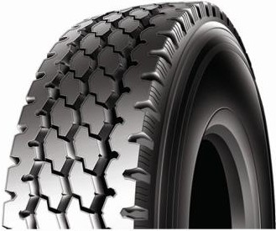
MX 9D I
;;mifflM-n
-;' ._.. l
-

Applied for highway,urban and country road, all position of trucks and bus,long haulover 800kms. Three rib pattern, extra sideslip resistance,delivers superior stability and drainage of driving.
Super steel belt carcass construction enhances casing strength and maximizes tire load capacity
TYRE SIZE I

TREAD DEPTH
LOAD CAPACITY (kg)

10 107/ 102
10.5 13. 2 5 .50F TT L 750 185
. . ..,
560
I •
560
975
I •
850

6 .50R 16LT
11 . 00R20

12
16
18
18

110/ 105
150/ 147
17.0 21 .4 8 .00 TT K 1096 293
150/ 149
154/ 153
670
830
930
830
670
830
930
830
1060
3350
3550
3750
925
3075
3250
3450

12.OOR20
17.0 21.4 8 .50 TT
20

156/ 153
K 1136 315
930
930
4000
3650

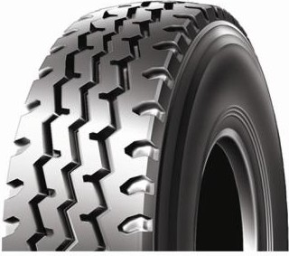

MX 902

Applied for highway, urban and country road, all position of trucks and bus, long haul over 800kms. Three rib pattern,extra sideslip resistance,delivers superior stability and drainage of driving.
• ••••••

lLATION PRcSSIJlE (kPa)

TYRE SIZE
TREAD DEPTH
• •
... ·'·
• •

7 .OOR 16LT

12PR

115/ 110

670 670

1215 1060

7 .50R16LT

8 . 25R 16LT

8 . 25R20

14PR
10.5 13.  14PR | 2 5.50F TT | L  118/ 114 | 775 200  770 |  | 770 | 1320 | 1180
12PR |  | 120/ 116 |  | 670 | 670 | 1400 | 1250

14PR
16PR
14PR
16PR
13.5 17. 0 6 .00G TT

14 .5 18.3 5.50H TT

15.0 18.9 6.50 TT
L
122/ 118
126/ 122
L
128/ 124
136/ 134
K
139/ 137
805 215

855 235

974 236

770 770
670 670
770 770
830 830
930 930

1500 1320
1700 1500
1800 1600
2240 2120
2430 2300

9. OOR20

10.OOR20

11 .00R20

12. OOR20

11R22.5
14PR
15.5 19.5 7.00 TT
16PR
16PR
16.0 20. 2 7 .50 TT
18PR
16PR
15.5 19. 5 8 .00 TT
18PR
18PR
16.0 20. 2 8.50 TT
20PR
14 PR
17.5 22 .0 8 . 25 TL
16PR
14PR
141/ 139
K

144/ 142
146/ 143
K
149/ 146
150/ 147
K
152/ 149
154/ 151
K
156/ 153
144/ 142
M
146/ 143
146/ 143

1019 259

1054 278

1085 293

1125 315

1054 279
790 790
900 900
830 830
930 930
830 830
930 930
830 830
930 930
720 720
830 830
720 720
2575 2430
2800 2650
3000 2750
3250 3000
3350 3075
3550 3250
3750 3450
4000 3650
2800 2650
3000 2725
3000 2725

11R24 .5

16PR
16PR
18PR
17.5 22 .0 8 . 25 TL L
149/ 146
151/ 148
M
154/ 151
1104 279
830 830
760 760
830 830

3250 3000
3450 3150
3750 3450

315/ 80R22 .5
22PR |  | 167/ 164 |  |  |  |  | L | 950 |  |  | 950 | 5450 | 5000
22PR |  | 167 |  |  |  |  | C | 950 |  |  | 950 |  | 5450
12 . OOR24 | 18PR  20PR | 16.0 | 20 . 2 | 8.50 | TT | 158/ 155  160/ 157 | K | 1226 | 315 | 830  930 | 830  930 | 4250  4500 | 3875  4 125
205/ 85R16LT | 14PR | 10.5 | 13. 2 | 6J | TL | 117/ 115 | L | 775 | 200 | 575 | 575 | 1285 | 1215

20PR 17.5 22 .0 9 .00 TL
156/ 150
1076
312
850 850
4000 3350

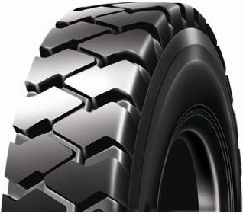

MX 908
'////
l///
....
.... ///////1 . .
;,
Applied for bad road conditions including mining application of heavy duty workloads, short haul w ithin 100kms, low speed less than 40kms/h.
Large lug pattern design provides excellent grip performance.Wear- resistant compound design provide super tread life.
Excelent stab-resistance, anti-eccentr ic worn, avulsion resistance and tread wear ability.

ltfLATION PRESSUU: (kPa) LOAD CAPACITY (kg)

TYRE-SIZE --

-
12PR 120/ 118 670 670 1400 1250
7 .50R16LT 16.5 20. 8 6.00F TT B 815 215
14PR 122/ 118 770 770 1500 1320
14PR 126/122 670 670 1700 1500
8 .25R16LT 17.0 21 . 4 5.50H TT L 855 235
16PR 128/124 770 770 1800 1600
14PR 136/ 134 830 830 2240 2120
8 .25R20 17. 0 21 .4 6 .50 TT K 974 236
16PR 139/ 137 930 930 2430 2300
16PR 150/ 147 830 830 3350 3075
11.00R20 24 .0 30. 2 8.00 TT B 1093 288
18PR 152/ 149 930 930 3550 3250
16PR 150/147 830 830 3350 3075
295/80R22 .5 15.0 18.9 9.00 TL L 1044 298
18PR 152/ 149 900 900 3550 3250
18PR 154/ 151 830 830 3750 3450
12.00R20 24 .0 30 . 2 8.50 TT B 1131 311
20PR 156/453 900 900 4000 3650
18PR 158/ 155 830 830 4250 3875
12.OOR24 25.0 31 . 5 8.50 TT B 1228 312
20PR 160/157 900 900 4500 4125

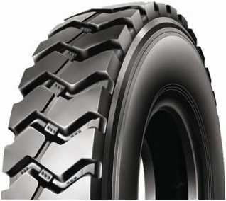
MX 909
'
'//////////////h! ...
. •;, e' •
-
Applied for bad road conditions including mining application of heavy duty workloads, short haul w ithin 100kms, low speed less than 40kms/h.
Large lug pattern design provides excellent grip performance,Wear- resistant compound design provide super tread life.
Excelent stab-resistance, anti-eccentr ic worn, avulsion resistance and tread wear ability.

12PR
-TREAD DEPTH

120/118
-670 670 1400 1250

7 .50R16LT

8 .25R16LT

8 .25R20

11.00R20

12.OOR20
17. 0 21 . 4 6 .00F TT B 815 215
14PR 122/ 118 770 770 1500 1320

TYRE SIZE
ltfLATION PRESSUU: (kPa)
LOAD CAPACITY (kg)
14PR 126/122 830 830 1700 1500
17.0 21 . 4 6.50H TT B 865 235
16PR 128/ 124 930 930 1800 1600
14PR 136/134 830 830 2240 2120
15.0 18. 9 6.50 TT K 974 236
16PR 139/137 930 930 2430 2300
16PR 150/ 147 830 830 3350 3075
24 .5 30 . 9 8.00 TT B 1093 288
18PR 152/ 149 930 930 3550 3250
18PR 154/151 830 830 3750 3450
24 .5 30 . 9 8.50 TT B 1131 311
20PR 156/153 1900 900 4000 3650

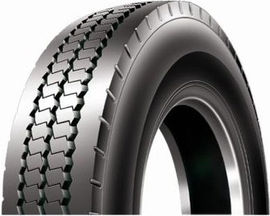

MX 926- l
-- ----
,,rw,nr,r,r,,,
• I";"

Design for good tread wear and sidewall scuff resistance.
Special tread compound design for lower heat build-up, excellent puncture and cut resistance.
TREAD DEPTH

r_v_RE_s,_z_E _I
LOAD CAPACITY (tg)
Suitable for u..rb.a.n..bus.

I • I •

. • ..,

 | 14PR |  |  |  |  | 142/139 |  |  |  | 760 | 760 | 2650 | 2430
275/70R22 .5 | 16PR | 20 . 0 | 25 .2 | 8 .25 | TL | 144 /141 | M | 967 | 270 | 830 | 830 | 2800 | 2575
 | 18PR |  |  |  |  | 148/145 |  |  |  | 900 | 900 | 3150 | 2900



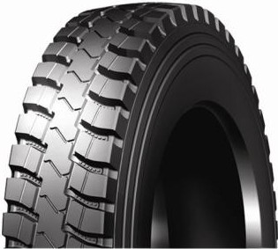
Patented unique design for mixed road conditions,nationaland regional haul Tread design makes it wear-resistant and anti-cut
Super steel belt carcass construction enhance casing strength and maximizes tire load capacity

TREAD DEPTH
TYRE SIZE
••••• • lLATION PIESSLIIE (tPa)

1 • 1 • '•

I •

7 .OOR16LT

7 .50R16LT

8 .25R16LT
12PR
14PR
12PR
14PR
14PR
16PR
16PR
10. 5 13.2

14 . 5 18.3

15.5 19.5
5.50F TT

6 .00F TT

6.50H TT
115/110
L
I •
118/114
120/118
L
122/118
126/122
L
128/124
150/147
783 200

815 215

865 235
670 670
770 770
670 670
770 770
670 670
770 770
830 830
1215 1060
1320 1180
1400 1250
1500 1320
1700 1500
1800 1600
3350 3075

11 .OOR20

12.00R20

18PR
18PR
20PR
19. 0 24.0

19. 5 24 . 6
8.00 TT K
152/149
154 /151
8 .50 TT K
156/153
1096 293

1136 315

930 930
830 830
930 930

3550 3250
3750 3450
4000 3650

11R22 .5
14PR
16PR
16PR
18PR

19.0 24.0

8.25 TL
144 /142
M
146/143
151/148
M
154/151

1054 279
720 720
830 830
760 760
830 830
2800 2650
3000 2725
3450 3150
3750 3450

315/80R22. 5 20PR
22PR
17. 5 22.0
9.00 TL
156/150
L
167/164
1076 312
850 850
950 950
400 0 3350
5450 5000

22PR
205/85R16LT 14PR

10. 5 13.2

6J TL
167 C
117/115 L

783

200
950
575 575
5450
1285 1215



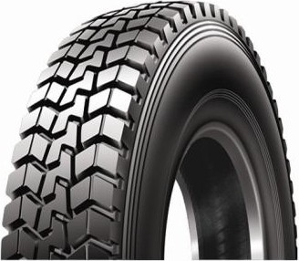
Provides excellent traction power
Tough belt construction for longer mileage
Special tread compound for high resistance against tread cut and chipping Suitable for light truck,heavy duty truck.

TREAD DEPTH •• • •• ••

TYRE SIZE

IIJLATION PRESSUIE (kPa)
• •

LOAD CAPACITY (kg)

315/80R22. 5

18PR
20PR

19. 5

19.5

9 . 00

154 / 151 M
TL
156/150 L

1076
1076

312
312

830
850

830
850

3750
4000

3450
3350

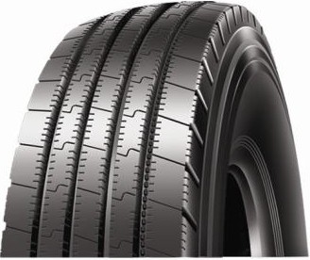
MX 936 ..
Designed for highway transportation with good road conditions,

;; r,r;i, ,
'.'
r;,
.'

Unique tread compound design with low rolling resistance,low heat build-up and minimized gasoline consumption.
Enhanced channel siping and wide grooves allow for premium wet and dry traction

TREAD DEPTH ••• •• ••

TYRE SIZE
. LOAD CAPACITY (kg)

18PR

154/151 M

1076

312

830
.
830

3750

3450

315/80R22 .5

20PR
19. 5
19.5 9 . 00 TL

156/ 150 L

1076

312
850
850
4000
3350

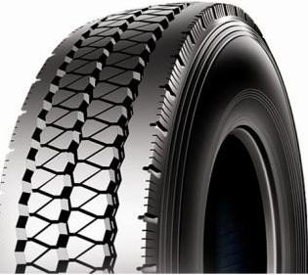
MX 937
-; .im .1

Mixed highway and freeway for long distance and national transportation service,
;
Mn
•..
Unique inner liner compound and bead design ensures tyre stability under tough applications. Reinforced shoulder belt design provides premium puncture and cut resistance .
Suitable for heavy duty truck and dump truck.
• • •• ••

• • ••

TYRE SIZE
TREAD DEPTH
IIJLATION PRESSUIE (kPa) LOAD CAPACITY (kg)

12R22.5
14PR
16PR

15. 0

18.9 9.00 TL
146/ 143
150/ 147
L 1085
300
720
830
720
830
3000
3350
2725
3075

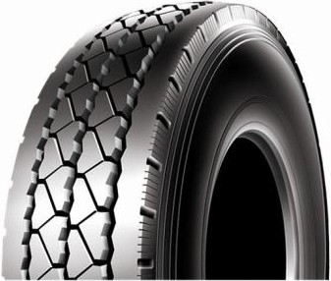
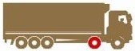
;;mrmrmn
MX 938
,-;- ... ..

Mixed highway and freeway for long distance and nationaltransportation service, Unique inner liner compound and bead design ensures tyre stability under tough applica­ tions.
Reinforced shoulder belt design provides premium puncture and cut resistance. Suitable for heavy duty truck and dump truck.
-TYRE SI , -1111
LOAD CAPACITY (kg)
- ' ti " 't

I • I •

12R22 .5
14PR
16PR

17.5

22 .0 9 .00 TL
146/ 143
L
150/ 147

1085 300
720
830
720
830
3000
3350
2725
3075

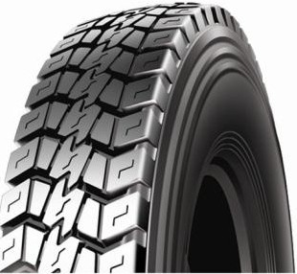

MX 958
Applied for express way,highway and urban road, drive position of truck.
Special tread compound design for lower heat build-up, excellent puncture and cut resistance and minimized gasoline consumption.
Super steelbelt carcass construction enhances casing strength and maxmizes tyre load capacity.

IMlATION PRESSUU: (kPa) LOAD CAPACITY (kg)

-TYRE SI ,

8.25R16LT

9 .OOR20

10. 00R20

11 . O OR20

12. O OR20

_ _ _ _ _ _
14PR 126/ 122 670 670 1700 1500
15.2 19.2 6.50F TT L 865 235
16PR 128/ 124 770 770 1800 1600
14PR 141/ 139 790 790 2575 2430
15.5 19.5 7 .OOF TT K 1132 259
16PR 144 /142 900 900 2800 2650
16PR 146/ 143 830 830 3000 2725
16.0 20 .2 7.50F TT K 1054 278
18PR 149/146 930 930 3250 3000
16PR 150/ 147 830 830 3350 3075
18.5 23 .3 8.00F TT K 1096 293
18PR 152/ 149 930 930 3550 3250
18PR 154/151 830 830 3750 3450
19.0 24 .0 8.50F TT K 1136 315
20PR 156/ 153 930 930 4000 3650


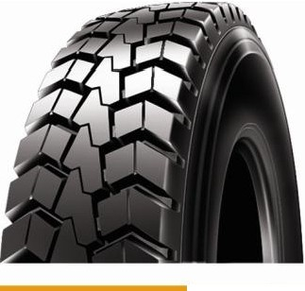MX 959,,,,. 'I//////////////J f ·
• • e' ·;
Open shoulder drive tire applied for highway urban and country road, drive position of truck. Reinforced steelbelt carcass enhances casing strength and maximizes load capacity Special wear- resistant tread design of low heat build-up
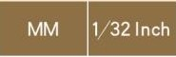
I

TYRE SIZE

LT235/ 85R16

12PR
TREAD DEPTH

18.3

TL 123/ 120
ltflAT ION PRESSUlE (kPa)
LOAD CAPACITY (kg)


235 650 650 1550 1400

14PR
14 . 5 61/2J
N
144/ 142
806

720 720 2800 2650

11R22 .5

295/80R22 .5
16PR
16PR
18PR
23 . 5

15. 0
29 .6

18.9
8.25 TL M
146/ 143
150/ 147
9 .00 TL L
152/ 149
1054

1044
279

298
830 830 3000 2725
830 830 3350 3075
900 900 3550 3250

18PR
20PR
154/ 151 M
156/ 150
830 830 3750 3450
850 850 4000 3350

315/80R22 .5

22PR
19. 5
24.6
9.00
TL L
167/ 164
1076
312

950 950 5450 5000

22PR
167 C
950 950 5450

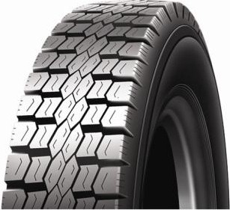
_,.. ____
,,nnnr,ru,,,
MX 96D -
r;,. '-' I 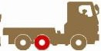

Mixed highway and freeway for long distance and national transportation service, All position tube­ less type for both city and highway applications.
Special tread compound design for lower heat build-up, lower rolling resistance and minimized gasoline consumption.
Special tread design offers good grasp capability on wet road and minimized driving noise.
-lt..fLATION PRESSUlE (kPa) LOAD CAPACITY (kg)

TYRE SIZE
TREAD DEPTH

11R22 .5

11R24 .5
14PR 144/ 142 720 720 2800 2650
18.0 22 . 7 8.25 TL M 1054 279
16PR 146/143 830 830 3000 2725
14PR 146/143 720 720 3000 2725
18.0 22 . 7 8.25 TL L 1104 279
16PR 149/ 146 830 830 3250 3000

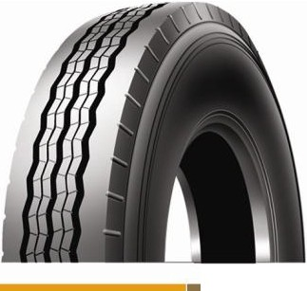

MX 96/
-- ----

,,nnnr,r,r,,,
"°;'
- I
Suitable for low plateform,specialty trailers and truck.
Dual compound rubber helps ensure cool operating temperatures while upper tread abration resis­ tance helps keep wear rates low.

Unique tread p•at•te•rn design minimizes side sliding on wet road.

TYRE SIZE
TREAD DEPTH
•

lt..fLATION PRESSUlE (kPa) LOAD CAPACITY (kg)
• • • •

215/75R17.5 18PR
13.5 17.0 6.00 TL
135/133
J 767
21 1 900
900
2180
2060

11R22 .5
14PR
16PR
14 .0 17. 6 8.25 TL
144/ 142
M
146/ 143

1051

279
720
830
720
830
2800
3000
2650
2725

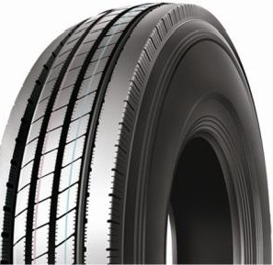
MX 963
-
Mixed highway and freeway for long distance and national transportation service, high speed, high loading.
Special tread compound offers excellent performance of lower heat build-up and cut resistance, super grip on wet road and improved riding comfort.
Suitable for local and inter-state bus and truck.

11R22 .5

TYRE SIZE
••1054 279
720 •

' t ''t LOAD CAPACITY (kg)
I •

12R22.5
14PR 144/142
15.0 18. 9 8.25 TL M
TREAD DEPTH
16PR 146/143
14PR 146/143
15.0 18. 9 9 .00 TL L
16PR 150/147

1085 300

830
720
830
720 2800 2650
830 3000 2725
720 3000 2725
830 3350 3075

215/ 75R 17 .5

MX 967

Applied for express way, highway and urban road, all position of the light truck and bus Horizontal groove design between ribs prevents slippage and side-slippage.
-- ----

,,rw,nr,nr,,,
r.'
.... l
Strong bead structure insures longer endurance and lifespan .

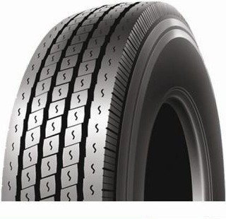--
- f
1 '

TYRE SIZE
TREAD DEPTH
11 l• I • '·

SINGLE
DUAL
SINGLE
DUAL
16PR 15.0 18 .9 6 .00 TL 135/ 133 J 767 21 1 900 900 2180 2060

225/70R19 .5
12PR 125/123
13.8 17.4 6.75 TL
M

811 226
660 660 1650 1550

14PR 128/126 760 760 1800 1700
235/75R17 .5 | 16PR | 15. 0 | 18 . 9 | 6 . 00 | TL | 132/129 | J | 797 | 233 | 830 | 830 | 2000 | 1850
265/70R19 .5 | 18PR | 15.0 | 18 . 9 | 7.50 | TL | 143/141 | J | 867 | 262 | 825 | 825 | 2725 | 2575

255/ 70R22 .5
14PR
14 .5

18 . 3 7 .50
TL 138/ 134 M 930 255 760 760 2360 2120

275/70R22 .5
16PR 140/137 830 830 2500 2300
14PR 142/139 760 760 2560 2430
16PR | 15.0 | 18 .9 | 8.25 | TL | 144/141 M | 958 276 | 830 | 830 | 2800 | 2575
18PR |  |  |  |  | 148/ 145 |  | 900 | 900 | 3150 | 2900

11R22 .5
14PR

15.0 18 . 9 8.25
TL 14 4/ 142 M 1054 279
720 720 2800 2650

16PR 146/143 830 830 3000 2725

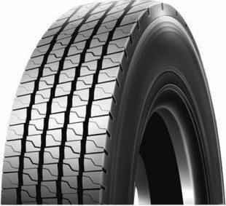
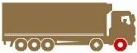
MX 96C
-- ----
w,n
r:--
,,
,
,,r r,i,l"'t
.
.I
Suitable for long journey, applied to steer wheels for highway and good road condition.
Unique tread design and compound for lower heat and lower rolling resistance and minimized gaso­ line consumption.
Horizontal rib design offers the top guiding and stability at high speed service, which also provides

- IMlAT ION PRESSLII (kPa)
295/80R22 .5
TYRE SIZE '

LOAD CAPACITY (kg)

12R22.5

315/80R22. 5
16PR 150/ 147 830 830 3350 3075
15.0 18.9 9.00 TL - M 1044 298
18PR 152/ 149 900 900 3550 3250
14PR 146/143 720 720 3000 2725
15. 0 18.9 9.00 TL L 1085 300
16PR 150/147 830 830 3350 3075
16PR 151/ 148 760 760 3450 3150
M
18PR 15. 0 18.9 9 .00 TL 154 / 151 1076 312 830 830 3750 3450
20PR 156/ 150 L 850 850 4000 3350

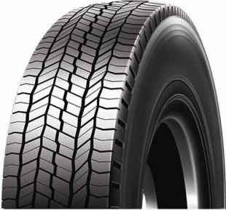
;;mrmMtt
MX 966-
• ,;,, I

Mixed highway and freeway for long distance and national transportation service on improved roads, All position tubeless type .
Special tread compound design for lower heat build-up, lower rolling resistance and minimized gasoline consumption.
TYRE SIZE

TREAD DEPTH ••••• • . I " ' •,
LOAD CAPACITY (kg)

Unique shoulder design provides excellent performance under long distance driving applications.

12R22.5

295/80R22. 5

14PR
16PR
16PR
18PR

18 22. 7 9.00 TL

18 22 . 7 9 .00 TL

146/143
L
150/ 147
150/ 147
M
152/ 149

1085 300

1044 298
•
720 720
830 830
830 830
900 900
• •
3000 2725
3350 3075
3350 3075
3550 3250

16PR
18PR
315/80R22 .5 20PR

18 22 . 7 9 .00 TL
151/ 148
M
154/ 151
156/ 150
L
22PR | 167/ 164 |  | 950 | 950 | 5450 | 5000
22PR | 167 | C |  | 950 |  | 5450

1076 312
760 760
830 830
850 850
3450 3150
3750 3450
4000 3350

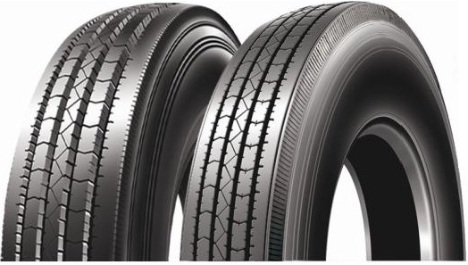
.... ____
,
n,,
, nnn
MX 965..
,;,. e' '

'SmartWay"
Smartway certified eco friendly all position or steer tire for long haul Optimum tread design guarantees even wear in trailer axle positions" Rib stone rejectors preserve casing integrity
TYRE SIZE ,
-11111•ltfLATION PRESS!Jll: (kPa) LOAD CAPACITY (kg)
14PR 144/142 720 720 2800 2650
11R22 .5 15.0 18.9 8 . 25 TL M 1054 279
16PR 146/ 143 830 830 3000 2725
14PR 144/141 760 760 2800 2575
295/ 75R 22. 5 14 .8 18.6 9 . 00 TL L 1014 298
16PR 146/ 143 830 830 3000 2725
14PR 146/ 143 720 720 3000 2725
12R22 .5 15.0 18.9 9 . 00 TL L 1085 300
16PR 150/147 830 830 3350 3075
14PR 146/ 143 720 720 3000 2725
11R24 .5 14 .8 18.6 8 . 25 TL L 1104 279
16PR 149/ 146 830 830 3250 3000
14PR 144/ 141 760 760 2800 2575
285/ 75R24. 5 14 .8 18.9 8 . 25 TL L 1050 283
16PR 147/144 830 830 3075 3000

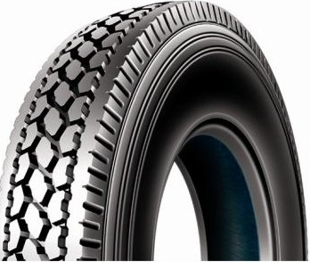
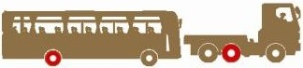
MX 969-
'- SmartWar
Mixed highway and freeway, drive position heavy duty rib tyre for on/off highway application. Special tread compound design for lower heat build-up, excellent puncture and cut resistance and minimized gasoline consumption.
Super steel belt carcass construction enhances casing strength and maxmizes tyre load capacity.

TREAD DEPTH .···11111

TYRE SIZE
14PR 144/ 142
11R22 .5 21 .0 26 .5 8 . 25 TL L 1065 279
16PR 146/ 143
14PR 144/ 141
295/75R22 . 5 22 .0 27 .7 9 .00 TL K 1020 298
16PR 146/ 143
14PR 146/ 143
11R24 .5 23 .8 30 .0 8 . 25 TL K 1116 279
16PR 149/ 146
14PR 144/ 141
285/75R24 . 5 22 .0 27.7 8 . 25 TL K 1056 283
16PR 147/ 144

ltfLATION PRESS!Jll: (kPa)

I •

720 720
830 830
760 760
830 830
720 720
830 830
760 760
830 830

l • I • '•

I •

2800 2650
3000 2725
2800 2575
3000 2725
3000 2725
3250 3000
2800 2575
3075 2800

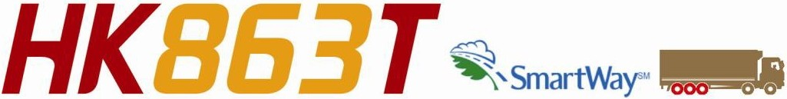

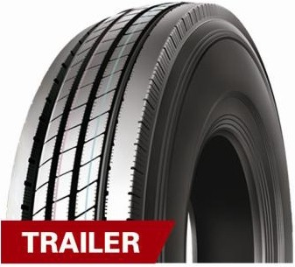
Smartway certified eco friendly trailer tire for long haul
Optimum tread design guarantees even wear in trailer axle positions" Rib stone rejectors preserve casing integrity

•• • •• •

. . ..

r_v_RE_si_z_E _,
TREAD DEPTH

LOAD CAPACITY (kg)
• • • •

255/ 70R22 .5 14PR
9.5 12. 0
7 .50
TL 138/ 134
M 930
255 760 760 760 2120

11R22 .5 | 14PR | 9 .5 | 12 . 0 | 8 .25 | TL | 144 / 142 | M | 1054 | 279 | 720 | 720 | 720 | 2650
11R24 .5 | 14PR | 9 .5 | 12. 0 | 8 .25 | TL | 146/ 143 | L | 1104 | 279 | 720 | 720 | 720 | 2725
295/ 75R22 .5 | 14PR | 9.5 | 12 . 0 | 9 .00 | TL | 144 / 141 | M | 1014 | 298 | 760 | 760 | 760 | 2575
285/ 75R24 .5 | 14PR | 9 .5 | 12. 0 | 8 .25 | TL | 144/ 141 | L | 1050 | 282 | 760 | 760 | 760 | 2575



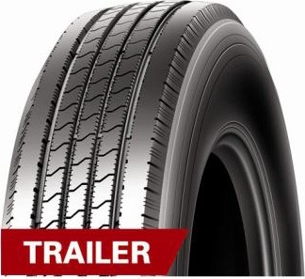
Smartway certified eco friendly trailer tire for long haul
Optimum tread design guarantees even wear in trailer axle positions" Rib pattern,extra sideslip resistance,pitch pattern designed.Low noise.
•••••• •
.

r_v_RE_si_z_E _,
LOAD CAPACITY (kg)
..
TREAD DEPTH
• • •• <ri •1

.

11R22 .5 14PR
9 .5 12. 0
8 .25
TL 144/ 142
M 1054 279
720
720 2800 2650

11R24 .5 | 14PR | 9.5 | 12. 0 | 8.25 | TL | 146/ 143 | L | 1104 | 279 | 720 | 720 | 3000 | 2725
295/ 75R22 .5 | 14PR | 9 .5 | 12. 0 | 9 .00 | TL | 144 / 141 | M | 1014 | 298 | 760 | 760 | 2800 | 2575
285/ 75R 24 .5 | 14PR | 9 .5 | 12 . 0 | 8 .25 | TL | 144/ 141 | L | 1050 | 282 | 760 | 760 | 2800 | 2575

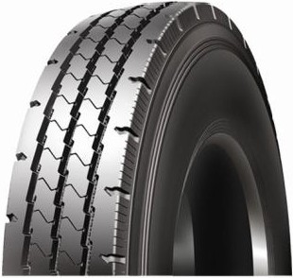
MX 968 - I
;;mifflMn
• ';>

Suita ble for heavy duty truck and dump truck .
Special tread compound design for lower heat build-up, excellent puncture and cut resistance and minimized gasoline consumption
Reinforced shoulder belt design provides premium puncture and cut resistance.

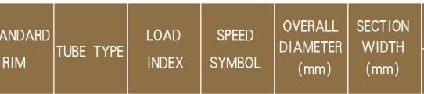
TREAD DEPTH I • OI <ii .11

TYRE SIZE

LOAD CAPACITY (kg)
. •

•

11.OOR20

16PR
18PR
14PR

16.0

150/ 147
20 . 2 8 .00 TT K 1085 293
152/ 149
146/ 143

830
930
720

830
930
720

3350
3550
3000

3075
3250
2725

12R22.5

16PR
15.0
18. 9 9 .00 TL
L
150/ 147
1085 300

830

830

3350

3075

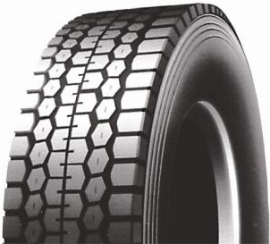

MX 975
Unique designed for mixed road surface and relatively poor road surface.

;;mifflM .I

Special tread compound design for lower heat build-up,excellent puncture and cut resistance and minimized gasoline consumption.
'ili
Super steel belt carcass construction enhances casing strength and maxmizes tyre load capacity.
l tflATION PRESSUU: (kPa)

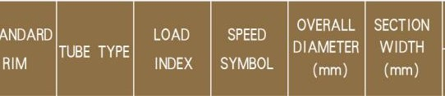
TREAD DEPTH

TYRE SIZE
830 | • •  830 | 3350 | • •  3075
900 | 900 | 3550 | 3250

... ,•,

295/ 80R22 . 5
16PR
18PR

15.0

18.9 9 . 00 TL
150/ 147
M
152/ 149

1050 298

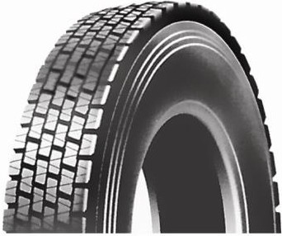
,....,nr,r,r,,,
-- ----
MX 977 -
r." ;> '

Application for driving wheels of highway service.
15° enhanced tread life design,avoiding irregular tread wear, intended performance is avaiable only with directional fitting.
Sidewall protector ribs resist scrubbing against curbs with long use life.
TREAD DEPTH •••••••••••• I " .

TYRE SIZE
LOAD CAPACITY (kg)
..
.

11R22.5
14PR
21 .0
26 .5
8 . 25
144/ 142
TL M
1065 279
720
720 2800 2650

16PR
146/ 143
830
830 3000
2725

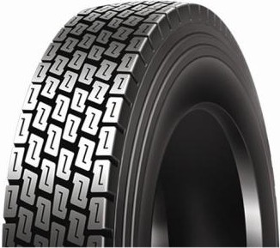
MX 978 -
--,l'll"IM!'l!'lrt,,
- l
Applied for national highway, standard highway with normal condition.
Drivingwheel of long haultrucks tractor trucks,Good traction,braking and sideslip resistance .. Extra deep tread provides excellent grip and driving capacity and also enhance tyre safty and abra­ sion resistance performance.
•••••••
•

TYRE SIZE
TREAD DEPTH
LOAD CAPACITY (kg)
. I .. '.,
I I •

11.OOR20

11R22 .5

12R22 .5
16PR 150/ 147
21 . 0 26. 5 8 .00 TT K 1096 293
18PR 152/ 149
14PR 144/142
21 . 0 26 .5 8 . 25 TL M 1065 279
16PR 146/143
14PR 146/143
19. 0 24 .0 9.00 TL L 1085 300
16PR 150/147
840 770
930 930
720 720
830 830
720 720
830 830
3350 3075
3550 3250
2800 2650
3000 2725
3000 2725
3350 3075

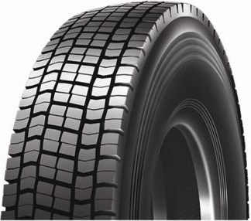
MX 979

;;mimMn
-
,;-. ;- l

Applicationfor driving wheels of passenger vehicle and truck on express way and city roads. This tread patterned tyre with good pulling force.
Sidewall protector ribs resist scrubbing against curbs with long use life.
• •••••••

TYRE SIZE
TREAD DEPTH

ltfLATION PRESSLl!E (kPa)
1•1 ,,,

I • I •

11. 00R20
16PR
MX979 19
8 .00 TT
150/ 147
K 1096
293
840
770 3350 3075

18PR
152/ 149

MX 980
930

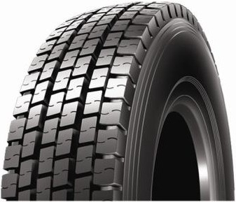
-
--,l'll"IM!'l!'lrt,,
e' l
/;"
930 3550
3250

For drive I highway service. Enhanced tread life design avoiding irregular tread wear, intended per­
formance is avaiable only with directional fitting.
Full Silica design (50% higher over previous version) reduce rolling resistance.

Excellent grip p•e••r•formance on wet grand. •
TYRE SIZE
TREAD DEPTH

LOAD CAPACITY (kg)

. I "

I • I •
•

12R22 .5
14PR
16PR

22 . 0

27 .7 9 .00 TL
146/143
150/147
L 1095
300
720
830
720
830
3000
3350
2725
3075

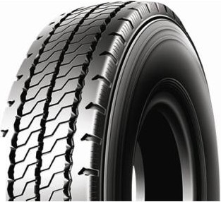

I
;;r;;r,i;rm,,
;

Heavy load series. Suitable for city, town and uneven road.
Special tread compound design for lower heat build-up, excellent puncture and cut resistance and
y minimized gasoline consumption.
.. Super steel belt carcass construction enhances casing strength and maxmizes tyre load capacity.
l LATION PRESSUU: (kPa)

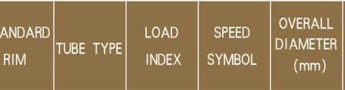
TREAD DEPTH
I
TYRE SIZE
... , ,,
• • • •

11.OOR2 0

16PR
18PR
16PR

18. 0 22 . 7 8.00 TT

150/ 147
152/ 149
146/ 143
K 1085 293

830
930
830

830
930
830

3350 3075
3550 3250
3000 2725

10.00R20

18PR
16. 0 20. 2 7.50 TT--
149/146
K 1054 278
930
930
3250 3000

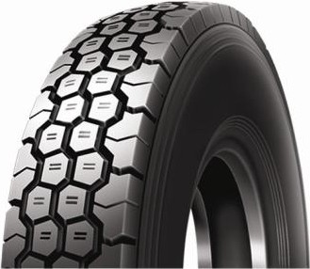
MX 998

..////
'I//////

.:·. .-

Suitable for heavy duty truck, applied for city, town and uneven roads, especially off the roads with
////J
..
stones, gravels in mining and construction sites.
Aggressive tread pattern and extra depth tread ensures the long hauling life of the tyre on tough roads.
Unique compounds prevent bead deformation under high road, which ensures great tyre stability on various applications.

TYRE SIZE .. .
LOAD CAPACITY (kg)
_ _ _ _ _
l fLATION PIISSIJlE (kPa)

9. OOR20

10.00R20

11 .OOR20

12.OOR20
14PR 141/139 790 790 2575 2430
15.5 19.5 7 .00 TT K 1019 259
16PR 144 /142 900 900 2800 2650
16PR 146/143 830 830 3000 2725
16. 0 20 .2 7 .50 TT K 1054 278
18PR 149/146 930 930 3250 3000
16PR 150/147 830 830 3350 3075
19.0 24 .0 8 .00 TT K 1093 285
18PR 152/149 930 930 3550 3250
18PR 154 /151 830 830 3750 3450
19. 0 24.0 8.50 TT K 1136 315
20PR 156/153 900 900 4000 3650

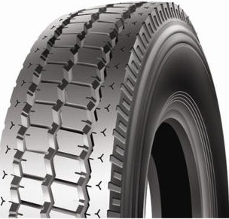
MX OB6

///////
'I///
.
•'
.:·. -

High powered mixed; Quansi-sovereign tread; Integrative shoulder pattern;
////J
....
High loading capability; Suitable for all kinds of road conditions .
Special tread compound design for lower heat build-up,perform well in hot weather.
TREAD DEPTH •••••• • lLATION PRESSUIE (kPa) •·• ,,,
r_v_RE_si_z_E _,
• • • •

12 .OOR24
18PR
20PR
15. 2
158/155
19. 2 8.50 TT K 1226 315
160/ 157
830
900
830
900
4250
4500
3875
4125

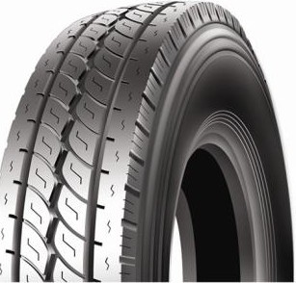
MX OBB
..////I/.·... -

High powered mixed;Quansi-sovereigntread ; Integrative shoulder pattern;
'I//////
I/J
..
High loading capability; Suitable for all kinds of road conditions.
Special tread compound design for lower heat build-up,perform well in hot weather .

TREAD DEPTH
r_v_RE_si_z_E _,

•• •• •

. • •• !'I •, '. LOAD CAPACITY (kg)
• • • •

12 .00R24
18PR
20PR
15.2
19. 2 8 .50 TT
158/ 155
K
160/ 157
1226 315
830
900
830
900
4250
4500
3875
4125

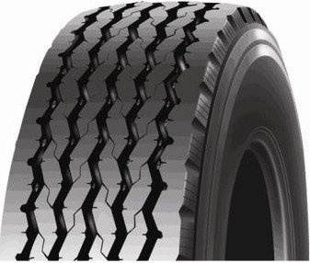
MX 906
-
Wide base single tire for highway transportation
Special tread compound with low rolling resistance effectively fuelconsumption
Super steel belt carcass construction enhances casing strength and maximizes tire load capacity

TREAD DEPTH •••••• •
r_v_RE_si_z_E _,

' • 0 f 1, I • LOAD CAPACITY (kg)

365/65R22 .5

18PR
15
..
158 830
18. 9 11 .75 TL K 1072 389
..
4250

20PR
160
900
4500


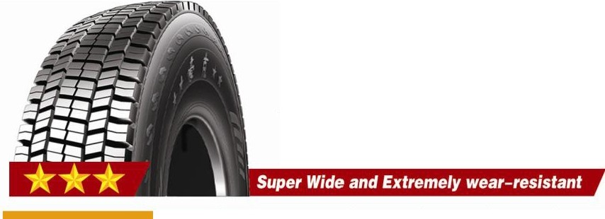MX 990
-
Special designed for long haul. Perform well on good road condistion high speed.
Contact Area 10% bigger than regular design. Larger footprint for drive comfort and long tread wear.
Tread formula exclusively designed for tires on trailer and steer positions.

IM'i.ATION PRESSllif (kPa) LOAD CAPACITY (kg)

-TYRE
SIZE -,
_ _ __ _

12R22.5 24 .0 30.2 9.00 252 146/143
150/147
720
L 1095 300
830
720
830
3000
3350
2725
3075

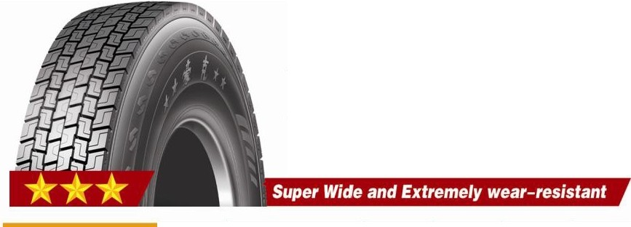MX 970 -;;mnrimiu
/;" ;
Applied for national highway, standard highway with normal condition.
Contact Area 10% bigger than regular design. Larger footprint for drive comfort and long tread wear.
Driving wheelof long haul trucks tractor trucks,Good traction,braking and sideslip resistance ..

IM'LATION PRESSllif (kPa) LOAD CAPACITY (kg)

-TYRE

SIZE -

, - ·

12R22.5 21 .0 26.5 9.00 255 146/143
150/147
720
L 1095 300
830
720
830
3000
3350
2725
3075

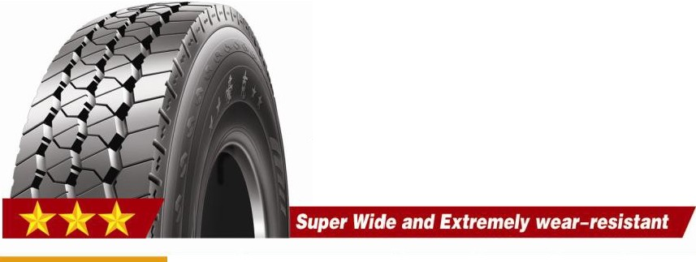MX 930
,--, Ml"tl"tl"t,,
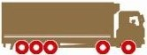
I'. ,... '

Mixed highway and freeway for long distance and national transportation service,
Contact Area 10% bigger than regular design. Larger footprint for drive comfort and long tread wear.
Enhanced channel siping and wide grooves allow for premium wet and dry traction

TREAD DEPTH
.. .. .

, t ti 'Ii '1 LOAD CAPACITY (kg)

TYRE s,_z_E _,
·• ····•·•
· I··1
:t·1··

I • I •

12R22.5 18.0 22.7 9.00 240 146/143
150/147
720
L 1095 300
830
720
830
3000
3350
2725
3075

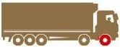
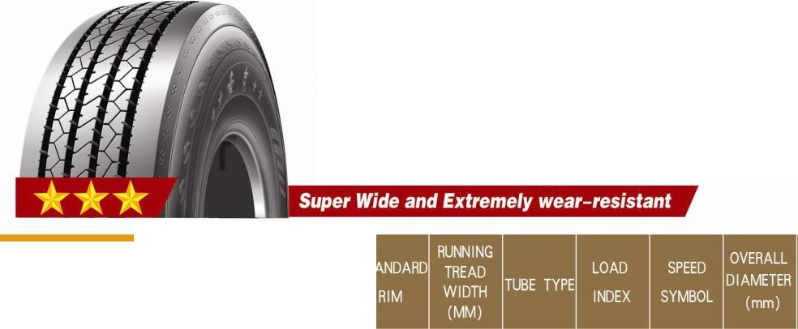;rw:;rmlffl,,
MX 920
';' _.. l

Special designed for long haul. Perform well on good road condistion high speed.
Contact Area 10% bigger than regular design. Larger footprint for drive comfort and long tread wear.Strong bead structure insures longer endurance and lifespan.

TYRE SIZE
TREAD DEPTH

t • I ,•,

.
ltfl.ATION PRfSSU1E (kPa)
• • .

12R22.5

17 .0

21 . 4

9. 00

240 TL
146/143
150/147
L 1095
300
720
830
720
830
3000
3350
2725
3075

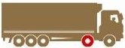
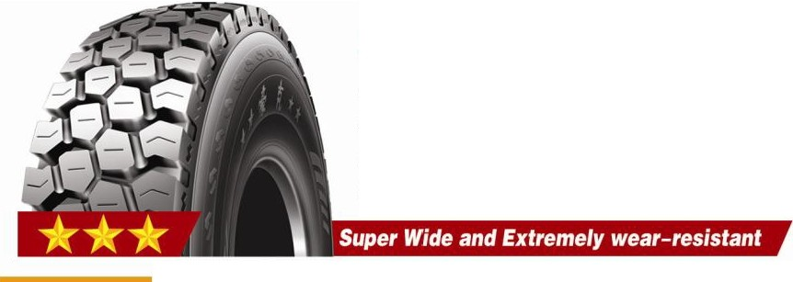MX 950
'///////
Applied for short-haul within 200kms, low speed,and heavy loaded dumping trucks.
..//// .! .·

Special tread compound with high wear-resistant, suitable for mining application and construction sites.
///h
Aggressive block pattern design provides excellent grip and traction performance

TREAD DEPTH
. ....
ltflATION PRESSU1E (kPa)
LOAD CAPACITY (kg)

TYRE SIZE
• • ••••••••

11 .OOR20
16PR
18PR
18PR
150/147
19 .0 23.9 8 .00 240 TT K
152/149
154/151
1094
293
830
930
830
830
930
830
3350
3550
3750
3075
3250
3450

12 .OOR20

20PR
20.0 25.2 8 .50 250 TT
K
156/153
1136
315

900

900

4000

3650

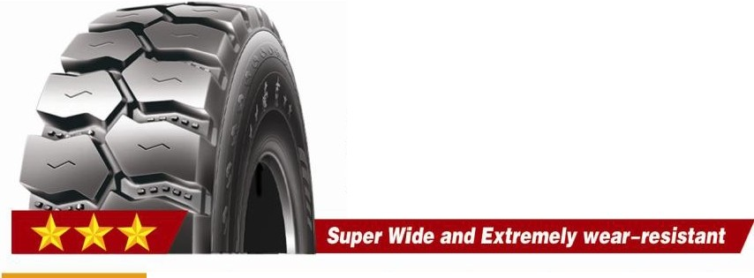MX 907
-..////

.! .·
///h

Applied for short-haul within 200kms, low speed,and heavy loaded dumping trucks.
'///////
Excelent stab-resistance,anti-eccentric worn,avulsion resistance and tread wear ability. Aggressive lug pattern design provides excellent grip and traction performance

TYRE SIZE .. -

t • I • '•

• • • •
ltflATION PRESSU1E (kPa)

11.00R20

16PR
18PR

150/147
16.0 20 . 2 8.00 240 TT K
152/149

1085

293

830
930

830
930

3350
3550

3075
3250

SPE ED SYMBOL
The SPEED SYMBOL indicates the speed at which the tyre can carry a load corresponding to its load
index service conditions  Speed Symbol | specified by MARVEMAX .  Speed(km/h) | Speed Symbol | Speod(km/ h)
B | 50 | M | 1 30
C | 60 | N | 1 40

D 65 p 1 50

 |  | E |  |  | 70 |  |  |  |  | Q |  |  |  |  | 1 60
 |  | F |  |  | 80 |  |  |  |  | R |  |  |  |  | 1 70
 |  | G |  |  | 90 |  |  |  |  | s |  |  |  |  | 1 80
 |  | J |  |  | 1 00 |  |  |  |  | T |  |  |  |  | 190
 |  | K |  |  | 1 1 0 |  |  |  |  | u |  |  |  |  | 200
 |  | L |  |  | 1 20 |  |  |  |  | H |  |  |  |  | 21 0

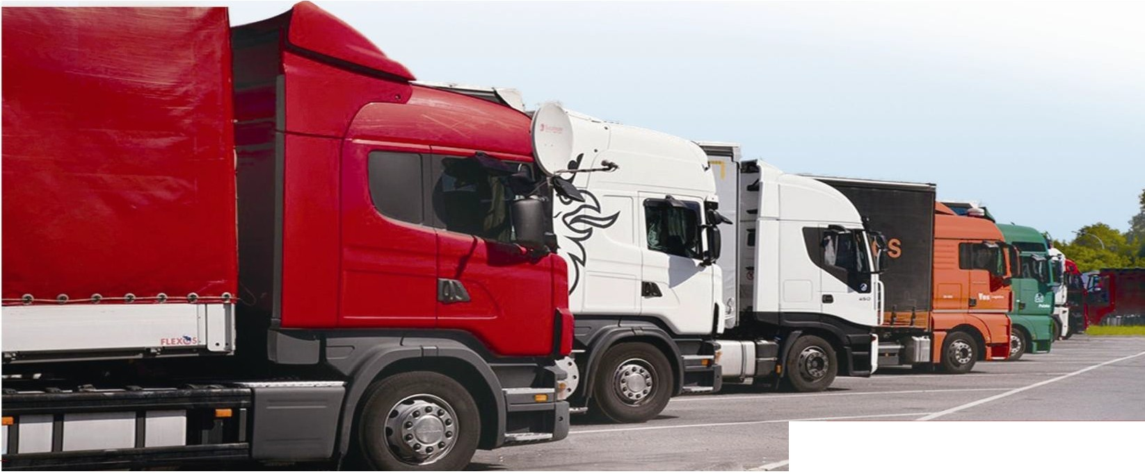
26 www hawktyre com MARVEMAX ·

