Hi Dave,
Please see comments below for front cover.
1 change bottom image to one of a construction site.. I NEED TO CHANGE THE IMAGE TO GUYS WEARING HIGH VIS clothing, THIS FELLA IS JUST WEARING A VEST.. my bad for sending an example that was wrong. You can use this image I have uploaded.. to brief – make image grey scale tint..
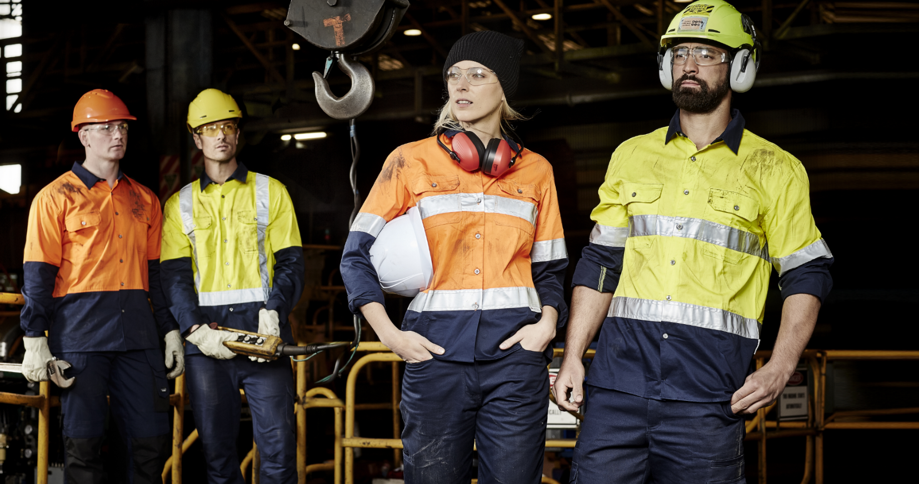

2 We would like to see 2 cover options one with a HIGH VIS YELLOW and HIGH VIS ORANGE WE GOT YOU COVERED BANNER, TOP STRIPE AND ROCK-DEPENDABILITY IN THE SAME COLOUR both of these colours are associated with High Vis and Industry, done make holes in banner solid like rivets..
4 Inside pages
Where shirts are offered in multiple colours, please show icons as half yellow half navy etc. as below. THE COLOUR OF THE GARMENT SHOWN BEING THE FIRST ICON..


Products and colours for SYZMIK bold items to be featured on page.
SUPPLIER | CODE(S) |  | Price ex GST | SIZE RANGE | ITEM COLOUR | DESCRIPTION
SYZMIK | ZP501R | D | $ 29.00 | 72 - 117 | NAVY | Basic Cargo Pant – 100% Cotton Drill 310gsm, 8 pockets, cargo pockets with Velcro quick close tape, adjustable side tab on waist.
SYZMIK | ZS502 | D | $ 26.00 | 72 - 132 | NAVY | Basic Cargo Short – 100% Cotton Drill 310gsm, 8 pockets, cargo pockets with Velcro quick close tape, adjustable side tab on waist.
SYZMIK | ZW122 | D | $ 25.00 | S - 7XL | YELLOW/NAVY & ORANGE/NAVY | Mens Hi Vis Spliced Industrial Shirt – 100% Cotton Twill 170gsm, underarm and upper back mesh vents, extended curved back hem.
SYZMIK | ZWL123 | DN | $ 36.00 | S - 7XL | YELLOW/NAVY & ORANGE/NAVY | Womens Hi Vis 3M Reflective Industrial Shirt - 100% Cotton Twill 170gsm, underarm and upper back mesh vents, 3M 8910 reflective tape.
SYZMIK | ZH231 | D | $ 10.00 | 2XS - 7XL | YELLOW/NAVY & ORANGE/NAVY | Hi Vis Basic Spliced S/S Polo – 100% Polyester 175gsm, supreme quick dry moisture wicking material, chest pocket with pen insert.
SYZMIK | ZH233 | DN | $ 20.00 | 2XS - 7XL | YELLOW/NAVY & ORANGE/NAVY | Hi Vis 3 M Reflective S/S Polo - 100% Polyester 175gsm, quick dry material, 3M 8910 reflective tape, chest pocket with pen insert.
OLIVER | 45632Z |  | $ 153.00 | 5 -14, 6.5 - 10.5 | WHEAT | AT 45 - Lace Up Boot, Water Resistant with Side Zip , Nubuck Leather, Fully Lined, Lace Locking Device, Composite Toe Cap,

6 Change RHC image to Grey Tint – done EACH CORNER IMAGE SHOULD BE TINT IMAGE AND SOLID COLOUR TO MATCH BRAND LOGO
7 Make SYZMIK bigger by 20% - done
8 Products and colours for WORKIT bold items to be featured on page. - done
9 Change WORKIT logo to green and make 20% bigger ( done ) add Green tint to image in LHC of page(done) , change colour top RHC to Green EACH CORNER IMAGE SHOULD BE TINT IMAGE AND SOLID COLOUR TO MATCH BRAND LOGO
SUPPLIER | CODE(S) |  | Price ex GST | SIZE RANGE | ITEM COLOUR | DESCRIPTION
WORKIT | 1003T | DN | $ 28.00 | 77-112 | BLACK, NAVY, KHAKI | Cotton Drill Multi Pocket Cargo Pants – 100% Cotton Drill 310gsm, Adjustable side tab on waist, Velcro tape side and back pockets.
WORKIT | 6003 | D | $ 19.00 | 77-112 | BLACK, NAVY, KHAKI | Lightweight Cotton Drill Shorts – 100% Cotton Drill 240gsm, Utility open pocket with Velcro closure and pen division.
WORKIT | 2002 | DN | $ 38.00 | 2XS - 6XL | ORANGE/NAVY & YELLOW/NAVY | Hi Vis 2-Tone Shirt with 3M™ Reflective Tape - Long Sleeve 100% Cotton 190gsm, Twin button flap chest pocket with pen division.
WORKIT | 2003 | D | $ 25.00 | XS - 6XL | ORANGE/NAVY & YELLOW/NAVY | Hi Vis 2-Tone Drill Shirt - Long Sleeve 100% Cotton 190gsm, Twin button chest pocket with pen division. 2 button adjustable cuff.
WORKIT | 2008 | D | $ 25.00 | XS - 6XL | ORANGE/NAVY & YELLOW/NAVY | Hi Vis 2-Tone Lightweight Drill Shirt - Short Sleeve 100% Cotton 155gsm, ventilated mesh back pleats and underarm panels.
WORKIT | 5005 | D | $ 19.00 | XS - 6XL | ORANGE/NAVY & YELLOW/NAVY | Hi Vis 2-Tone Lightweight Poly Cotton 80% /20% 185gsm, chest pocket with pen division.
WORKIT | 2012 | DN | $ 38.00 | 6-24 | ORANGE/NAVY & YELLOW/NAVY | Ladies Hi Vis 2-Tone Lightweight Drill Shirt with 3M™ Tape - Long Sleeve – 100% Cotton 155gsm, ventilated mesh back pleats and underarm panels.
STEEL BLUE | 522760 |  | $ 159.00 | 3-14, 6.5 - 12.5 | PINK | 150mm lace-up Ladies boot, with padded collar and tongue, steel toe cap, anti-static, nitrile sole, water resistant

10 Where shirts are offered in multiple colours, please show icons as half yellow half navy etc. as below. THE COLOUR SHOWN BEING THE FIRST ICON..
10A Change description of Steel Blue Boot to Steel Blue Southern Cross Ladies Boot
11 Change 2003DN to Yellow/Navy shirt, also available in O/N colour – done PLEASE REMOVE “N” FROMCODE
12 Change code on 5008D to 2008D done also available in Y/N colour ADD ORANGE NAVY ICON THE COLOUR SHOWN BEING THE FIRST ICON
13 remove 5005D replace with 2012DN IN Yellow, also available on ORANGE/NAVY, CHANGE TEXT TO Ladies 2-Tone Lightweight Drill Shirt image uploaded
14 Products and colours for Ritemate bold items to be featured on page.
15 make RITEMATE logo 20% bigger - done
16 Change image in LHC to Blue tint - done
17 Change image in top RHC to one without people, or move so not in shot. -done EACH CORNER IMAGE SHOULD BE TINT IMAGE AND SOLID COLOUR TO MATCH BRAND LOGO make image tint 20 % more blue
18 Change RM1050 to ROYAL/NAVY – done other colours available as shown in table, THE COLOUR SHOWN BEING THE FIRST ICON
19 Remove RM1004R replace with RM1004S Khaki- done change code to RM1004S change text to Cargo short 100% cotton drill other colours available as shown. THE COLOUR SHOWN BEING THE FIRST ICON

SUPPLIER | CODE(S) |  | Price ex GST | SIZE RANGE | ITEM COLOUR | DESCRIPTION
RITEMATE | RM1004 | D | $ 31.00 | 72-112R | NAVY/ BOTTLE/ KHAKI/ BLACK | Cargo Trouser 100% Cotton 310gsm, mercerized double preshrunk, twin needle stitching with bar tacks for strength, YKK zip.
RITEMATE | RM1004S | D | $ 24.00 | 77-127 | NAVY/ BOTTLE/ KHAKI/ BLACK | Cargo Shorts 100% Cotton Drill 310gsm, mercerized double preshrunk, twin needle stitching with bar tacks for strength, YKK zip.
RITEMATE | RM1050R | DN | $ 39.00 | XS-5XL | YELLOW-NAVY, ORANGE-NAVY, EMERALD-NAVY, PINK-NAVY, ROYAL-NAVY | Open Front 2 Tone L/S Shirt with 3M 8910 Reflective Tape, 100% Cotton 190gsm, twin needle stitching for extra strength, UPF 50+
RITEMATE | RM1050RS | DN | $ 39.00 | XS-5XL | YELLOW-NAVY, ORANGE-NAVY, EMERALD-NAVY, PINK-NAVY, ROYAL-NAVY | Open Front 2 Tone S/S Shirt with 3M 8910 Reflective Tape , 100% Cotton 190gsm, twin needle stitching for extra strength, UPF 50+
RITEMATE | RM1050 | D | $ 24.00 | XS-5XL | YELLOW-NAVY, ORANGE-NAVY | Open Front 2 Tone Long sleeve shirt , 100% Cotton 190gsm, twin needle stitching for extra strength, UPF 50+
RITEMATE | RM1050S | D | $ 22.00 | XS-5XL | YELLOW-NAVY, ORANGE-NAVY | Open Front 2 Tone Short sleeve shirt 100% Cotton 190gsm, twin needle stitching for extra strength, UPF 50+
OLIVER | 45632Z | DN | $ 153.00 | 5 -14, 6.5 - 10.5 | Wheat | AT 45 - Lace Up Boot, Water Resistant with Side Zip , Nubuck Leather, Fully Lined, Lace Locking Device, Composite Toe Cap,

20 Products and colours for BISLEY bold items to be featured on page.
21 make logo 20% bigger - done
22 change image in LHC to have LIGHT GOLD tint, change image in top RHC to LIGHT GOLD – EACH CORNER IMAGE SHOULD BE TINT IMAGE AND SOLID COLOUR TO MATCH BRAND LOGO
23 change code on shorts to BSHC1007 – done remove word Pant add in other colour options NAVY first icon
24 remove style BPC007T-done
25 remove style BV0363T, replace with BK1234 Polo shirt in Yellow/Navy-done

26 remove BS1234 Yellow, replace with BS1895D Yellow/Navy, change text 2-tone Lightweight Cotton Drill shirt change price to $30.00 image uploaded
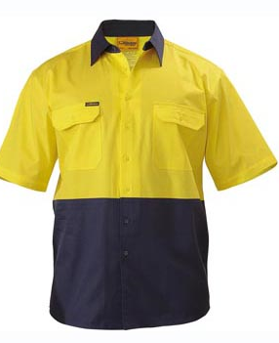
27 Swap image for BK1258TDN for the one below, show ORANGE/NAVY icon first, change text to 2-tone Polyester Polo with 3M reflective tape
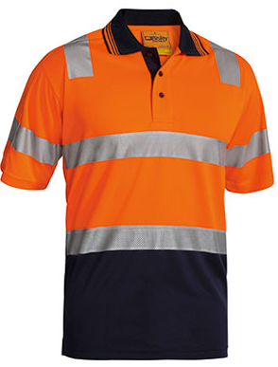
28 change image for BS1895 to BS6267D long sleeve orange, change description to 2-tone Hi Vis Cotton Drill Shirt change price $29.00, make first Colour icon Orange/Navy
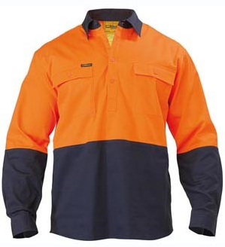
29 use image below for BS6415TDN change text to 2-Tone Hi Vis Cool Lightweight Drill Shirt 3M reflective
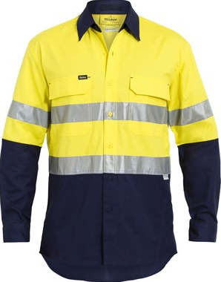
30 change text on Steel Blue boot to Steel Blue ARGYLE Boot remove DERBY

SUPPLIER | CODE(S) |  | Price ex GST | SIZE RANGE | ITEM COLOUR | DESCRIPTION
BISLEY | BPC6007 | D | $ 33.00 | 77-112 | NAVY/ BOTTLE/ KHAKI/ BLACK | 8 POCKET CARGO PANT 100% preshrunk cotton 310gsm, adjustable side tab, Side welt and cargo pockets.
BISLEY | BSHC1007 | D | $ 29.00 | 77-132 | NAVY/ BOTTLE/ KHAKI/ BLACK | ORIGINAL 8 POCKET Cargo Short 100% preshrunk cotton 310gsm, angled side pockets, mobile phone pocket, YKK zipper
BISLEY | BK1895 | D | $ 30.00 | XS-6XL | ORANGE/NAVY & YELLOW NAVY | 2-Tone Lightweight Short Sleeve 100% Cotton Drill, 2 chest pockets, left pen pocket reinforced stitching.
BISLEY | BK1258T | DN | $ 34.00 | S-6XL | ORANGE/NAVY & YELLOW NAVY | 3M TAPED TWO TONE HI VIS POLO – Short Sleeve 100% Polyester micromesh 165gsm, constructed to reduce heat stress.
BISLEY | BS6415T | DN | $ 59.00 | S-6XL | ORANGE/NAVY & YELLOW NAVY | 3M TAPED TWO TONE HI VIS X AIRFLOW - Long Sleeve 100% Cotton Ripstop 150gsm, perforated tape for cooling, modern fit.
BISLEY | BS6267 | D | $ 29.00 | S-6XL | ORANGE/NAVY & YELLOW NAVY | TWO TONE HI VIS COTTON DRILL SHIRT 100% Cotton 190GSM – Short Sleeve, under arm mesh ventilation,
STEEL BLUE | 312152 |  | $ 164.00 | 3-14, 6.5 - 12.5 | WHEAT | Argyle Zip sided ankle boot with padded collar and tongue.

Back Cover..
Copy
As Industry experts Lifestyle Australia supplies branded products that promote company image, brand values and enable health and safety compliance. In supplying specific items that exactly meet a business’s needs relating to brand identity, performance and cost, Lifestyle Australia provides solutions that allow our partners to focus on their core strengths.
Products and Services
Uniform supply solutions, sourcing, branding and delivery | Embroidery and embellishment
Innovative branding solutions for all products | Stock holding and fulfilment programs
Screen Printed Tee shirts and related screen printing services | Transfer printing of unique designs

Business Advantage
Lifestyle can screen print, embroider and embellish all products in house to specific colour standards and levels of detail other companies cannot achieve. We provide unique patent protected print and application processes to a wide range of products. In controlling our own production and certified Quality Control we can achieve 100% delivery on time and in full, quality checked, repackaged, and despatched from our own production facility in Yatala.
Problem Solved
Uniform supply solutions, sourcing, branding and delivery, are all part of the Lifestyle total care package that we can provide to your employees. From project start up to annual supply or fair wear and tear replacements. There are many options available in this area and the 24 hour personalised online webstore is rapidly becoming the most popular and economical supply solution.
Stock holding and fulfilment programs are part of the total solution offered by Lifestyle. We offer a bulk storage and delivery function from our 1000m2 warehouse or bespoke individual customer or employee packs from our climate controlled storage in the “Vault”. We have the ability to create any number of supply solutions using our inventory control system to create complex BOM’s specific to each campaign or project.
Free Digitising and Design
Lifestyle Australia have multi award winning designers continually creating detailed artwork that can be seen all around Australia.. With unlimited use of colours and layers we combine futuristic designs with corporate logos and messages, to provide eye catching and powerful embellishments. Please send your logo to us and we will provide a proof for your uniforms, all orders are digitized free of charge and logos kept on file for future repeat orders, reducing lead time even further.

