Mendonoma refers to an area on the northern California coast that includes parts of two counties: Mendocino County and Sonoma County. This is a very rural and sparsely populated area.
Here’s some info about the area:
Much of the MHA service area is dramatically beautiful, consisting of a rugged coast line, Redwood forests, rivers and lakes. In addition to industries such as fishing, logging and ranching (all of which have declined in prominence over recent years), outdoor activities such as boating, hiking and abalone diving, along with access to nearby wineries, helps boost tourism in the area.
The total population for the area is estimated to be approximately 8,500. However, it is difficult to confirm this number or obtain formal or consistent data for the area because the targeted population is split between two counties and much of the population is living in small, unincorporated communities. The 2010 Census Data identified 6,800 living in the service area but estimates at the time of the census indicated that approximately 25% of the Mendocino County areas had not been counted and approximated that actual number at 8,500. The local Chamber of Commerce estimates that part-time and vacation residents increase this to an estimated 11,000.

Here’s some other used of the term “Mendonoma”
There is Go Local initaitve in the area and one of the categories is “Heal Local” – here’s a link to that website - http://golocalmendonoma.org/about-go-local-mendonoma/

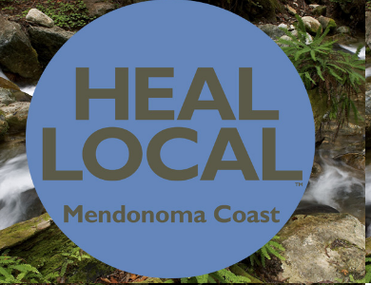

Also, the local newspaper – The Independent Coast Observer uses mendonma. http://www.mendonoma.com/ as their URL. A local author/naturalist write an article in this weekly paper and has published a photo book about local fauna and flora - http://www.mendonomasightings.com/

