BSB31115 Certificate III in Business Administration (Medical)
Course Outline
Gain the knowledge and skills to become a professional Medical Administrator by completing the Nationally Recognised Qualification in Business Administration (Medical). You will be employed in a variety of professional environments where your skills and contribution will be highly valued.
This qualification is designed to give you the knowledge and skills required to become an integral part of the medical healthcare team. Find yourself in a role where you’re appreciated by patients and your support is relied upon by the clinical team to keep the business administration running smoothly.
Your efficient, diligent, caring approach makes a significant difference to the lives of others and engenders a sense of job satisfaction second to none.
Medical Administration is a vibrant career with qualified administrators being widely sought after in industry – therefore career opportunities are strong. With an aging population, medical administration is a government recognised growth area with strong upwards projections of job opportunities predicted into 2020 and beyond.
There are a variety of opportunities in diverse fields such as general practice, specialist practice, hospitals, dental and allied health. For students interested in career advancement, there are strong pathways to promotion available into more senior levels of administration and practice management.
This course is ideal for those wanting to begin a career in the health professions and for workplace trainees. Mature aged students are also highly sought after in the medical space. Career opportunities are high for both part-time and full-time employees.

Graphic etc on the front page
Design elements

Maybe a testimonial ….
“The trainers were excellent in their delivery and knowledge. I want to say a huge thank you to Wesley for the course and knowledge I came away with. I have secured a fantastic job after my first application! Such good value for money too! I would highly recommend it. I'm a mature age person so it's never too late to up-skill yourself to get what you deserve"! - Ann Scott

Wesley Institute of Training
Enriching Minds | Accelerating Careers www.wesleytraining.edu.au FREECALL : 1800 001 256
Course Content
Units of Competency Covered in the Wesley Programme :

Core
BSBITU307 Develop keyboarding speed and accuracy
BSBWHS201 Contribute to health and safety of self and others

Medical Skill Set
BSBMED301 Interpret and apply medical terminology appropriately
BSBMED302 Prepare and process medical accounts
BSBMED303 Maintain patient records
BSBMED305 Apply the principles of confidentiality, privacy and security within the medical environment
BSBMED304 Assist in controlling stocks and supplies

Business Administration (Medical) Skill Set including an introduction to Audio-typing
BSBITU309 Produce desktop published documents
BSBITU303 Design and produce text documents
BSBITU306 Design and produce business documents
BSBWRT301 Write simple documents
BSBADM303 Produce texts from audio transcription

Customer Service for Medical Administrators
BSBCUS301 Deliver and monitor a service to customers

Bonus training offered as part of the Wesley Programme

- Medical Triage for Non-Clinical Staff and Customer Service (BSBCUS301)
- CPR First Aid Qualification with Australian Red Cross (BSBSXXXXX)
- Microsoft Word 2010 Essentials Short Course
- Microsoft Publisher 2010 Essentials Short Course
- Wesley Typefast Online Keyboard Programme and certification to Australian Standards

Career Outcomes
Completing your Certificate III in Business Administration (Medical), you’ll be qualified to work in the following areas :-
- Medical Receptionist
- Medical Secretary
- Administration Assistant
- Medical Administration
- Ward Clerk
- Dental Receptionist
- Medical Accounts Clerk
- Medical Records Administration
- Front Desk Hospital Admissions

Industry Insights (this could be set in a right-hand side bar next to Career Outcomes)

Industry Insights (this could be set in a right-hand side bar next to Career Outcomes)

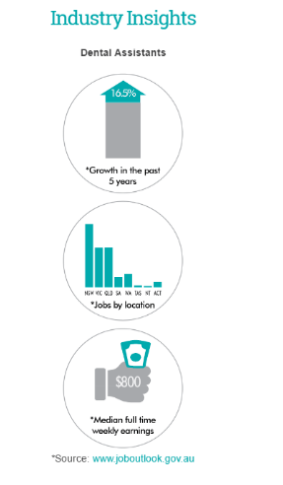
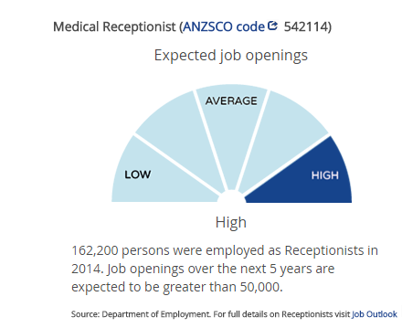
(Above needs to be re-graphically set - ie use above image but redoit,
Please replace words dental assistants with medical receptionist, leave out ‘jobs by location’.)

Page 2/

The student study package – what you receive

Students receive an array of helpful resources to keep as part of the Wesley Programme. These include :

- Wesley Institute Workbook ‘Medical Receptionist and Secretary’s Handbook’
- Wesley Institute Workbook ‘Write, Design and Produce Documents for the Australian Medical Office’
- Wesley Institute Workbook ‘Medical Triage and Customer Service for non-clinical staff’
- Access to Wesley Online Learning platform
- Access to Wesley Type-fast programme with testing and certification to Australian standards
- Microsoft Word and Publisher online tutorials and certification
- Digital Medical Transcription Software – student version.
- Medical Accounts Software Pracsoft – demo version to keep

- 9ACGP endorsed Triage Guide Chart
- Red Cross Basic First Aid Booklet and CPR Wallet Card
- CPR Accredited Training
- Heart Foundation endorsed online training programme
- Heart Foundation DVD and Facts Pack for medical professionals
- Access to accredited specialist mentors and trainers
- Registration into Wesley’s Job-Network Club

Entry Requirements
There are no formal entry requirements for this qualification, however it is recommended that individuals have a Year 10 standard of English and basic keyboard skills. Students with English as a second language may request a language, literacy and numeracy assessment during the enrolment and orientation session to determine learning support needs.

Unique Delivery Model – Combining face-to-face learning with self paced
The Wesley Cert III Business Admin (Medical) Programme offers a unique structure to the medical administrative trainee - offering flexibility, intensive face-to-face training of crucial medical units combined with a self-paced home learning and a unique on-line learning programme. This allows studies to be undertaken at a convenient time by students and trainees.

The programme will adjust to differing skill levels and ability to commit time to the programme and can be completed in as little as 6 months to a maximum of 12 months – depending on prior experience and skills.

Wesley believe some units can only be taught effectively with face to face training led by industry experts and cannot be taught effectively by online learning alone. Therefore Wesley’s Core Medical units are taught in workshop settings in 5 Saturdays (or through the week by prior arrangement) followed by self-paced and online delivery of core administration modules. The programme is further followed up with an intensive one day workshop.

For Traineeships, our Trainers physically attend site 1-2 times for personalised mentoring. There is a mentor/trainer assessor available at all times during our programme for all students.

All students are invited to Wesley’s Computing Medical Software workshop day, where students work hands-on in a workplace simulated environment. Participants receive a complimentary demo copy of a Popular Medical software programme.

Combined Assessment Approach
Duration : 6 – 12 months

Wesley utilise a variety of assessment processes which allow different learning styles to benefit from our programme. Assessment tools may include questioning, quizzes, assignments, projects, case studies and more.
Workplace project work simulates real workplace activities utilising real medical forms, situations, case histories, resources, practice software and represents industry standards including RACGP, AMA, the Australian Medical Board, Australian Red Cross and the Heart Foundation.

Student Support

Students have direct access to a Trainer/Mentor for the duration of the programme and have direct access to Wesley Health Student On-Line Forum which students can engage with fellow students and trainers from across Australia.


Page 4/
Funding (Queensland)
The Queensland Government will offset the cost of study for eligible students. You will still need to pay for a portion of your study costs.

Wesley Institute of Training has been chosen by the Department of Education and Training to deliver Government Subsidised Courses through the Certificate 3 Guarantee programme, VET Investment Plan and User Choice initiatives.
Therefore Wesley Institute are able to offer subsidised training for students who are eligible for the Certificate 3 Guarantee Programme, delivery and manage Traineeships in Cert III Business Administration (Medical) and offer services in Vocational Training for Schools (VETis). For Course and funding opportunities, please contact our office by email or phone to find out more.

Certificate 3 Guarantee
You can receive a subsidy towards one certificate III qualification from a list of eligible courses. Give us a call to find out more.
You're eligible for the Certificate 3 Guarantee if you:
- Not hold or be currently undertaking a certificate III or higher level qualification. This does not include qualifications completed while at secondary school.
- Be 15 years of age or older
- Have finished secondary school or left school
- Be an Australian citizen or permanent resident residing in Queensland, or New Zealand citizen permanently residing in Queensland.

Corporates and Traineeships
Wesley offer a range of training opportunities to Corporates, Hospitals and Industry in either the full qualification or a range of individuals units, including Patient Confidentiality, Medical Terminology, Medical Triage and Customer Service for Non-Clinical Staff. For corporate enquiries, please email info@wesleytraining.edu.au. Great incentives are available for employers wanting to sponsor new staff to study the BSB31115 Business Administration (Medical) with bonus employer payments of between $1500 - $5000. Enquire today.
Make an Enquiry
Wesley’s range of Medical Administration Training courses are designed to suit every budget and study situation. You may be eligible for Government subsidies for the Wesley Cert III Qualification where course costs are heavily discounted.
Enquiries : info@wesleytraining.edu.au or FREECALL 1800 001 256


1800 001 256
No matter your question,
we are here to help!
Info@wesleytraining.edu.au (

Partners
Logos –

Wesley Institute of Training details etc
RTO Reg 50921
www.wesleytraining.edu.au PO Box 1228 Bentley DC Technology Park 6983

