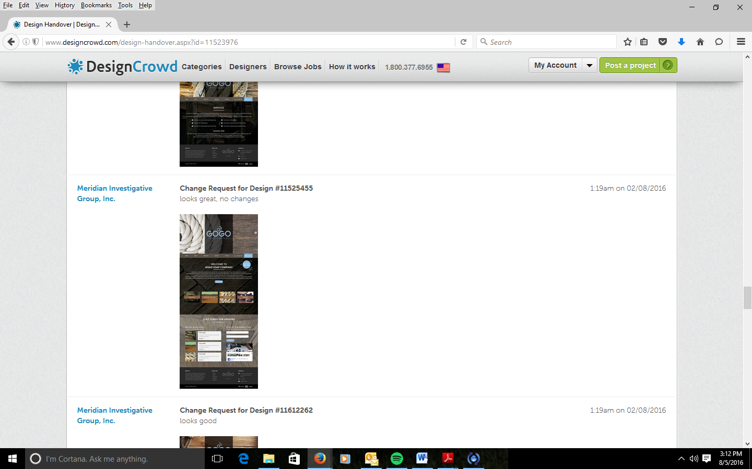
I like this one with the wood for all the pages, keep it
Remove the light background pic and replace it with one that is not so light

