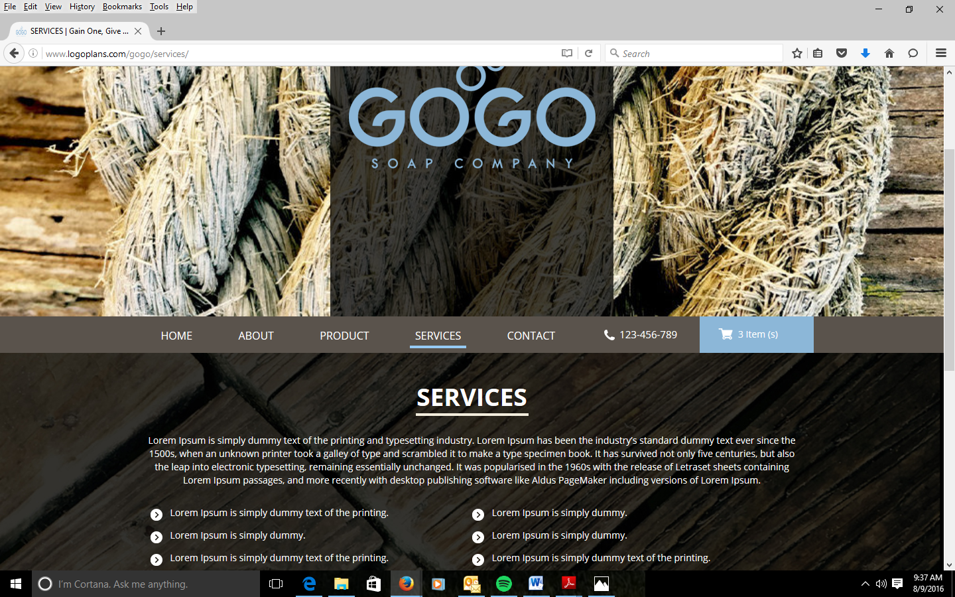
HOW WE GIVE
GAIN ONE GIVE ONE CONCEPT

