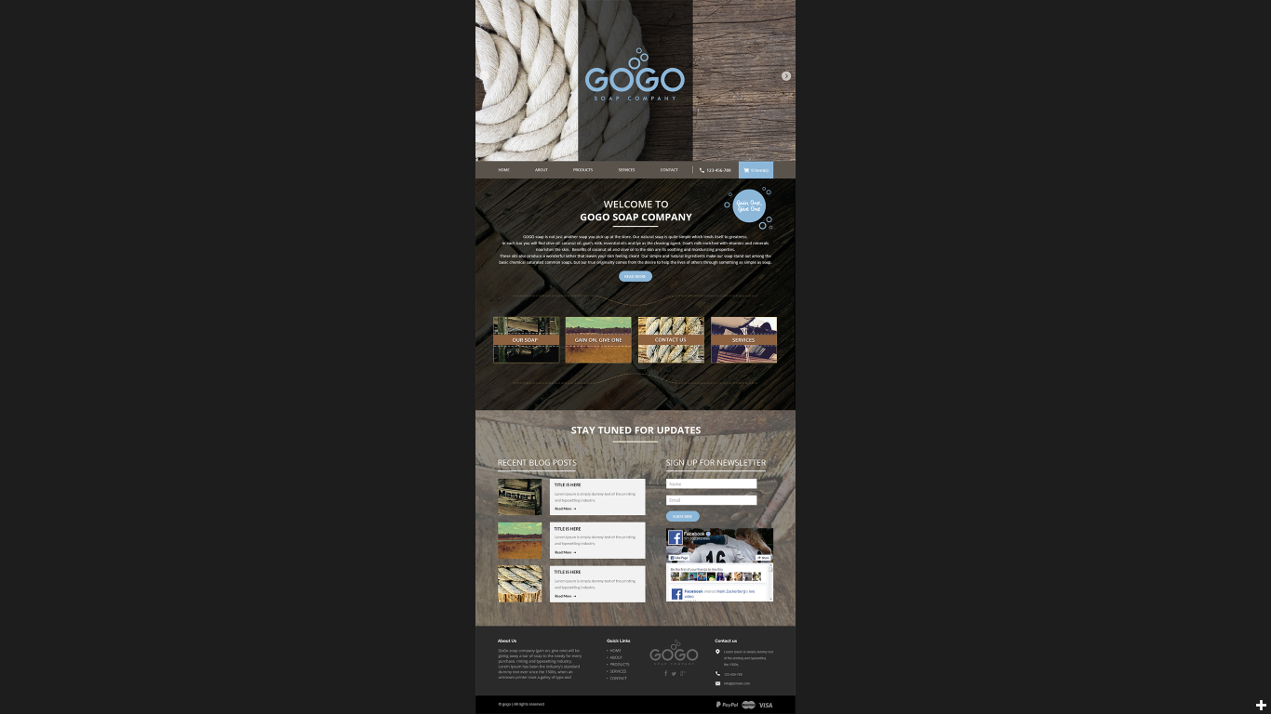
Keep this background picture
Keep the face book box
I want this background picture NOT to be the same as the one above it. I would like a little contrast, but just not as light as it is here. Is there a different picture you can modify?

