
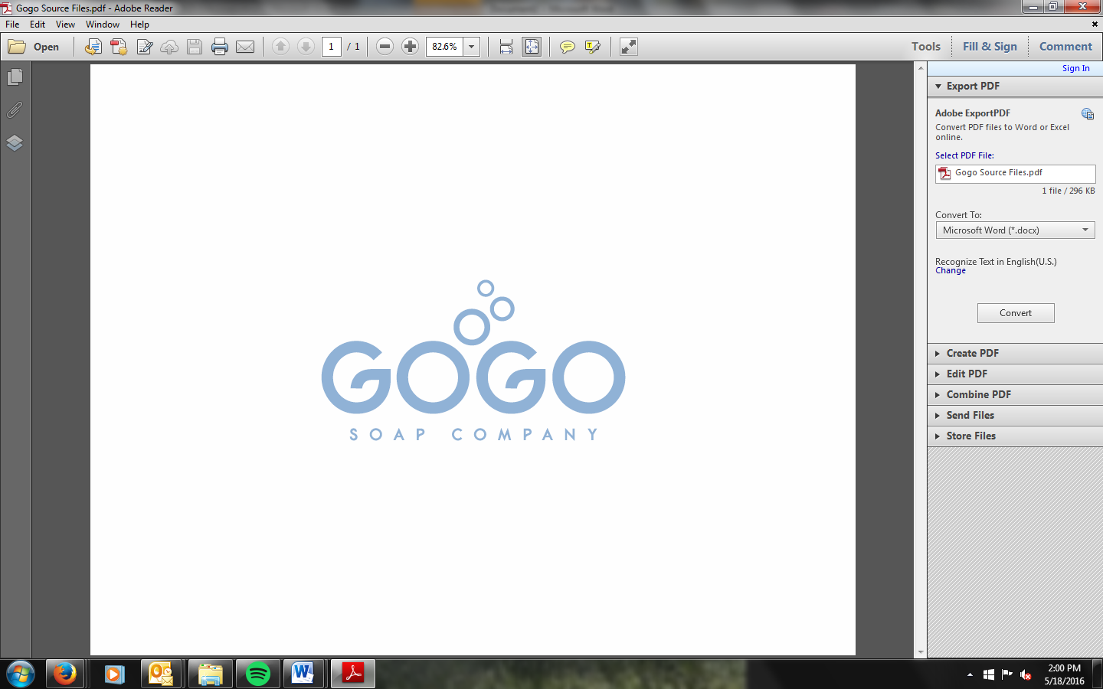

GOGO soap is not just another soap you pick up at the store. Our natural soap is quite simple which lends itself to greatness. In each bar you will find olive oil, coconut oil, goat’s milk, essential oils and lye as the cleaning agent. Goat’s milk enriched with vitamins and minerals nourishes the skin. Benefits of coconut oil and olive oil to the skin are its soothing and moisturizing properties. These oils also produce a wonderful lather that leaves your skin feeling clean! Our simple and natural ingredients make our soap stand out among the basic chemical saturated common soaps, but our true originality comes from the desire to help the lives of others through something as simple as soap. We are convinced that no one can help everyone, but everyone can help someone!

Gain One, Give One, Is our motto. Giving underprivileged individuals both local and abroad healthy living promoted by free soap for better hygiene. GOGO is family owned and invested in the lives of orphans in Fond Parisian, Haiti and here in the U.S. We also have the opportunity to partner with Family Promise a nationwide program designed to establish homeless families with secure jobs and housing. Our needs are great, but we believe there are a lot of awesome people looking to help somebody! Partner with us in making a difference in the hygiene of one person with one bar of soap. Gain One and Give One! Your skin will thank you and someone else will smile with thanksgiving and the opportunity of healthy living!

