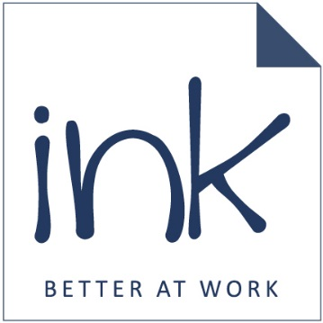
This is a design concept we like – the Ink logo in the middle to symbolise that we advise clients on these benefits, and then smaller or larger boxes / bubbles / shapes to denote the benefits themselves.
Employee Benefit
Employee Benefit
Employee Benefit
Employee Benefit
Employee Benefit

