Logo Design Brief

1. Describing the business
Our business is looking for a logo to complement the name change. The company has recently changed its name to Starboard IT and will relaunch the company using this new name.
Special Note: We would prefer to use the current website theme for the new logo so that we can keep the costs of changing our website and associated material to a minimum. However, if you have great design idea that is outside the current theme then we welcome these ideas and will give it full consideration.
- New Name: Starboard IT
- Old Name: Orizon IT
- Current Website: http://www.orizonit.com.au
- Industry: Information and Communications Technology (ICT).
- Main product/service: Our services span everything from proposing and delivering IT solutions tailored to the requirements of each client, to assisting businesses take the journey into Cloud services, to managing the IT assets for clients, to providing consulting and advisory services.
- Brand values or stories important to your brand: The word Starboard is derived from the first initial of each company director Richard, Steve and Tim. We are an energetic, forward thinking company that prided itself on solving pain points that its clients are experiencing across a range of business IT systems.

2. Logos we like
We tend to like simple, clean, fresh designs. It would be preferable if the logo incorporates the company name. An example of this is Coca-Cola, where the logo is incorporated into the name.
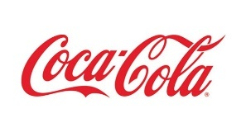
We want to project a forward thinking professional approach to IT. The logo needs to be memorable and simple so that someone can explain the design easily in words.
- Some other examples of logos we like:
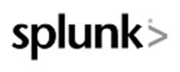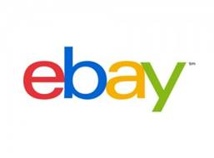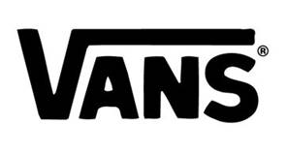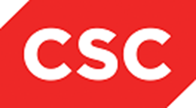
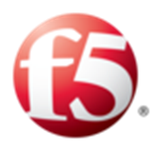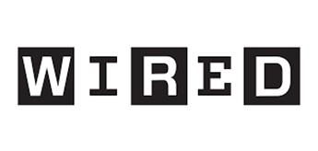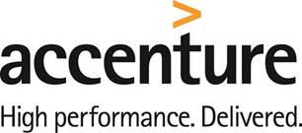
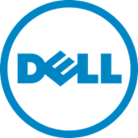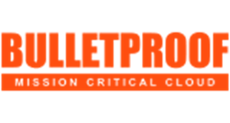
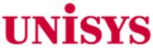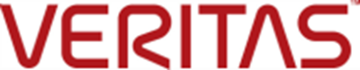

- Examples of logos we do not think are appropriate for us are shown below. As you can see below these logos do not have the company name imbedded in them and would rely on extensive marketing and advertising to ensure the logo is well known.
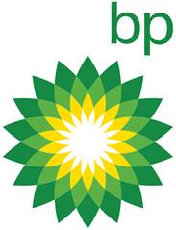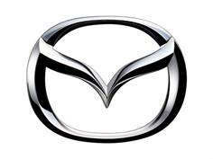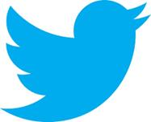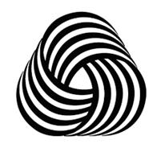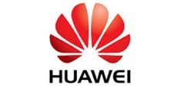
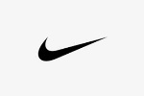
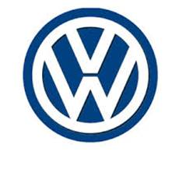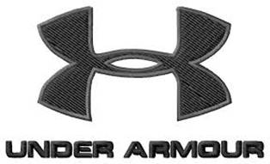
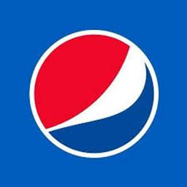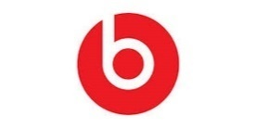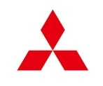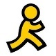

3. Feelings to convey
We want to convey our company core values and other feelings
- Core values:
Innovative
Communicative
Collaborative
Customer Focused
Integrity
Ownership
- Professionalism
- Forward thinking
- Confidence
- Calm
- Soothing
- Trustworthy

4. Colours and fonts
One requirement is the logo should be usable again a white background, e.g. White background on a website or a white background on a business card.
Refer to the Special Note above. In summary, we would prefer to stay with the current colour theme to keep the costs of changing to a minimum. In saying that, we are not averse to the use of other colours that highlight or accents the current theme.
If you want to be more adventurous and use a completely different theme, then we are very open to this and will give the design full consideration.
For informational purposed, the current website uses a White-Blue-Grey colour theme, in particular the hex codes are:
blue: #3774b7
grey: #757575
No specific fonts are required. However, the logo needs to be easy to read and it would be preferable that the fonts are readily available across a wide range of platforms, such as MS Office, PhotoShop, Illustrator, etc.

5. Where will this logo will be used
- Website
- Email signatures for staff.
- Stationary.
- Brochures and marketing products
- Signage – Office and industry events
- Business cards

6. Who is the target market?
- Business to business operation model
- Targeting many industries but more likely to include:
  - Banking
  - Insurance
  - Financials
  - Legal sector
  - Professionals
- Targeting organisations in the Small to Medium Businesses (SMB, between 10 and 200 staff) and niche markets in the larger enterprise businesses.
- No specific gender will be targeted.
- Targeting a particular age group? Being a B2B model, target age is the working age. 18 – 65 years of age.

