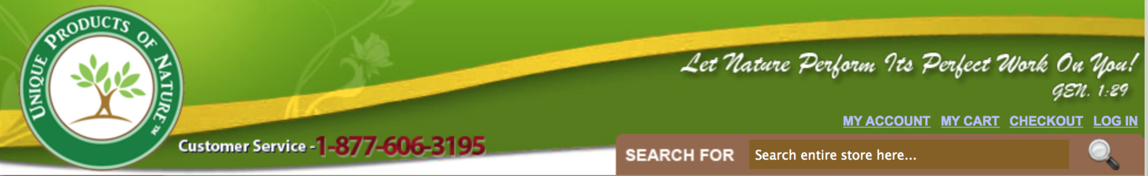

This is our logo and website header, please try to improve upon this look.

