ProCare Protects Doctor
 Lets say Your Worst Case Scenario Happens… Your Patient Dies..... Now the Family Says..... "you got them addicted"
and Sues the Practice!
What’s in Your Chart Right Now That is Protecting You???


Can You afford NOT to use ProCare ??

Pro Active Addiction Counseling Helping your Patients identify issues and concerns before they turn into problems, thus keeping Your Good Patients Compliant Longer. Signatures of Understandings will Make the Patient More Responsible for their Opioid therapy, thus Strengthening the Doctors Chart and Lowering the Physician's Risk of Treating that Patient.
How Well Do You (Dr.)Know Your Patient??

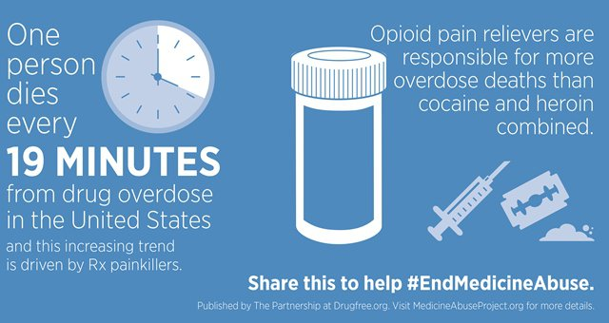 Patients Can Sue Doctors Can you afford not to have ProCare in Your Charts
ProCare was designed to give Patient's Individualized Opioid Education and Counseling and Provide a Risk Management Package to Physicians with Signatures of Understandings that will Make the Patient More Responsible for their Opioid therapy, thus Strengthening the Doctors Chart and Lowering the Physician's Risk of Treating that Patient.

