INFORMATION TO BE INCLUDED ON THE FRONT OF THE CARD

[HEADLINE:]
Let INSIDE FOOTBALL Be Your Guide through New York Giants Summer Training Camp

[COPY:]
Inside Football has covered the New York Giants for more than 35 seasons. Our game plan covers individual player performances, coaching strategies, and so much more. See why we are the preferred publication of the BEST informed Giants fans!

[PACKAGE OPTIONS:]
[Design note: Please use small American football bullets.]

Option A: Summer Coverage (limited availability)
Five weekly issues starting in early August
- One training camp report
- Four preseason game reports

Email/Digital Delivery: $24.95
First-class mail delivery: $29.95

Option B: Summer-Plus Coverage
21 weekly issues starting in early August
- One training camp report
- Four preseason game reports
- 16 regular season game reports (no bye week)

Email/Digital Delivery: $49.95
First-class mail delivery: $79.95

[Design Note: You don’t have to use the icons I have here, but I would like to see small icons for web, phone and snail mail.]

[ORDER INFO:]
To Order:
shop.insidefootball.com
732-743-5694
P.O. Box 6434, Edison, NJ 08818-6434

[BOILERPLATE:]
Inside Football is a fully accredited, independent media organization that is neither sponsored by nor affiliated with the New York Football Giants or National Football League. All rights reserved.

COLOR SCHEME
Please incorporate the following colors (dark blue, red, white and gray) somewhere in the design. Here is the color chart.
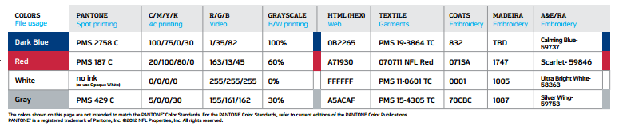

I have also uploaded the logo – it should be in a high res format.

