Extra Virgin oil from roasted Roasted Sunflower seeds – LABEL, two sides

We start with the English version and will need identical Swedish later.

FRONT LABEL size is 91 mm( height) X 57 mm (length)
BACK LABEL size: 91 mm ( height)x 45 mm( length)

The label, please put in eye-catching way with emphasis on ROASTED

IMPORTANT note: English and Swedish versions have different barcodes. If you have your own program to generate barcode, you can use it. Otherwise we havet hem in the attachemnts, not in very good resolution probably. Here are the numbers for barcodes ( EAN 13):

7350085290098 - English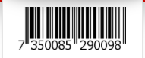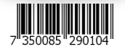
7350085290104 -Swedish

Optional :Simple Map of Georgia and some surrounding countries to understand where Georgia is located on front or back side

Front side
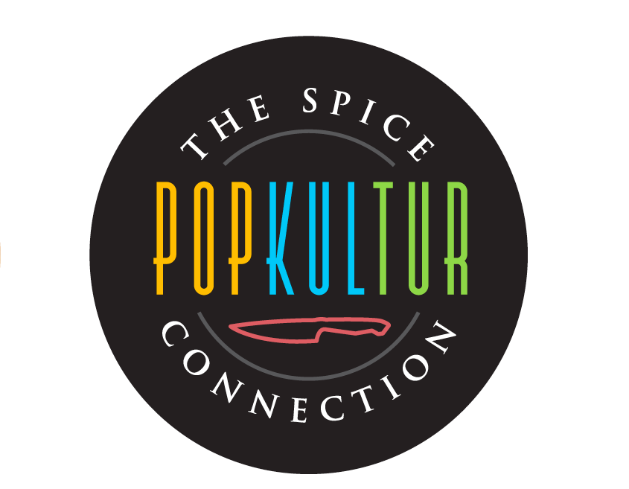
Logotype ”Popkultur” . Please, take away ” The spice connection around the label.
Here we can play with the the logotype circle to be as a middle of the sunflower, and put yellow leaves around it.

We found the picture on blue background and yellow sunflower very inspiring. Maybe you could make smth with this colors and feeling? The quotation is not relevant, just the colors and style.


slogan ”Sunflower power”

ENGLISH

Extra Virgin Oil
from ROASTED
sunflower seeds

from family gardens in Georgia

Unrefined
All natural

260 ml

Back side:
100 % natural sunflower oil from roasted sunflower seeds.
First cold press.

Nutrition information per 100 g
Energy: 900 kcal
Fat 100 g
of which saturates 13 g
of which mono-unsaturates 27 g
of which poly-unsaturates 60 g
Carbohydrate 0 g
Protein 0 g
Salt 0 g

Store away from light and heat.

Produced in Georgia for Popkultur Food, Sweden
contact@popkulturfood.com

Sign for recycling of glas
Use by date/Bäst före: ( possibiity to put a stamp)

Barcode ( find in the beginning of the brief)

Unrefined cold-pressed oil with full-bodied nutty flavor from fire roasted sunflower seeds. The seeds are grown at family gardens in sunny Kakheti region in Georgia, and pressed by mechanical methods as it has been done for hundreds of years.

Use: Enhances any dish by few drops, from salads to desserts. Perfect for dipping bread.

High content of vitamins (E, K) and antioxidants. No preservatives or color.

END OF ENGLISH VERSION

SWEDISH

Kallpressad solrosolja
av ROSTADE solrosfrön

Från familjegårdar i Georgien

Oraffinerad

260 ml

Back side

100 % kallpressad olja av rostade solrosfrön.
Producerad uteslutande genom mekaniska processer.
Förvaras svalt och mörkt.

Näringsvärde (per 100 g)
Energi 900 kkal
Fett 100 g
varav mättat 13 g
varav enkelomättat 27 g
varav fleromättat 60 g
Kolhydrater 0 g
Protein 0 g
Salt 0 g

Tillverkad i Georgien för Popkultur Food
contact@popkulturfood.com

Oraffinerad olja med fyllig och nötig smak från solrosfrön som rostats over eld. Från familjegårdar i soliga Kakheti-regionen i Georgien, där solroskärnorna pressas på traditionellt vis, med uteslutande mekaniska metoder.

Förhöjer smaker med några få droppar. För allt från sallader till desserter. Oemotståndlig att doppa ett rustikt lantbröd i.

Högt innehåll av vitaminer (E, K) och antioxidanter. Utan tillsatser eller färgämnen.

+ barcode and sign for recyckling of glas

