Our current website (http://www.lucysecurity.com/) uses a standard word press template we want to keep. So you don’t need to offer a re-design of the whole page. But there a few areas we want to improve the design of sub sites or single elements:

- PROBLEM 1: Many graphics are just created from PowerPoint. One Example: http://www.lucysecurity.com/product/server-plug-ins/
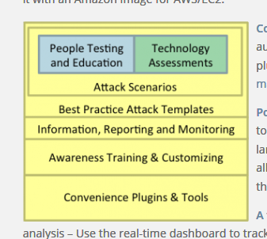

Here is another Example. This graphics give an overall overview of the product:
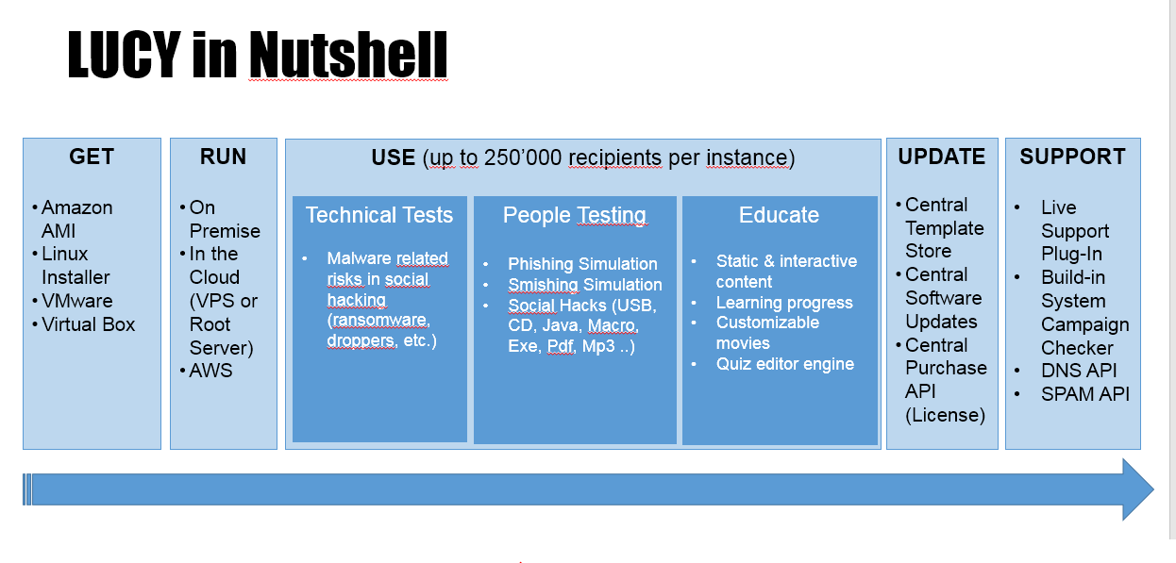

GOAL: We want to improve the designs so they match the website overall design. Maybe some graphics like the one above can be converted into graphics like below, where the user then may click on a topic to get linked to more details. So the amount of text in the graphics have to be reduced, visual elements have to be inserted to match the according topic etc.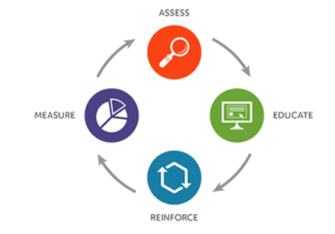

- Problem 2: In many areas we use a lot of text and tabs (e.g. http://www.lucysecurity.com/product/#tab-id-1). I would like those to be merged into some graphics that contain some titles or short descriptions that can be expanded or linked to subpages.
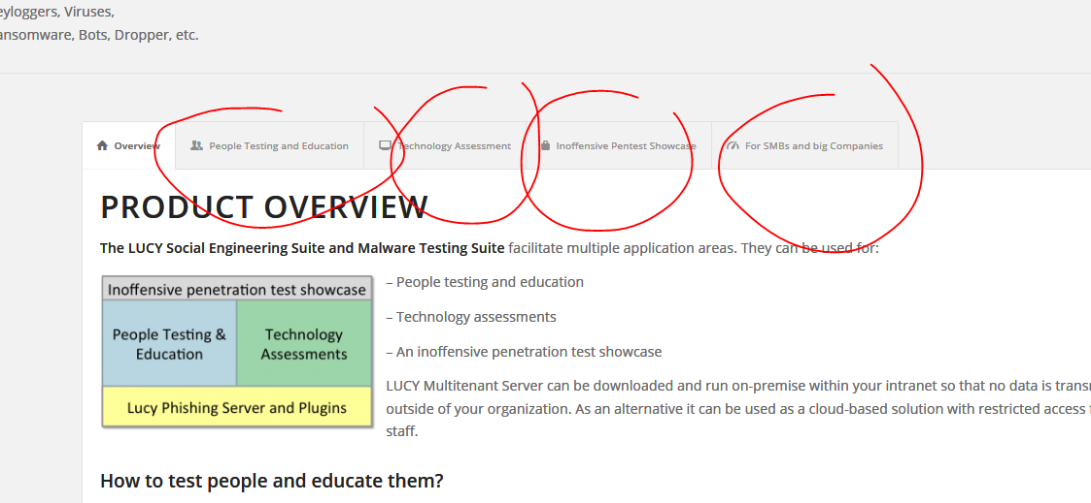
Maybe this whole section can be transformed into one single page graphic where the details expand as you click on them:

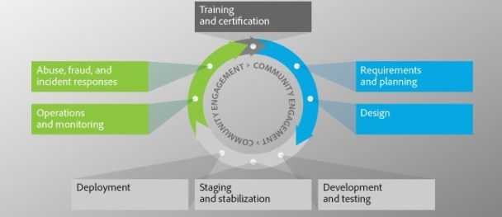

-Problem 2: many of the template product bullet points look very much "out of the box" standard WP design. (e.g. http://www.lucysecurity.com/why-lucy/ or the feature list under http://www.lucysecurity.com/product/) Maybe we can also replace them with graphics where the graphic or the symbols already give the viewer an idea of the advantages/features.

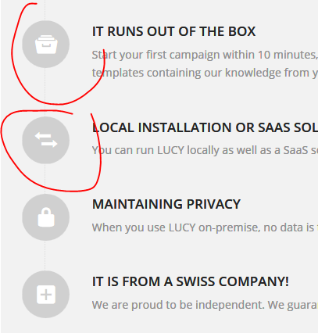

- some pages need complete re-design (e.g. http://www.lucysecurity.com/resources/shop/ where the pic and the whole layout with the cut off face is not so professional)
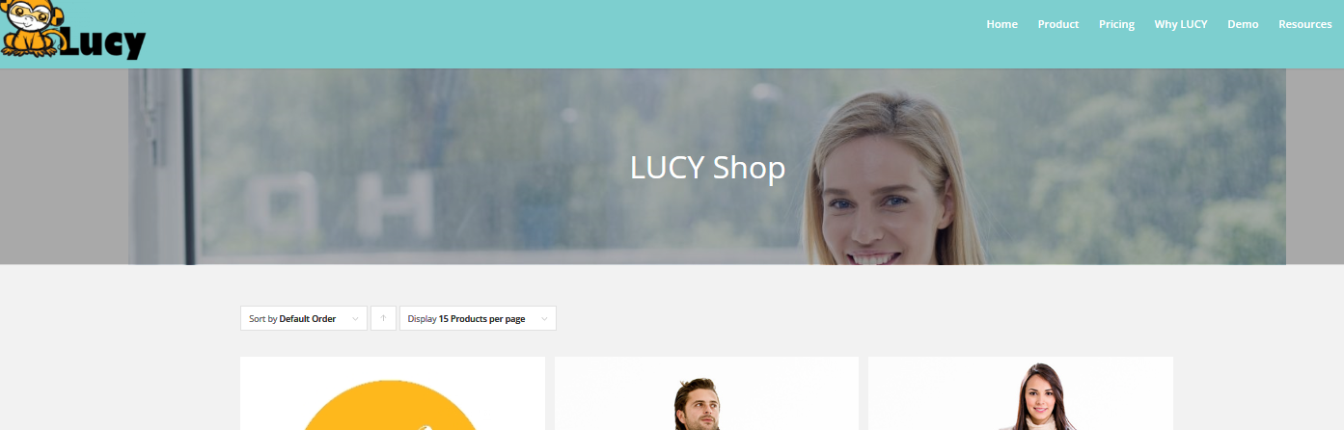

- Symbols (like product boxes) also need a redesign http://www.lucysecurity.com/product-category/product/ . This could be converted into software product boxes
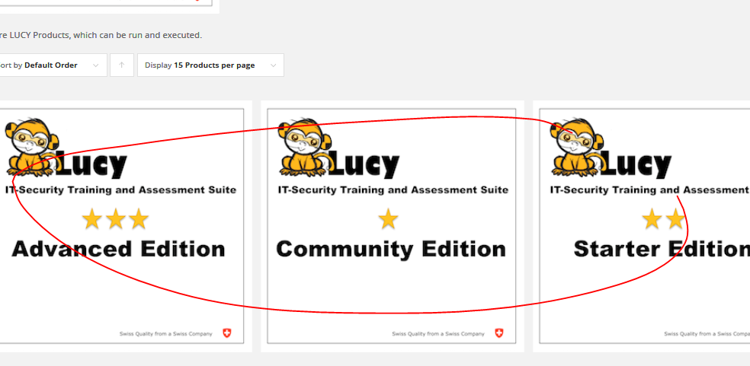

Of course we are open to any other suggestion that improves the design but as well the whole navigation workflow which is currently very complex.

So we are looking for a designer who can do ALL the changes. BUT: as a start we would ask you to just pick ONE OR TWO elements from the list above and create a proposal for a re-design. If we like it we can continue from there on a hourly base....

