  Welda Consults offers two professional books to help in ongoing assessing of your students and incorporating their learning styles and interests. Purchase them at: http://weldaconsults.com/resources  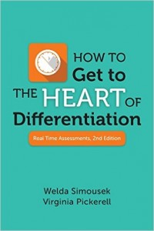 (Also available on Amazon)  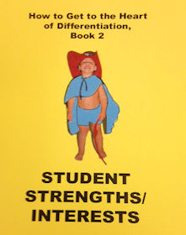 |  |  |  |  | 
  Engaging & Relevant Professional Development
  Sessions are tailored to meet the needs and goals of districts, schools, and classrooms. Participants engage in activities that deepen content knowledge and add tools to their pedagogical toolboxes. All sessions are:
  - Designed to meet participants at current levels of understanding
  - Hands-on; no “sit-n-get”
  - Grounded in research and best practices
  - Collaborative
  - Combined with ongoing, free online resources and support
  Our Philosophy:
  We believe that learning does not occur at the same pace for all students and adults, that there is value in personalized learning experiences for all. We provide “just in time” professional development that meets current needs while addressing anticipated needs based on long-term goals.
  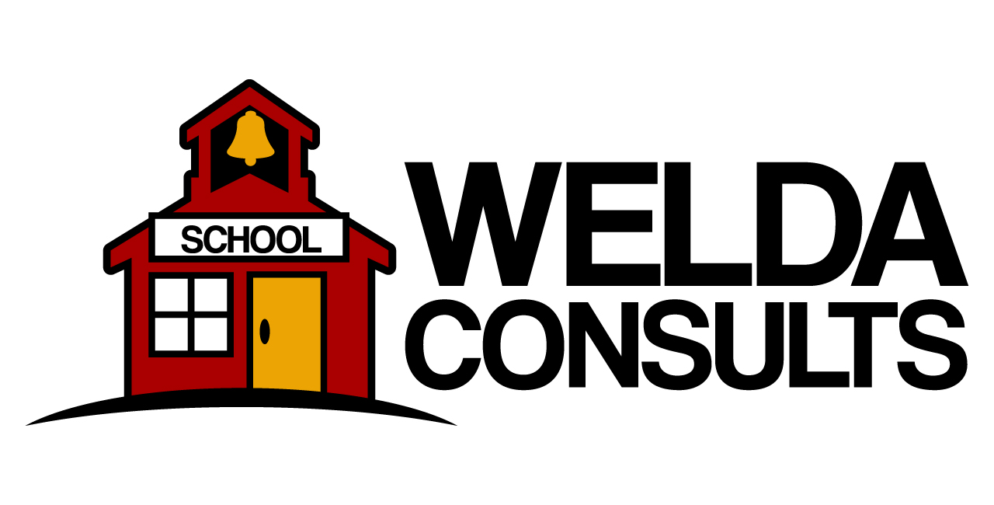 |  | (608) 320-0069  welda@weldaconsults.com
  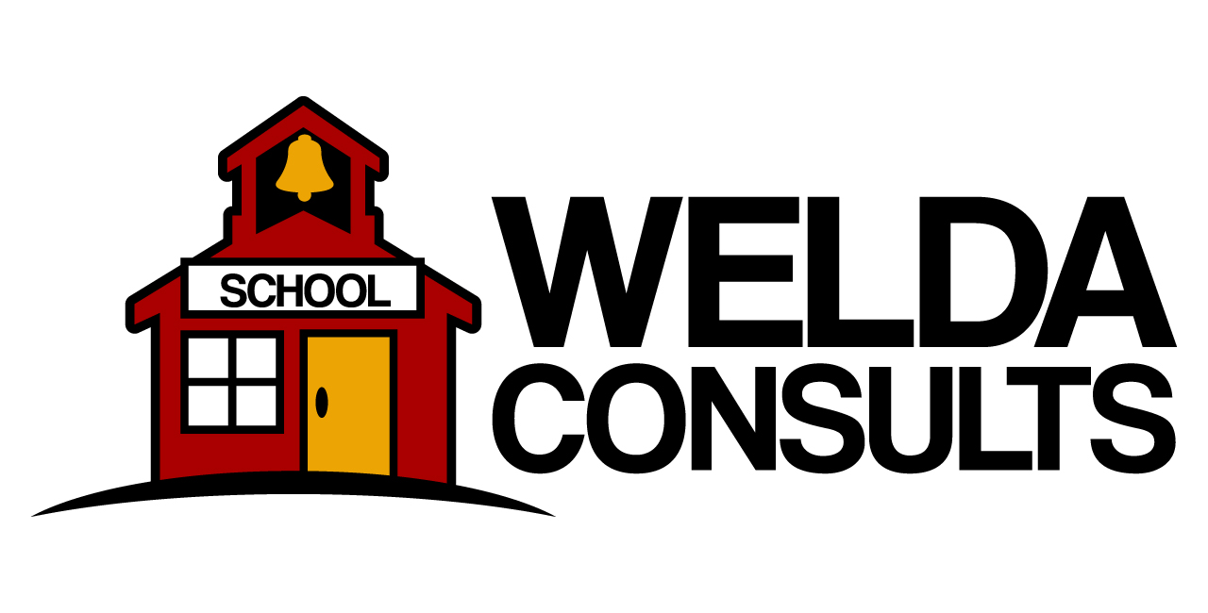
    - “Welda’s knowledge and experience with differentiation strategies, enthusiasm for the subject matter, and techniques for engaging students is without parallel.” ((B. Wood)
    - (B. Wood)B. Wood). t promote and honor student choice, peer collaboration, creative problem-solving, higher-order thinking skills, and varied learning styles.” (A. Vonbank)

  Let the philosophy of a one-room school solve your big school issues!  One-room schools had to meet the needs of all students. Personalized learning was the norm and is currently the focus of many educational initiatives. We work with partners to determine needs and gaps to be filled through customized professional development sessions.  - Proactive Behavior Practices  - School Climate & Social-Emotional Learning  - Instructional Best Practices  - Differentiation  - Personalized Learning Through Technology  - Project and Problem-based Learning  - Professional Learning Communities  - Writing Workshop  - Currintz Project |  |  | CURRINTZ: Ask us about a 9-week literacy project that engages and empowers all students.  CURRINTZ: Students will focus on their heritage and/or their communities. They will engage in project-based exploration utilizing the 21st Century strategies of creative and critical thinking, research, production, and presentation. In the end, students will share their products beyond the school walls with real-world audiences.  Just 9 weeks to help students grow in their reading, research, language, writing, speaking, and listening skills.  4 on-site visits & 3 webinars  - 5 webinars. |  |  |   Our professional development services support your goals!  Our K-12 experience and knowledge of best practices instruction is unmatched. Grounded in research, our highly engaging sessions provide hands-on practice with tools and pedagogies while deepening content-area knowledge.  Empower your teachers to empower their students!

