For the figures shown we would like a graph designed (with Y axis being % and X axis starting at July 2015 and ending at July 2016), either interactive like below

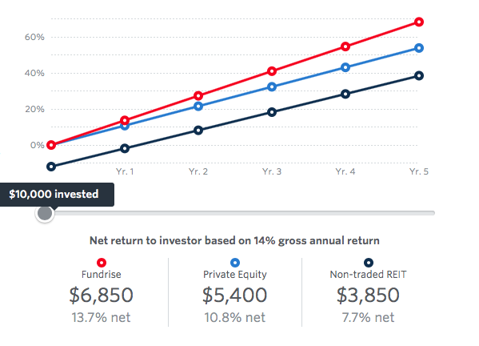
located at https://fundrise.com/investing-with-fundrise where you can scroll across with various investment amounts

or

an interactive gif like below - where the graphs grow from the left in less than 2 seconds when you scroll to it

