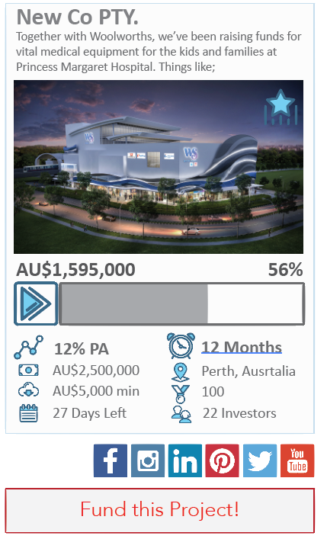
Concept for project snapshot/preview.

We require a fresh clean summarized preview of projects.

Please use the concept a guide:
- Icons required.
- Progress bar with figures/amounts/ %
- Return %
- Amount to be raised
- Minimum investment amount
- Days left
- Length of investment
- Location
- Number of investors
- Social sharing icons

