Dear Design Crowd,

This is Fanie.
I am starting a T shirt business. Doing research’s font on internet,
I found your website.
I wish to request a Logo Design.

The name of my company is: Christal Faith.

Please find below the describption of my project in detail.

The project is built around this bible Scripture: Luc 17 : 6 .
⁶ He replied, “If you have faith as small as a mustard seed, you can say to this mulberry tree, ‘Be uprooted and planted in the sea,’ and it will obey you."

I want a combination of these two logos below in one.

I want this same Tree below but his leaves has to be in heavy green,
And, instead of the Words Mustard seed on it write rather Christal on the left and Faith on the right on Sharkshock old school font.

The Mustard seed under the tree has to be visible just as here.
Built a small house (same blue as in the logo below) in the trunk of the tree
and in the house put this family.

NB: The family should be:
The all family in Black; or in white and the 3rd option is to have (the father in White, the mum in Black, the son in Yellow and the daughter in red).
PS: from the 2nd logo just use the Blue and the Family (but create the family in the color I mentioned earlier).
The logo as to give a story. 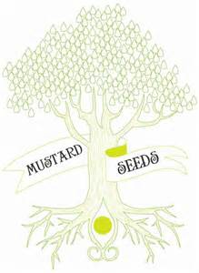 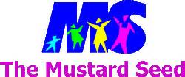

We will work the logo together to come up with the best way to present it.

The Purpose of my Business is “to Spread the Gospel of Jesus Christ”,
trough selling Christians Items, such as T shirts with the Logo and Bible scripture on them, but also Caps, mugs, note books, etc...

NB: My desire completion date for this project is a week, since I want to go very fast.

My target audience is every one ( Men, women, youth, children, young people, old people, black people, white people, red people, yellow people, Christians people, atheist etc...)

What I am trying to communicate to my audience is :
To encourage them; to help them have self esteem,
self confidence, Faith, Love, Joy, Hope in life and Hope in Jesus.

My main competitors are two bibles shop in Geneva where I live.
My Primary Graphic will be the combination of the Two logos i just described above.

Lettering: instead of the Words Mustard seed on the tree,
write rather Christal on the left and Faith on the right on Sharkshock old school font

My Secondary Graphic: will be CF (for Christal Faith), in Sharkshock old school font

Slogan: Pure Faith moves Mountains.

Thank you for your Quick response.
Best regards,
Fanie

