Brand STRATeGy
LOGO NAME : Coreoz

(to pronounce co-ré-oz in French)
(or co-re-oz in English)

Idea behid the name :

CORE OZ
Core & Osmosis
Core : Simplicity, Project, Passion, Curiosity
Osmosis : team, intuitive

OBJECT :
Core business :
Coreoz is a service company specializing in the design, steering and implementation of custom solution in web, mobile and IoT to major company in France.

Ambitions :
Our ambition is to help our customers from start to finish, to develop innovative solutions, leveraging advanced tech, new uses and the latest ergonomic trends.

Axis :
- Project: We are not only a link in the chain in the project but support our customers globally to make the project a success,
- Advanced technology: We are always at the forefront of technology trends to help our clients create new uses,
- User Centered, UX: We are inspired by web giants to develop attractive applications, simple and intuitive,
TARGET :
B2B, CTO, Chief Digital Officer, developers, graduates, ergonomists, engineers.

Recent Projects & Domain :
- Website, mobile app and connected devices (watch) for connected health project,
- Mobile app & backend for organizing leisure trip,
- eBeacons based solutions mobile app to geolocate customer in shopping mall,
- ergonomic redesign of a web/mobile application for young drivers
- Ecommerce website/mobile (b2b2c, b2c, b2e),
- B2B web/mobile application (education, fidelity program, credit, insurance, gift card, connected home, connected building, audio streaming, event ticketing)
- Promotional website
- Android Auto / Connected TV app

VALues to convey :
Young, dynamic, modern,
user experience,
Innovation,

Logo uses :
Website, business cards, leaflet
CREATIVE DIRECTION

TYPOGRAPHICAL constraint:
No

OBLIGATIONS AND RECOMMANDATIONS :
The name should appear fully spelled out

Creative tone:
Free, as long as it corresponds to the values, the business environment and the company description.
It will focus on a simple expression, clear, recognizable, understandable either by a typography associated with a graphic symbol or a typography marked by a graphic sign built in the name.

Colors: at least 2, not more than 4

Effect: preferred flat design

LOGOS APPRECIATED BY THE CLIENT :
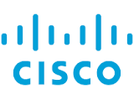
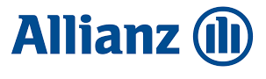
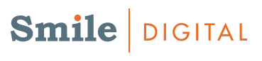

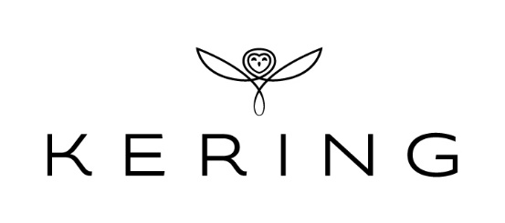
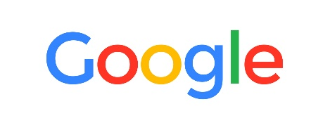



LOGOS NOT APPRECIATED BY THE CLIENT :

