

Wanted: Smart, intuitive SaaS dashboard design for ContractZen

ContractZen is young startup and our vision is to change the way companies manage their contracts and other important documents.

The users of our software come from heterogeneous roles of the business management, for example, small business owners, department managers, CEOs, legal professionals, and PAs for the management.

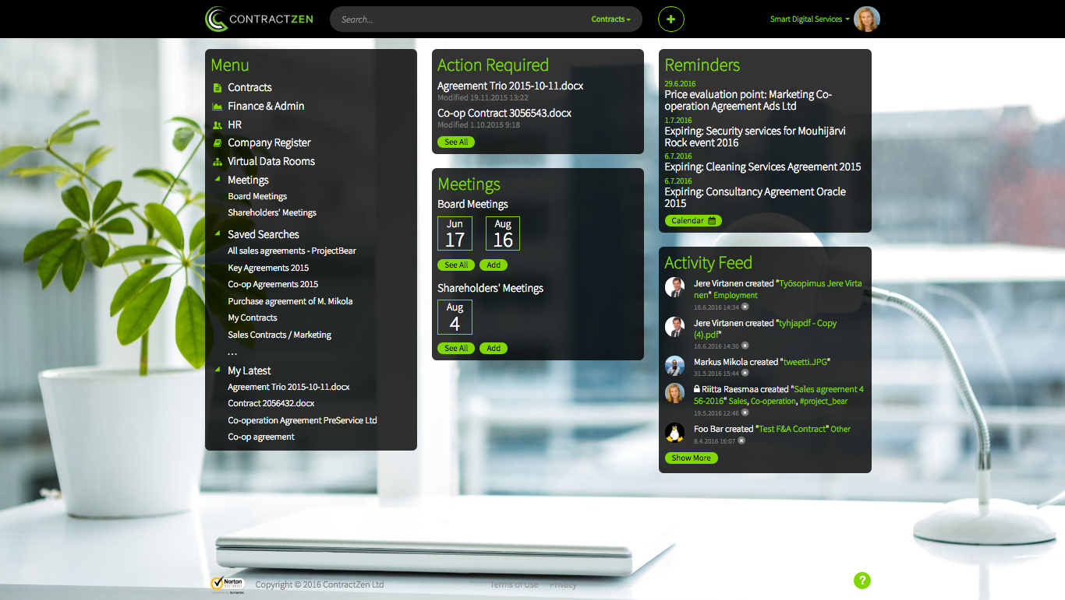

Our existing dashboard looks like this (an example in the picture above), and we have three different themes available. The main functions are as you can see: Contracts, Finance & Admin documents, HR documents, Company Register, Virtual data rooms, and Meetings. All these are listed on the left side column as well as Saved Searches and My Latest (Documents) areas.

In the middle there’s Action Required area, (which is not needed anymore, so you can leave it out in your design), and Meetings. On the right column (menu) you can see Reminders and Activity Feed.

However, the existing dashboard is not yet what we wish it to be. Therefore we need your help.

Challenge us and suggest freely even more unconventional ideas. Just keep in mind that we wish that using our software must always be easy and intuitive for the users.

Summarized, our new dashboard design should be aligned with these objectives:

- It should be clear, intuitive, creative and with the smart layout so that the user gets to see how “the whole company seems to be in order” :)
- The colors to be used are the ones you can pick from the current two themes the green or the (Microsoft Outlook) blue. Check those out.
- Related to the current themes you can choose whether you use the background picture or not, you can of course omit if you like.
- Remember that easy-to-use is the main differentiator from our competitors.
- In addition, ContractZen is used via all kinds of devices, so the dashboard must be responsive i.e. designed so that it is working well on mobiles, tablets and web browsers.
- Note: As mentioned earlier the Action Required area is not needed anymore and you can skip it.

Looking forward to receive your input!

The ContractZen Team

