Wesley Institute of Training
Enriching Minds | Accelerating Careers

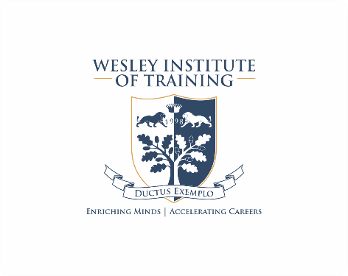

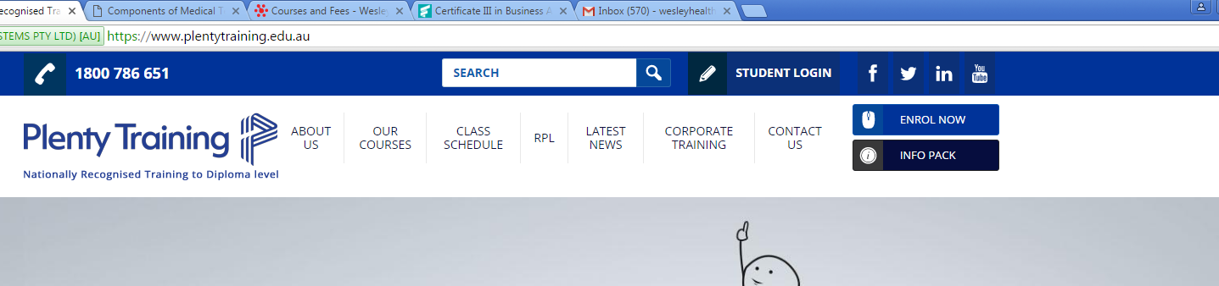

ENROL NOW and INFO PACK at the top as per above.

Home Page (Landing page)

Intro

Wesley is Australia's Leading Provider of Educational, Training and Support Services for the Medical and Dental industry - enabling students to be immediately skilled and 'Job Ready' for a career in Health.

Wesley is a Registered Training Organisation offering specialised Medical Administration Training in over 15 locations Australia wide. Wesley have trained thousands of students the required knowledge and skills to become successful health care administrators.

Our unique Short Medical Reception and Terminology Course and our Full Qualification is Nationally Accredited and the go-to recognised qualification in industry.

Did you know that Wesley has been operating in Australia for over 16 years! During this time, Wesley have developed a reputation second to none for training highly sought after medical receptionists, secretaries and administrators.

Our course material and unique training programme is developed in conjunction with Industry to reflect the latest requirements in health administration. Wesley also believe understanding the medical culture is as important as good skills. Our team of specialised trainers are both experienced in industry and also hold special qualifications in adult education and are fully accredited.

LIST OF COURSES WITH LOGOS AT TOP

- Medical Reception & Terminology
(ask if there is any description under these buttons)

- Cert III Business Administration (Medical)

- Medical Terminology

- Keyboard and Typing

- Wesley Online

- Confidentiality

Why Wesley Institute ?
Quality
Wesley delivery quality, effective training facilitated by industry leaders. Just ask our students who rate us on average of 4.7 out of 5.
Experience
Wesley is Australia’s largest and leading providers of nationally recognised training in health administration – training from over 17 locations Australia wide.
Value
Our innovative teaching approach allows us to deliver exceptional training at affordable prices with no hidden extras.
Industry Recognised
Wesley work hand in hand with industry to develop our core programme and consolidate the programme annually to keep the programme fresh and relevant.

Great Job Results
Wesley students get jobs! Our focus is to create job-ready students who are mentored to achieve their goals. Wesley also provide a recruitment service for industry and graduates.

EMAIL me an Info Pack
Details : Name, Email, Course, State, Mobile
The Joomla site had BLOGS on the Home page – I am fine with this on or off.

Testimonials
I completed the course on Feb 13th. Loved it. The trainers, Anita and Sue were excellent in their delivery and knowledge. I want to say a huge thank you for the course and knowledge I came away with. I have secured a fantastic job after my first application! Such good value for money too! I would highly recommend it. I'm a mature age person so it's never too late to up -skill yourself to get what you deserve!
Ann Scott

“I have just completed my 6 month probation period at Ashford Hospital and loving it. It was my first medical job I applied for literally 1-2 weeks after I finished the course. Thanks to you, Mimi, and all the other teachers and staff at Wesley Health Management.” – Kelly -
I completed your Medical Receptionist course over a year ago. It was the best experience by far. I got a job 2 months after completing this course as a receptionist at a Neuro Physiotherapy practice. I have been with the practice little over a year and I am now the practice administrator. I love my job, I love the people I work with and I love going to work every day! Jenny

I started my working career in childcare. I always knew I am capable of more all I needed was the Wesley course – and to have faith in myself. My message to your future students is: believe in yourselves and everything will fall into place it doesn't matter if you're loud or quiet, shy or confident. I love my new position as a medical receptionist and I have never looked back!” – Alex

“I completed the Wesley Medical Reception and Terminology Course coupled with the Medical Computing Course in 2014 and I found the course to be packed with information but easy to learn. The trainers was amazing, she was able to relate the course to real life situations which made for an easier and relaxed learning environment. The Wesley course definitely helped me in securing a position as a Medical Receptionist; I found that at each interview I went to they would mention the course.” - Belinda

