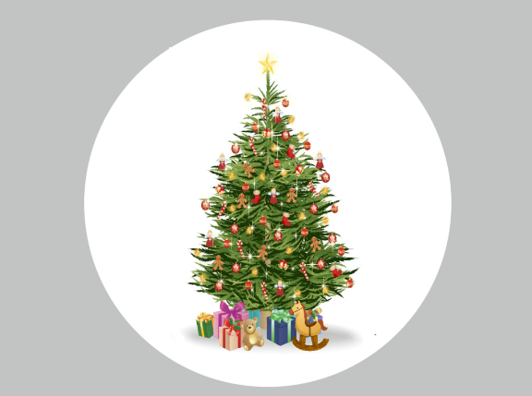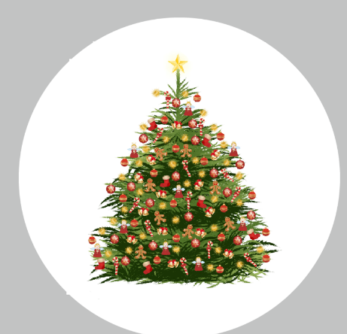
- The Shape tree should be more like first tree but it should be wider than high.
- I like the green distribution of skinnier tree more may be with candle light some more structured shade in dark and light can be achieved. At the moment it seems random. Also the ending how branches go up.
- Ornaments are already on the full size but we should have more different things.
  - Please add some candles to the tree. With a golden shine from candle. ( This must substitute some of existing ornaments.
  - Add a house a snowmen and a doll in the tree and substitute for some items
  - Add garlands to the tree
  - The spiky balls in gold I am not a big fan lets make harts and stars.
- Your presents and rocking horse are in color and shape not to standard of tree. Please work on those. Tree must have Presents, Rocking horse, Doll , car and train and may be a tree skirt. ( Look at Below images of position of presents and bushy tree which looks good.

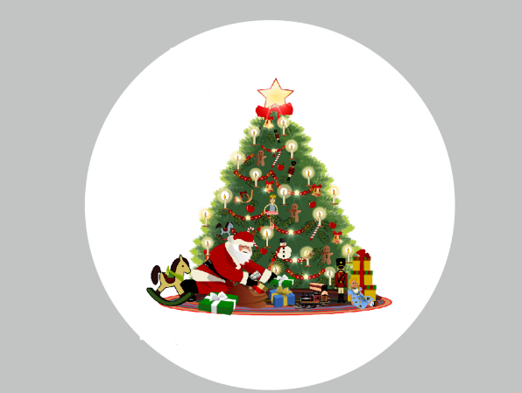
- Increase Star size
- Ornaments: Please add candles to ornament

