Doll
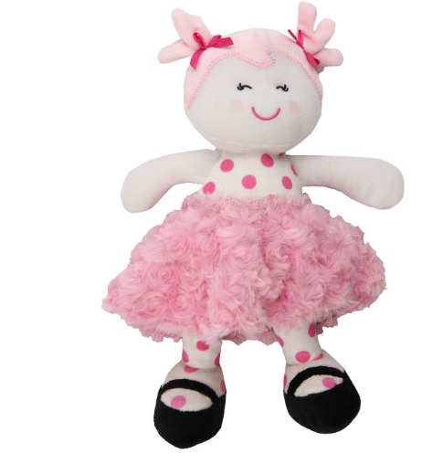
Teddy Bear ( Please work on his fur to be more like below. I also like the peek a boo position. But we should see one eye through his hand
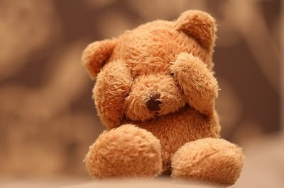
Duplo/ Lego may be
