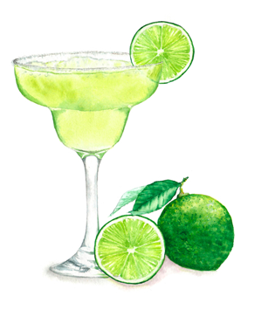 Why not have a drink?

- Filtered Water
- Sparkling Water £1.50
- Coke / Diet Coke £2
- 100% real Fruit Juice £2
- Dry White Wine / Red Wine £4
- Prosecco / Rose Prosecco £5
- Prosecco Cocktails
Choose from Elderflower, Peach, Spritz & Hibiscus – £7

Check out bar board for drink offers…

