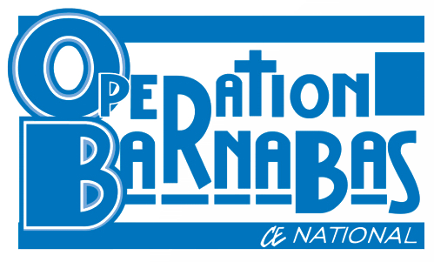

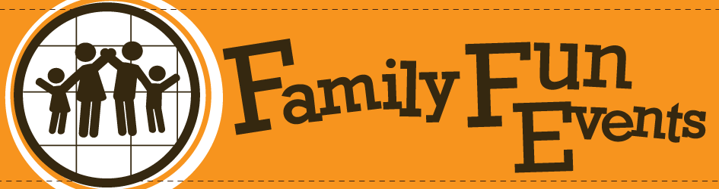
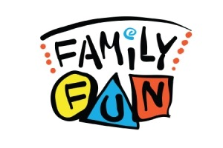
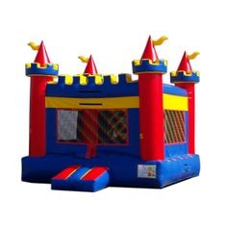
with special guests
June 26 Pleasant Park w/ Operation Barnabas Invite your friends!!
June 27 McKinley Park w/ Operation Barnabas Please pray!
July 12 Academy of Arts @ Marion Grace Bring your family
July 31 Neighborhood Bible Club “Opening Ceremony” @ Marion Grace
August 11 RPM Men’s Group “Car Show” @ Marion Grace
August 27 Saturday in the Park
Pleasant Park
Sunday June 26
4:00 - 8:30pm

Food
Games
Fun!
Prizes
Music
More!
McKinley Park
Monday June 27
4:00 - 8:30pm

