I like this logo having all three riding style horse silhouettes in it.
Showjumping, Western riding and Dressage
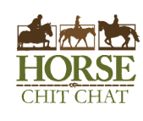
I like this round logo. Real old school. Round or Oval.
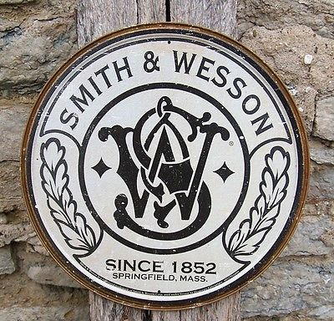
This logo is a good combination of modern design, old school fond and horse silhouette.
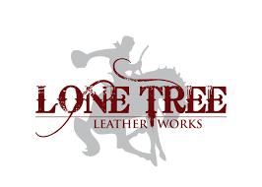
Other designs I like
