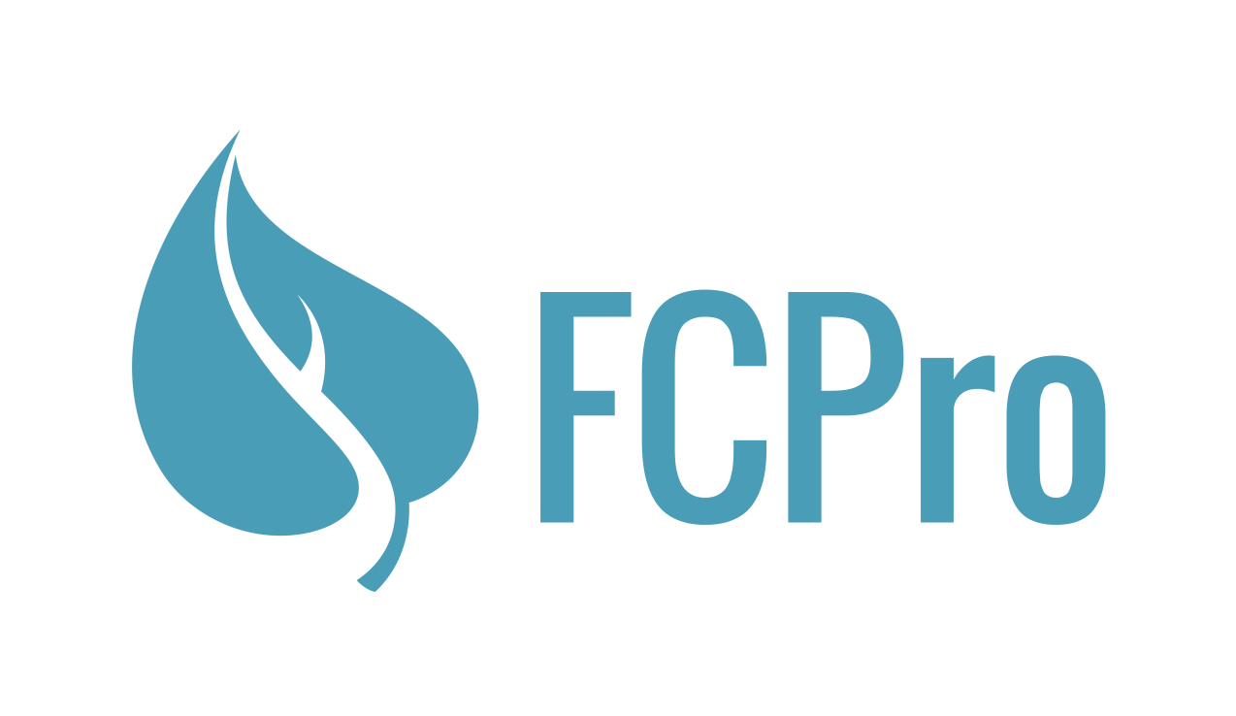
www.FCPro.org
Use Promo code annualmeeting16 - unlimited Active Clients for $15/month*

Add in Security/confidentiality – lock, etc.
And display screenshots in an artful, eye-catching way
The SMART client logbook for FertilityCare Practitioners
"*Promo code valid for a limited number of account registrations. FCPro reserves the right to discontinue promo code at any time."

- Easily accessible digital client records
- Historical appointment records
- Revolutionary reporting

