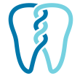
South Edmonton Prosthodontics

