Artwork Specifications
Please read through the checklist for providing design files.
Remember: If your files do not meet our specifications, your product may be printed incorrectly.

If you do not supply artwork which matches our requirements, you will not qualify for winning the design

One: File Format
+ ai, eps or pdf are the preferred file format. These are created in illustrator.
+ psd, jpg or tiff ( 300 dpi )

Two: Artwork Setup
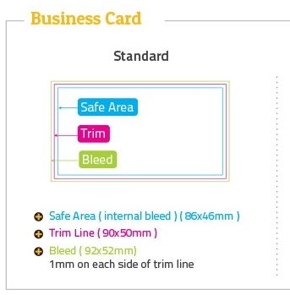

Three: Colour
+ All colour mode must be converted to CMYK
+ No designs to be supplied as RGB or PANTON files. This will not qualify you for winning the design.
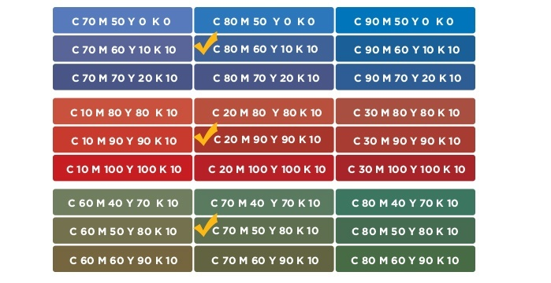

Four: Fonts
+ All fonts must be outlined or embedded
+ Fonts must be no less than 6pt
Font’s are:
Blair itc for PINNACLE
Orator STD for PROCUREMENT

Please convert texts to outlines or send actual font files. Select “Create Outlines” on your computer to do this.

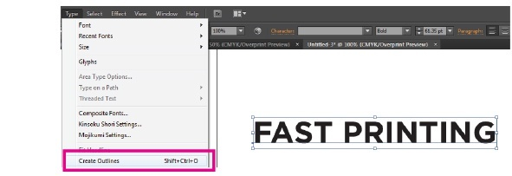

Five: Image resolution
Images created in Photoshop require minimum 300 dpi resolution.
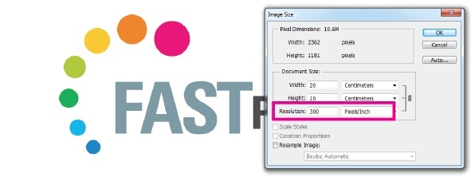

Six: Stroke
Weight has to be a minimum of 0.25pt

