Style guide for PPT and WORD

1. Powerpoint and Word Templates
- Letter head
- Proposal template for Powerpoint
- Presentation template for Powerpoint
- Proposal Template for Word
- Report Template for Word

Overall – the brand needs to look polished, sophisticated yet approachable. We like the use of Black and White images (or a similar filter) with a feature colour blue from our logo. We want as small design element that appears on each page. Using the blue HR Circle logo as a guide. We have all the images (all are mountain scenes).

Please note that we don’t want the documents to be too image heavy as they will need to be emailed to clients.

Please assume that all documents will be printed by our clients so they need to look good when printed.

The examples below show a PPT example from a client of ours, examples of ppt we like and what we are currently doing for our proposals. We are looking to take this to the next level.

Specific design features:
- A design element that can go on each page (see Step Change example with coloured blocks in a line as an example)
- A style guide for tables, graphs and charts that fit in with the theme. We will need to know how to recreate these
- Some design images (see paper and pencil image next to “Strategy Executive” in the Step Change example below) that can go along side different areas of the document such as:
- Tips
- Pricing
- Note
- Step 1, Step 2, Step 3 etc
- Bullet points
- What we need from you
- Next Steps

Sample of PPT

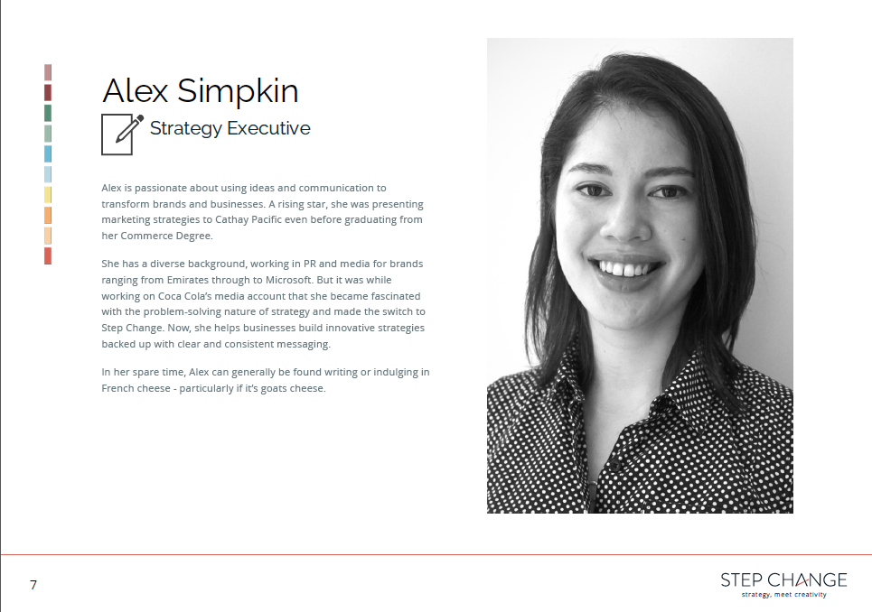
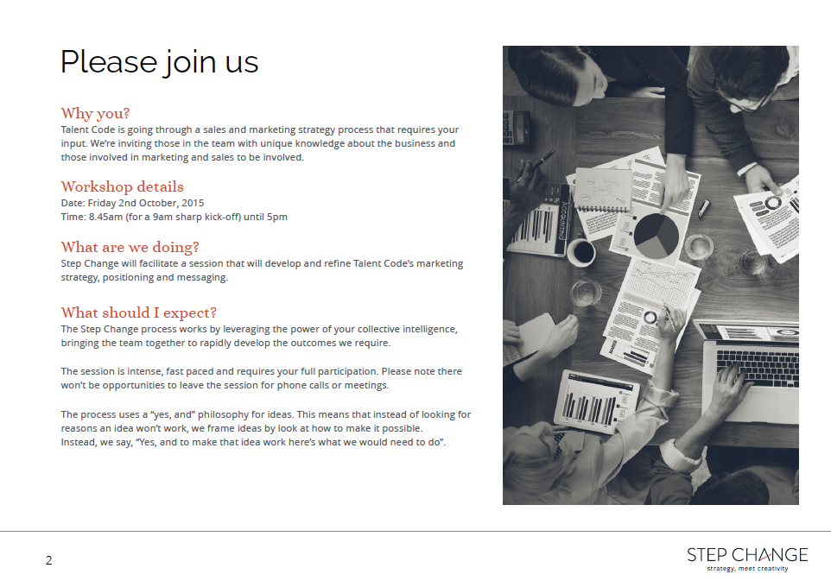





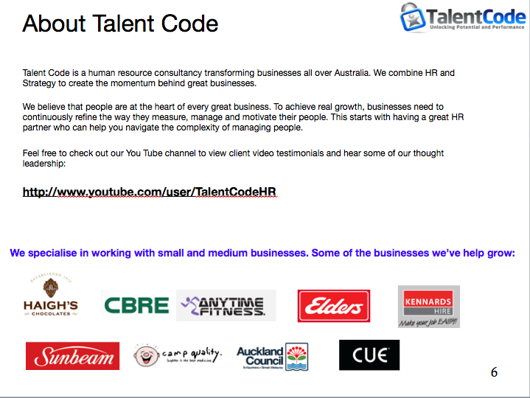

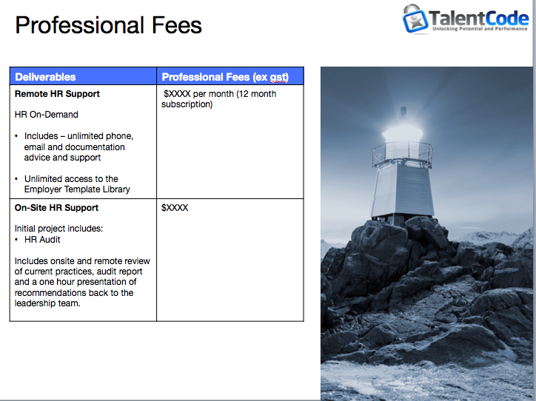





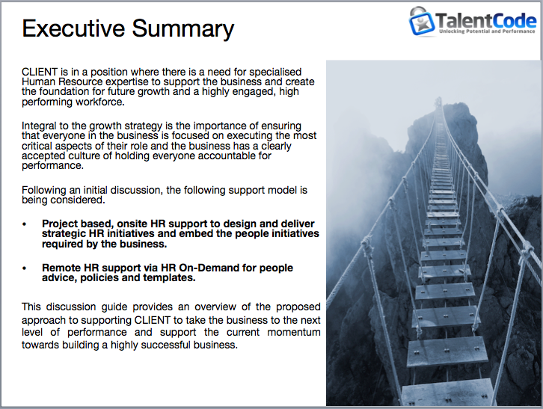

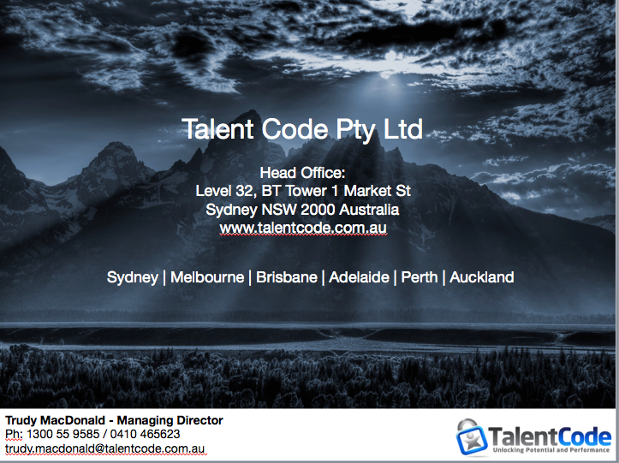

Third Party Documents for Inspiration
