SOMERSAULT PIKE
A short film by Kate Lefoe
Victorian College of the Arts, School of Film and Television 2016

Note for image – can it fill screen and be made into a portrait shot or square rather than landscape?

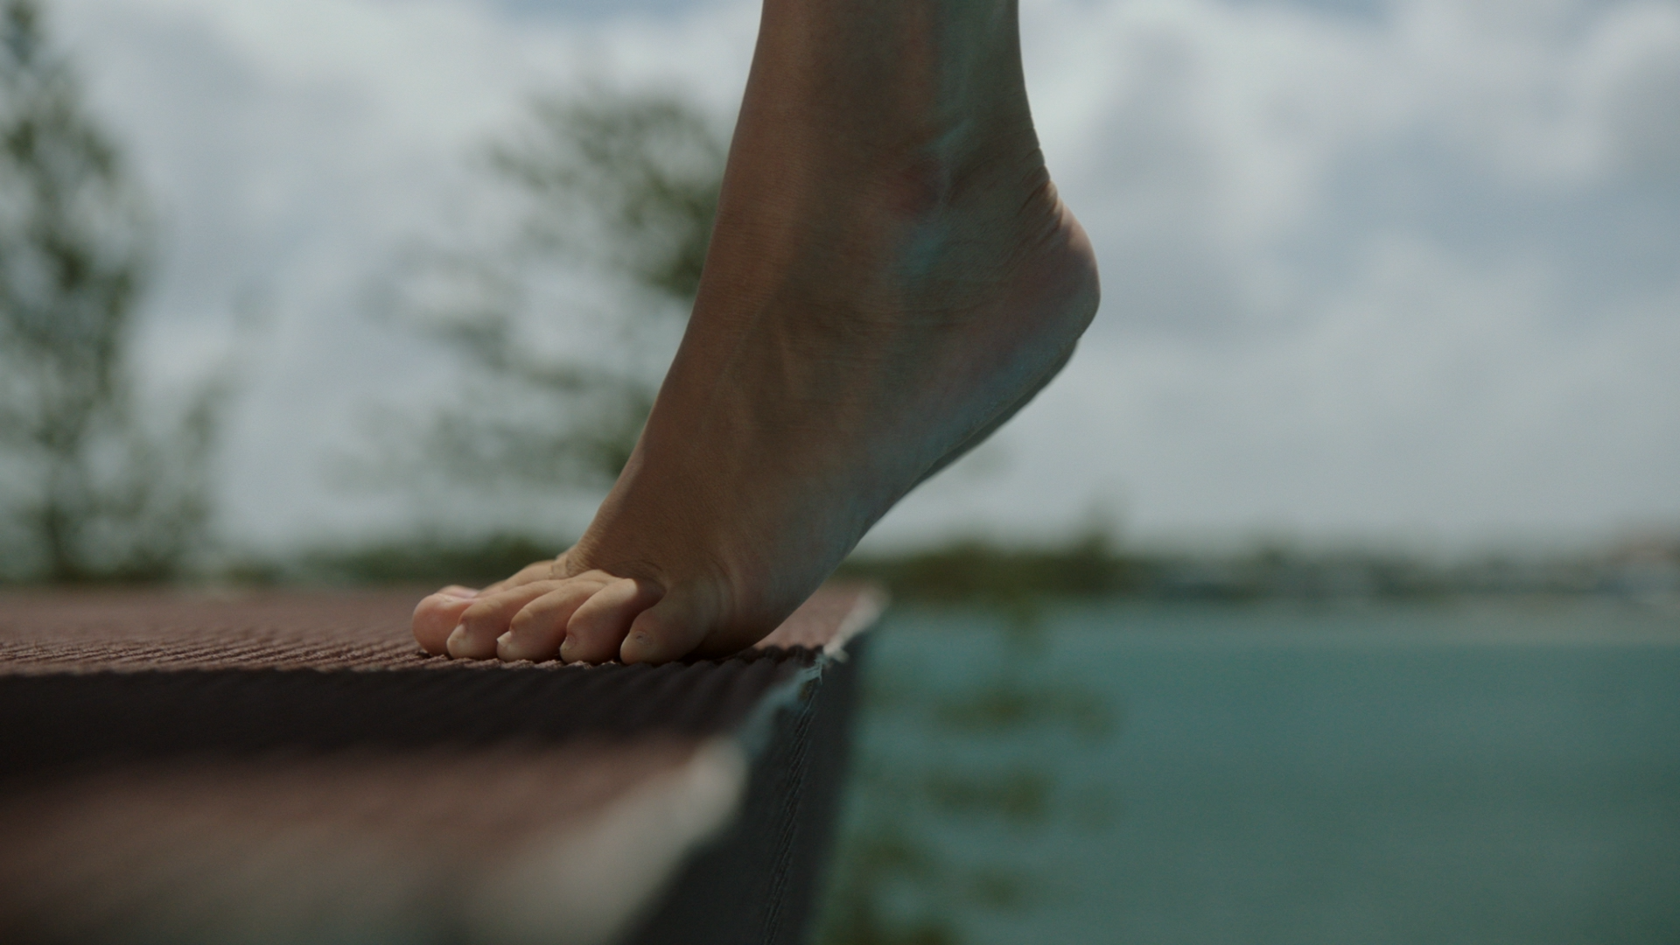

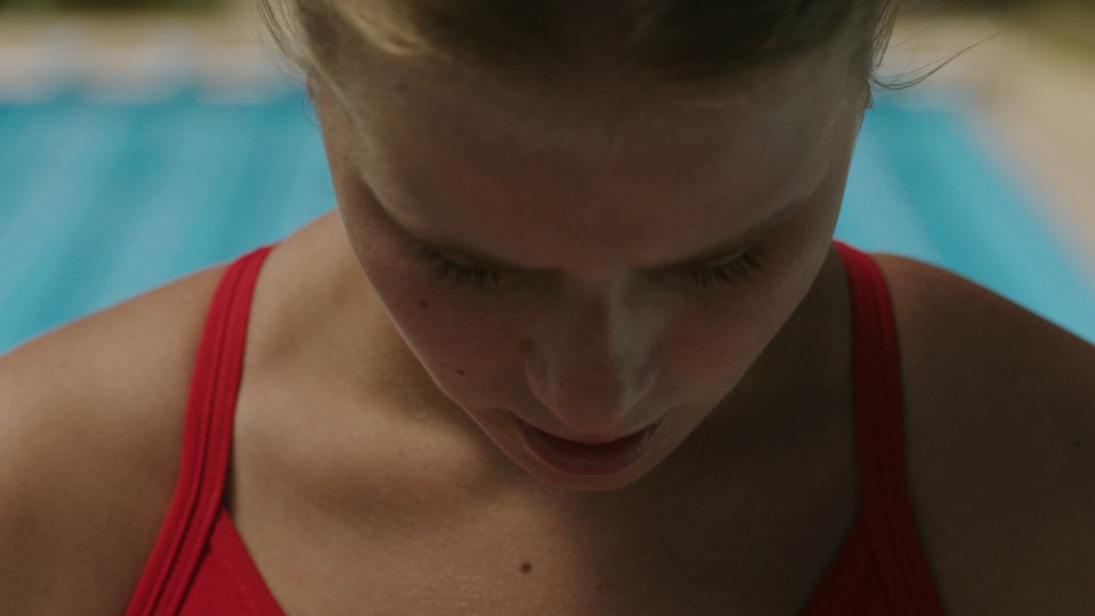
(NB – this photo is titled “Mary Holgate looking down – when getting file from photos)

Somersault Pike
Dark fears and high hopes drive a young competitive diver as she faces the ten-metre platform.

Essential Information
No dialogue
Running time 6:30 minutes
Shoot Format Arri Alexa, Phantom Flex
Aspect Ratio 16.9
Release Year 2017
Victorian College of the Arts, School of Film and Television,
The University of Melbourne

All enquiries
Kate Lefoe (writer / director /editor)
hello@katelefoe.com
Ph +61 412 403 604
katelefoe.com

Directors Statement

Somersault Pike is a poetic exploration of the thought process involved in working through self-doubt, mentally preparing for action, and taking the final steps towards achieving a goal. It is played out in on the ten-metre dive platform, where failure can mean serious injury. I was drawn into the world of competitive diving by the strength and commitment it demands to succeed. Divers chase the elusive perfect score of ten. Perfectionism can be a strong and powerful motivator, but it can be paralyzing if the focus is too much on the outcome rather than the process. This is universal. The film suggests that the final results matter less than the journey to get there.

During my Masters studies at the Victorian College of the Arts, I have developed a strong understanding of visual storytelling. My philosophy of filmmaking is to explore my own darkest fears, bringing them into the light to share with an audience. By tapping into a raw truth, I believe these stories will always resonate with an audience. I have learnt through the process of making Somersault Pike that through simplicity, there is poetry. Kate Lefoe

(Tahir can you make the page look good with some images? Can you use the quotes in a bigger font somewhere on the page? It is ok if it goes on top of an image. I like how you used the red background to highlight the text in the other page. It looked like it was a diving platform! Could use do something like this?

“I believe that through simplicity there is poetry.” Director Kate Lefoe)
“I know the feeling, your feet on the edge of platform, the sun on your face, terrified but knowing you have to dive” Actor and professional diver Mary Holgate

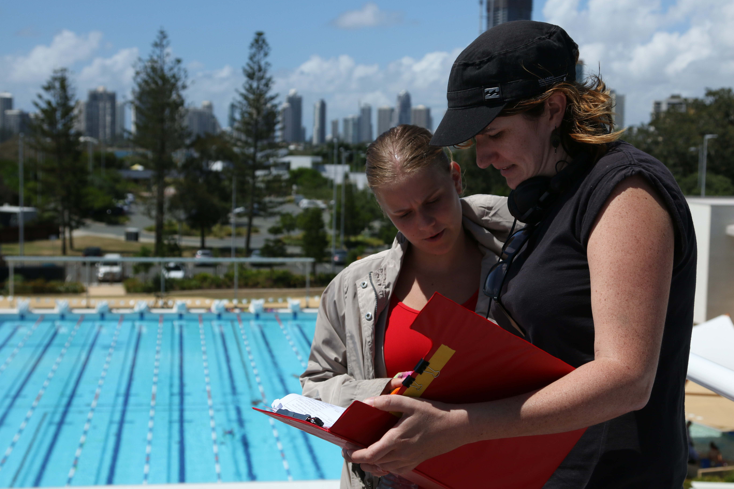

Behind the Scenes – Director Kate Lefoe with actor Mary Holgate on the ten-metre platform.

Writer, director, editor Kate Lefoe

Kate Lefoe is an award winning writer and director based in Melbourne, Australia. Kate graduated with a Masters of Film and Television (Narrative) from the prestigious Victorian College of the Arts in December 2016. Somersault Pike is her graduating film.

Kate’s most recent short film Plunge (2014) screened at more than 40 festivals and won several awards, including Best Director Short Film at the Long Beach Film Festival, Best Lesbian Short Film at the Durham Gay and Lesbian Film Festival in South Africa, Best Student Film at the Melbourne Fringe Festival and Best Senior Short Film at the Warburton Film Festival.

In 2014, Kate was awarded a two-week intensive film making scholarship to travel to Suzhou, China. The resulting short documentary, Age, Height, Education (2015), has screened in festivals in the USA and China and was a Finalist in the Phoenix Life Documentary Awards and awarded Best Youth Film at the Beijing Radio and Television Awards.

Kate’s first short film, Under Pressure (2010), was awarded Best Emerging Talent at the Sydney Mardi Gras Film Festival (2011) and screened at more than 25 festivals around the world, including the St Johns International Women’s Festival and the competitive Oz Shorts Program in the Melbourne Queer Film Festival.

When Kate’s not making films, she watches hundreds of them as part of her role on the Selection Committee for the Melbourne Queer Film Festival. She also runs filmmaking workshops teaching young queer people how to make their first films.

Associate Producer: Honeylyn Lisson
Honeylyn Lisson is an emerging Producer born in Canada, raised in Darwin, now based in Melbourne, Australia. From a very young age Honeylyn has loved movies, working with people and being incredibly organized, and has finally found a way to combine all of these passions - producing! Since completing a Bachelor of Arts (majoring in Film & Television Studies) at Monash University in 2015, Honeylyn has worked on approximately ten student films as well as multiple independent shorts, corporate projects and music videos, and hopes to do even more in the future.

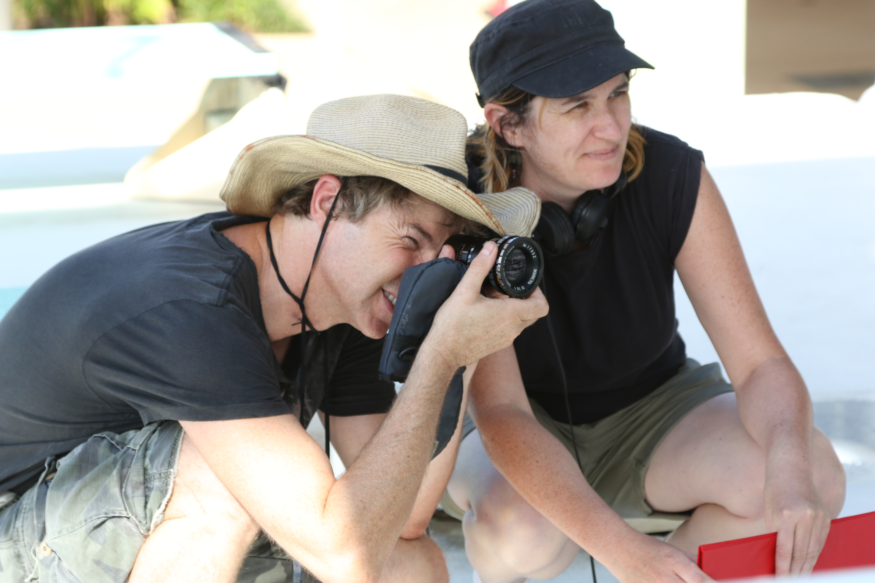
Cinematographer Darrell Martin with writer / director Kate Lefoe

Cinematographer Darrell Martin

“Somersault Pike was a joy to work on. I’d seen some of Kate’s earlier works and knew she would have a distinct style to the film. I wanted to work on a project that was different to a lot of the television work I’d been doing in recent years - a project that could stretch me in different directions. I felt Somersault Pike helped me do this.

Kate's approach is very filmic, with minimum dialogue, sparse cutting and where possible letting the action play out in frame but not necessarily in real time. To this effect we used the Phantom flex HD camera with speeds up to 1000fps for the diving shots. It gave us a very balletic feeling our sequences!

She was insistent in finding an outdoor diving pool, which meant travelling our cast and crew to Queensland. I think this was a very bold decision that paid off beautifully with the rich blue hues of the skies and pool playing off against the red swimsuit of our protagonist.

Kate is very much a great collaborator - she enjoys the relationship with her cinematographer and will take onboard any good suggestions the cinematographer has to give regarding style, process or logistics in shooting.

Cinematographer: Darrell Martin
Darrell Martin has been in the Film and Television industry for over 30 years. Starting as a trainee cameraman at the ABC in Melbourne in 1984 he has worked on programs as diverse as Countdown, Sea Change and The Late Show. He has been an award winning freelance DOP for the last 15 years shooting mainly long form TV Drama. He enjoys lighting and operating – often simultaneously- and has worked extensively in both Film and Digital formats. Darrell has shot 3 series of Satisfaction for Foxtel on film and most recently Mr & Mrs Murder for Network 10. He has worked as an 2nd Unit DOP and camera operator on many other shows including Molly, Offspring, Wentworth and The Dr Blake Murder Mysteries.

(HMTahir – this image at the top doesn’t have to be so big, you can use other ones on the page as you think looks good).

(HMTahir can you make the page look good with some images? Can you use the quote below in a bigger font somewhere on the page? It is ok if it goes on top of an image.

“Kate's approach is very filmic, with minimum dialogue, sparse cutting and where possible letting the action play out in frame but not necessarily in real time. To this effect we used the Phantom flex HD camera with speeds up to 1000fps for the diving shots. It gave us a very balletic feeling our sequences!” Cinematographer Darrell Martin

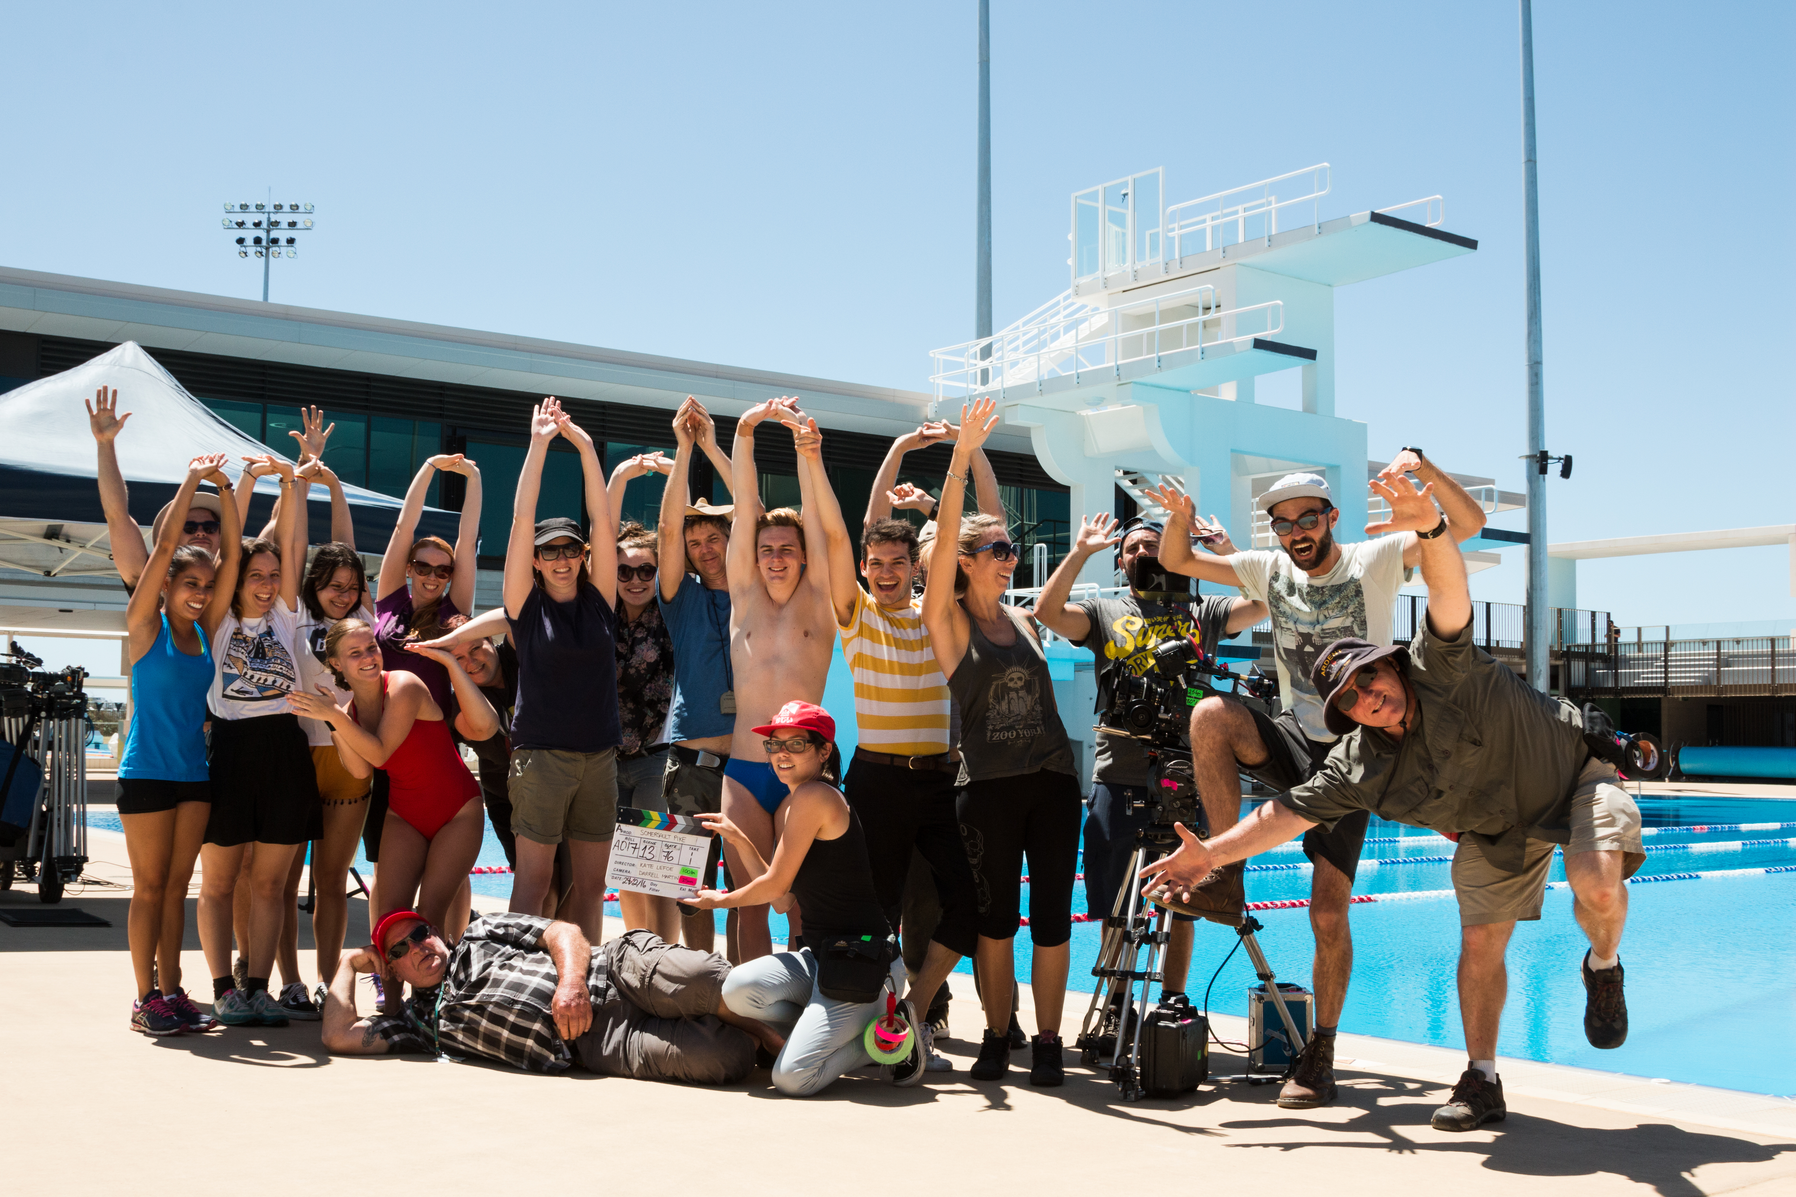
Tahir – I just put this photo for a suggestion – ok if you want to use something else. Please fit the text onto one page

Key Personnel

Diver
Mary Holgate

Writer, director & editor
Kate Lefoe

Associate Producer
Honeylyn Lisson

Cinematography
Darrell Martin

Steadicam
Andrew Condor SOC ACS

Phantom Technician
Brendan Isaac

1st Assistant Director
Jacob Livermore

Editing consultant
Lauren Anderson

Online Editor and Consultant
Declan Loughran

Sound Designer
Livia Rusic

Additional Sound Design
Ant Bohun

Sound Mixer
Ant Bohun

The filmmaker would like to acknowledge the generous support of

The Ian Potter Cultural Trust Foundation

And

The Jim Marks Postgraduate Scholarship

Special thanks to
Diving Victoria
Funkita Swimwear
Paradise Dive Club
St Kevin’s Dive Club
Ringwood Dive Club
The Gold Coast Aquatic Centre

