 |  | Orland Park Location  (Next to Orland Square Mall)  10 Orland Square Dr.  Orland Park, IL 60462  Phone: (708) 448-8913  Hours of Operation:  Open 7 Days a Week  8am to 12am (Midnight)  Midway Location  (Near to Midway Airport)  5907 W 63rd St, Chicago, IL 60638  Phone: (773) 585-4032  Hours of Operation:  Open 7 Days a Week  8am to 8pm  We’re here to help you 7 days a week.  No Appointment necessary  To learn more, visit www.24advancedcare.com  Email: info@24advancedcare.com | Page 2
  About Us:
  About Us:
  At Advanced Urgent Care, our mission is to deliver superior and compassionate medical care. We provide advanced treatments to our patients in a state-of-the-art facility.
  Our facility offers patients an alternative to the emergency room setting when they have injuries or illnesses that are not life-threatening. Patients gain a similar level of care to an emergency room while paying the more affordable cost and copay of a walk-in clinic.
  At Advanced Urgent Care, we offer:
  - Urgent Care Services
  - Primary care services for patients who have no regular physician
  - Multi-Specialty services
  - Advanced diagnostic services
  Page 3
  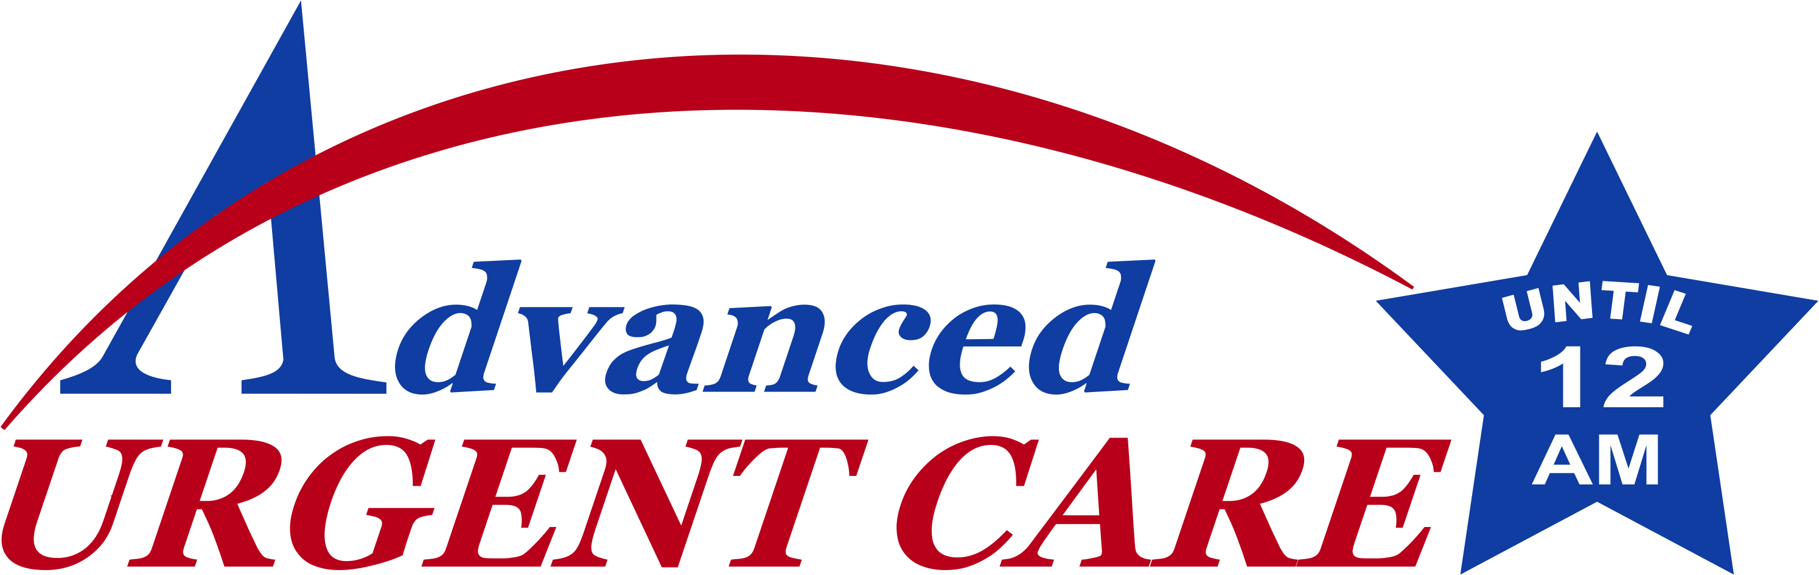
  Advanced Treatment
  a Step Ahead of
  Regular Urgent Care Clinics
  Page 1
  High Quality of Care
  Low Wait Time and Cost

 |  |  | When Would I Go to an Urgent Care Center?  An urgent care center offers you convenience and affordability compared to an emergency room’s long wait and high cost. This is the right choice when you need a medical provider for non-life threatening illnesses and injuries but you do not have an appointment. You could also visit an urgent care facility when your regular physician is on vacation, closed on nights and weekends or unable to offer you a timely appointment to address your medical concern.  Are All Urgent Care Centers the Same?  Not all urgent care facilities provide the same level of treatment. At Advanced Urgent Care, we deliver advanced medical treatments you cannot find at a regular urgent care center. Advanced Urgent Care also offers lower costs for care than a hospital-affiliated urgent care center or a trip to the ER.  Does Advanced Urgent Care Charge as an ER or Urgent Care Center?  We charge as an urgent care center while providing advanced treatment similar to an ER. Our cost is a fraction of what you would pay for a trip to the ER and close to the cost of a regular office visit.  Page 4
  Comprehensive Care for non-life treating illness and injuries
  Walk in to Advanced Urgent Care for quality treatments, including:
  - Allergic reactions
  - Neck/Back Pain
  - Gastroenteritis, stomach pain
  - Vomiting, dehydration
  - Kidney stones, renal colic
  - Asthma, bronchitis, pneumonia
  - Cuts, burns, bites
  - Sprains, strains, broken bones
  - Cold, Cough, Flu
  - Minor eye injuries
  - Rashes and other Skin condition
  - Infections
  - Aches and pains
  - IV fluid, IV Medications
  - Routine Check-Ups
  - Immunization and vaccination
  - EKG's, X-ray, laboratory services
  - DOT testing
  - School, camp, sports, work physicals
  - Occupational health
  - Most Illness and injuries
  - And more
  Page 6
  - Your text here
  - Your text here
  X-RAY ON SITE
  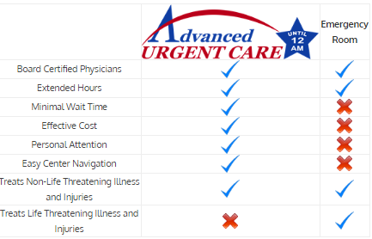
  Dial 911 immediately for any Medical Problem that appears to be Life-Threatening
  Page 5
 | X-RAY, LABORATORY, EKG SERVICES ON SITE

