


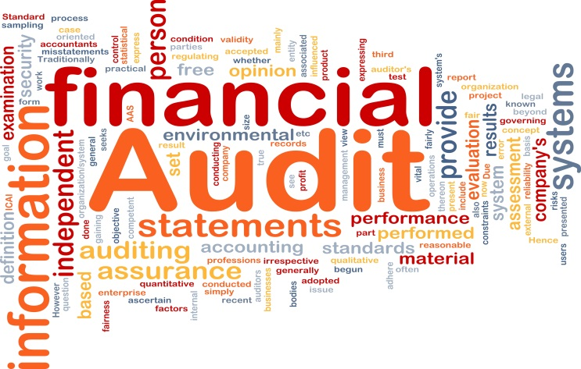

Why Franklin & Turner?
With seasoned professionals and an excellent reputation, Franklin & Turner is committed to professional excellence, high quality, and mission focused solutions to assist agencies in achieving their goals. We maintain a system of quality controls, subject to independent evaluation and review. Our management team is hands on with all staffing, solution development, and project management. Combining our quality control systems and management oversight with our dedication to operating with the utmost levels of honesty, reliability, integrity, and transparency allows us to exceed our client’s expectations.

Melissa Hamilton, MBA, CPA, PMP / Principal
Email: melissa.hamilton@usfti.com
Nazim Hamilton, MBA, CPA, CICA, CCS / Principal
Email: nazim.hamilton@usfti.com

Capabilities
Hamilton Enterprises (d/b/a Franklin & Turner) is a minority-owned, 8(a) CPA, management and IT consulting firm based in the Washington DC metropolitan area. We are committed to professional excellence within our core capabilities of auditing, accounting, and financial management advisory services. We offer the below services to government agencies:
- OMB Circular A-123 Internal Control Compliance
- CFO Act, ATDA, Grants, Loans and DCAA Contract Audits
- Information Systems, Performance and Compliance Audits
- Audit Readiness, Liaison and Remediation
- Policy and Procedures Development
- Financial Reporting and Analysis
- Accounting and Reconciliation Support
- Administrative and Clerical Services
- Risk and Financial Management Advisory Services
Prime Federal Contracts
- Department of Treasury
- Department of Commerce
- Department of Interior
- Government Accountability Office
- Federal Trade Commission
- Department of Homeland Security
- Department of Transportation
- Department of Health and Human Services
- Department of Veterans Affairs
- Small Business Administration
- Broadcasting Board of Governors
- Department of Agriculture
- Securities and Exchange Commission
Type of Business: CPA’s, SBA Certified 8(a) / SDB firm
Cage Code: 52DB6
DUNS Number: 825487130
GSA FABS No: GS-23F0091V
GSA OASIS SB No: GS00Q140ADS206

Primary NAICS Codes:
541211: Offices of Certified Public Accountants
541219: Other Accounting Services
541611: Management Consulting Services
541618: Other Management Consulting Services

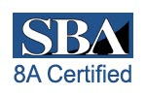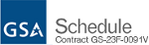

1629 K Street NW, Suite 300, Washington, DC 20006
Phone: 202.204.2238 Fax: 202.403.0550
Email: info@usfti.com www.usfti.com

1

