Ecocity
World Summit

Ecocity World Summit Bid Manual

08
Fall
Prepared by the Ecocity World Summit Bid Committee

Ecocity Builders
339 15th Street, Suite 208
Oakland, CA
USA
INTRODUCTION
The First International Ecocity Conference (now called Ecocity World Summit or ECWS) was convened in 1990 in Berkeley, California, and has continued through the organizing and authorizing auspices of Ecocity Builders, a California nonprofit corporation. Ecocity World Summit was the first and is now the longest running conference for ecological city design, development, operations and governance.
The Ecocity World Summit is the international forum…

for innovators and pioneers, designers and planners, policy makers and administrators, professionals and business people, environmentalists and developers, teachers and students;
of sustainable cities, towns and villages of the future;
from theory to the application of all things related to the ecological city
Financial transactions in support of Ecocity Builders’ role in communicating, selecting and working with the next conference host—including arranging prospective host application fees, specific sponsorship in support of the on-going conference series, and grants and donations for the series to Ecocity Builders—are tax-deductible under United States Internal Revenue Service rules. The host conference organizers are solely responsible for their own budget and profit or loss on the event itself.

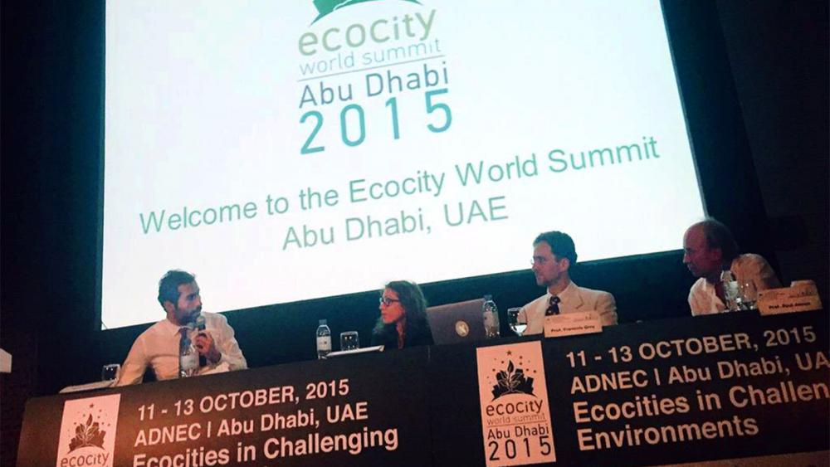
CONTENTS
This document is divided into three main sections:
- INFORMATION. Background on the Ecocity World Summit …………………..……...….. Page 4
  - What is the Ecocity World Summit? 4
  - Ecocity Worldwide 7
  - Organization 10
  - Costs & Finances 12
  - Delegates and Other Important Facts 13

- APPLICATION QUESTIONS AND REQUIREMENTS. The “Ecocity World Summit conditions and questions” section details quality assurances that we expect bidders to comply with and the conditions that the host and organizer agree to uphold. The questions are designed to elicit your ideas, innovations and imagination on all aspects of event planning………………………………………………………………………………………..…………………. Page 15

- REQUIREMENTS AND CRITERIA. This section includes the requirements for a bid and the criteria on which a bid will be evaluated. ………….…………..………………………………..… Page 20
  - Written Bid Material 20
  - Criteria for the Choice of Venue 20
  - Decision Making 21
  - Contract 21
  - Financial 22
  - Timetable for Proposals 23
  - Final Remarks 24

1. INFORMATION
Ecocity Builders now invites expressions of interest from those wishing to bid for hosting the next Ecocity World Summit after the event planned for Melbourne, Australia, July 12th through 14th, 2017. Ecocity Builders will select the city from among applicants we believe is most harmonious with the mission of the conference series as follows: to promote the understanding and development of cities that are ecologically healthy and sustainable, economically prosperous and fair, and socially just and caring.
Traditionally our conferences have been held every two years. The next conference will be held in 2019. This document contains the full bid manual including information required of bidders.
1.1. WHAT IS THE ECOCITY WORLD SUMMIT?
The term “ecocity” (alternately “eco-city”) was introduced by Ecocity Builders’ founder Richard Register in 1979. The term is now in common use in much of the world. “Sustainable city” and “green city” are popular as well. In our tradition of drawing directly from basic life principles for the design and organization of cities, the conference series has stayed committed to “eco” because the prefix is derived from “ecology,” the science of life and living systems on our planet.
The Ecocity World Summit, previously known as the International Ecocity Conference Series (IECS), was the first and is now the world’s longest running conference for ecological city design, development and functioning. From the beginning of planning the first conference in 1990 we have been committed to being the premier forum for leading innovative ideas, designs, policies and education about cities in balance with living systems. For twenty-six years Ecocity World Summit has been the vanguard conference on urban issues and solutions regarding climate change, renewable energy, non-car transportation, environmentally healthy architecture and city layout. We are also leaders in issues of democratic participation in the decision making process for how we live in our built communities.

Past Ecocity World Summits
The series to date has been held in this sequence:
- 1990 Berkeley, California
- 1992 Adelaide, Australia
- 1996 Yoff and Dakar, Senegal
- 2000 Curitiba, Brazil
- 2002 Shenzhen, China
- 2006 Bangalore, India
- 2008 San Francisco, California
- 2009 Istanbul, Turkey,
- 2011 Montreal, Canada
- 2013 Nantes, France
- 2015 Abu Dhabi, UAE
- 2017 Melbourne, Australia

We continue to be the unique conference series to feature a broad spectrum of presenters and participants — from architects and planners to environmentalists and developers; from alternative energy pioneers and transportation advocates to government officials and artists supporting and enriching the lives of all citizens. With our education and research emphasis we have provided a forum for scientists and philosophers, professors and early-learning professionals, writers and journalists, and even an astronaut who walked on the moon. Legislators and green business people of a wide variety of ventures, indigenous peoples and minorities, and historic preservationists and futurists have all been represented.
What inspires our emphasis on representing this complex network is the fact that cities are whole systems. Only when all of its parts are working together can we steadily improve the health and wellbeing of the whole.
1.1.1. Objectives of the Ecocity World Summit
1. Cities becoming ecocities
The major objective of the conference series is to promote healthy cities in all their aspects for long-term vitality of living systems. In addition to natural systems these include human social systems: political, economic, cultural and social.
The Ecocity World Summit showcases the “new towns” approach and the “transform existing cities” approach that aspire to meet ecologically healthy, socially fair and equitable goals. We emphasize that we seek not to support random technologies, practices and policies out of context with their built and natural environments; instead we promote approaches that fundamentally address basic principles for healthy whole-systems transformation. In other words, we seek solutions in design and layout as well as in technologies and lifestyles, the whole built and natural environment and its constituent parts harmonized.
2. Cutting across scales, systems and particulars
We seek solutions over all scales, from the single technological item that may contribute to healthier built communities to the whole system, from the small Ecovillage and Ecotown to the Ecocity and Ecotropolis becoming more harmonious with its bioregion and the planet. The term Ecocity is becoming the generic for ecologically healthy total built community at all scales.

3. Connecting people with Ecocity knowledge
The conferences series also aspires to provide the best information among its participants relative to their interests and to connect people of a wide variety of kindred disciplines and cross-cutting projects associated with the conference’s major themes. In our case, our chief objective is to facilitate outcomes, including new and refreshed partnerships and collaborations that help build and run the healthy city of the future.
4. Promoting the host city
Also importantly, the conference series serves to spotlight the best in the ecocity offerings of the host city and to bring them enhanced success in their relevant work.
1.2. ECOCITY WORLDWIDE
Ecocity Builders seeks conference hosts who agree that we need both bottom-up and top-down approaches to solving our urban and environmental problems and are dedicated to representing this in the programming of the event. We have been a conference series with a very international, multi-cultural and social justice-oriented set of events that go to very particular places looking for connections. We have held these conferences on all continents except Antarctica.
We understand that city design, planning, building and maintaining must respond creatively, appropriately and effectively to world conditions such as climate change, resource limits, supply of healthy soil, water and bioregional “ecological services.” This means balancing human settlements with the preservation of forests, grasslands, wetlands, open waters, and glaciers. We understand principles such as limits on a finite planet, ecological overshoot and the implications of the “ecological footprint.” All these concepts are basic background material to our programs and help guide our conference design and development process, selection of presenters, panelists, workshops, tours and exhibits.
1.2.1 Global themes:
- Resilience for adaptation
Resilience is one of our keywords and most important basic concepts. Still, we don’t limit our approach to simple response. The series has a powerful futurist element, and, like good artists, we value, promote and strive for the creative best we can accomplish.
- Prevention
We are working not only to adapt to climate change but to also build cities and towns that reverse the negative trends through their layout, design and functioning. For example, low-density automobile dependent development consumes enormous amounts of agricultural and natural landscapes with massive repercussions for carbon dioxide production and climate change. These problems can largely be solved by highly mixed-use compact development that works with transit, bicycles and pedestrian access.
- Creativity: the best, the beautiful, the healthy, the happy and the lovable
We strive to make cities themselves not just machines of survival but the best they can create: beautiful, vibrant, loved by their people, and each one an actual contribution to the health of the planet. We are interested in preserving the best of the city and at the same time, at close proximity to the built community, creating the best future we can for the natural environment as well.
- Best practices, urban models for honoring and emulating
Another feature of the Ecocity World Summit is our focus on best practices featuring environmentally healthy policies and well-functioning ecocity infrastructure. These policies are exemplified in the host cities, presenting the city as a “living laboratory.”
Some examples of range of places in which we’ve located conferences and/or highlighted as subject matter:
Curitiba, Brazil for its sustainable layout, design and many particular interrelated features: pedestrian centers, plazas and streets, density paired with transit around streets dedicated to buses; slum replacement with mixed use shops; flood control money removing dangerous housing to create parks that flood harmlessly temporarily, etc.
Tianjin Eco-city, China for its efforts to integrate solar and geothermal technology; restoration of wetlands; cogeneration of electricity and heat; and emphasis on pedestrian, bicycle and transit infrastructure.
Freiburg, Germany for its car-free district called Vauban; solar and energy conservation policies; bicycle emphasis, and wide spectrum of other features.
New York, USA for its new pedestrian Times Square and elevated remission rail line park, the Highline; plus its energy conserving density and transit system that makes automobile ownership obsolete.
Auroville, India, a city that aspires to specifically help shape the evolution of the internationally aware, world peace-promoting community solutions based on consciously helping evolve the more responsible world citizen.
Yoff, Senegal, the village that hosted the Third International Ecocity Conference, for melding the traditions its citizens feel are important with advancing organic food production and instituting ecocity issues in their early childhood schools.
Detroit, Michigan, USA with its historic role in bringing the car city into world dominance and in its role in saving democracy during the Second World War, focusing on its potential for transforming the auto industry in coordination with building the pedestrian/transit/bicycle city.
Adelaide, Australia hosted our second conference and has exhibited such novel features as an early and truly classic greenbelt. The Christie Walk residential development features narrow interior pedestrian streets, rooftop native plant gardens and the tallest straw bale building we know of.
Then there is Kathmandu, Nepal with its historic pedestrian plazas and multiple rooftop uses, Vancouver, Canada that refused to build a freeway through town and built an intensely mixed use downtown.
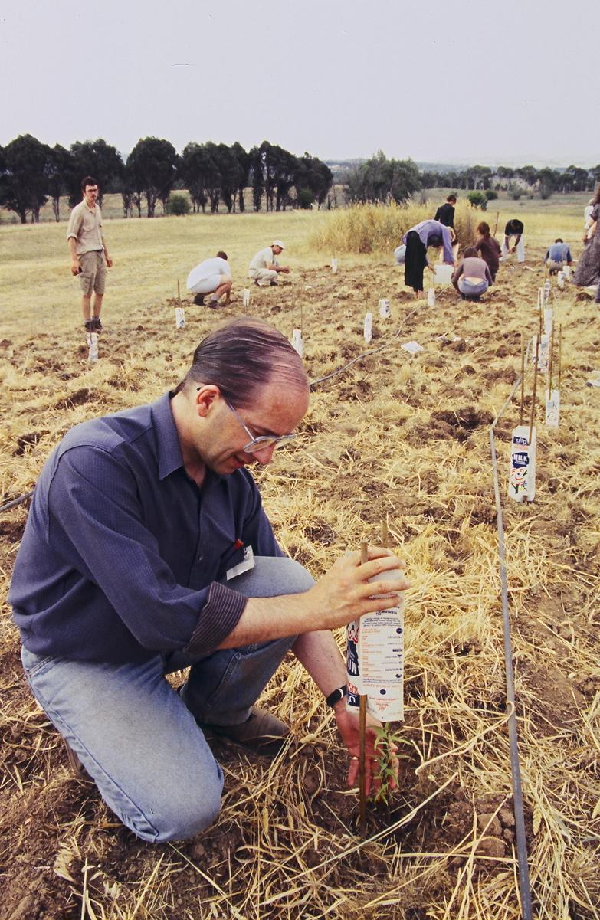
Some examples of presenters and the range of subject matter covered from past conferences: Stephen Schneider one of the United States two earliest and most important climate scientists warning—30 years ago and correctly—about what to expect. Jaime Lerner, three time mayor of Curitiba, Brazil and once Governor of Paraná, Brazil on their leading set of ecocity transformations there. Wang Rusong, Director of the Research Center for Ecological and Environmental Studies, Chinese Academy of Science, Member of the Chinese Peoples Congress and convener of the Fifth International Ecocity Conference on ancient philosophical and ecological conceptual constructs to help guide cities. Paolo Soleri, architect philosopher and founder of Arcosanti, Arizona, the first attempt at building a thoroughly conceptualized ecocity. Kenneth Yeang, world leading green architect of larger buildings with passive cooling by breezes and shade in “sky courts” and numerous other innovations in ecocity design. Marcia McNutt, president of the Monterey Bay Aquarium Research Institute, who addressed us and Director of the United States Geological Survey under Barack Obama on ocean acidification problems due largely to CO2 from cities. Sahar Attia, Professor of Planning and Urban Design, Cairo University, Egypt on design and improvement efforts in Egypt’s informal settlements. Peter Head, Director of Arup, the large-scale project engineering and design firm from England working on ecocity projects. Arnold Goldman, founder and Chairman of BrightSource Energy headquartered in Jerusalem, Israel. Edgar Mitchell, moon astronaut about the ecological and philosophical implications of the view of Earth while walking on the moon. Willy Willoya, representative of the Alaskan Eskimos with their perspective on climate and cultural change under duress. Marcel Diallo, artist and neighborhood activist and entrepreneur from West Oakland, California and New Orleans, Louisiana on his approach as an artist to changing his part of the city. And many dozens more.

1.3. ORGANIZATION
Coordination
Once the hosting conference production organization, or cooperating set of organizations, has been selected, the next Ecocity World Summit is planned in partnership with Ecocity Builders. Ecocity Builders and members of the conference planning committee must have access to the main planning process and documents as they request from the host. Generally we require at least two visits to the hosting city by Ecocity Builders representatives in advance of the conference, paid for by the conference-organizing Secretariat. A clear, well-organized flow of information is tantamount to a successful conference.

Program
Ecocity Builders strives to maintain the history of the conference series as pioneering and open to a wide range of interests and perspectives. For some measure of control toward that end we need to agree with our hosts that our program proposals are taken seriously. The hosts will have their own theme ideas but they must guarantee that the core themes and concerns of the EWS series as laid out in this manual are furthered. Ecocity Builders and conference host needs to agree that Ecocity Builders submits suggestions for speakers covering crucial themes and will see at least 20% of the speakers on the conference program itself as high-priority presenters in the mind of Ecocity Builders. This guarantees that the host has freedom in setting themes and determining the character of the whole conference but that continuity and quality of the series can be maintained through the content of a number of the important presentations.

All of the trade-show and exhibition booths for businesses, governments and NGOs and all tours can be selected by the local host without official approval by Ecocity Builders, but we may have suggestions to be taken seriously in this regard.
We request that conference hosts provide program slots for other cities that bid for the 2019 conference.
Production
Ecocity Builders are official advisors to the planning process but local organizers of the next Ecocity World Summit are solely responsible for matters of communication and coordination with all subcontractors in the production process. This includes but is not limited to seeking partners and sponsors, negotiating for venue facilities and services, inviting and coordinating travel, negotiating with presenters about program, payment for expenses and speakers’ fees, provision for meals, entertainment and special events. However, Ecocity Builders on some occasions can help in a number of ways with these responsibilities and always has.

1.3.1. Opportunities for Hosts
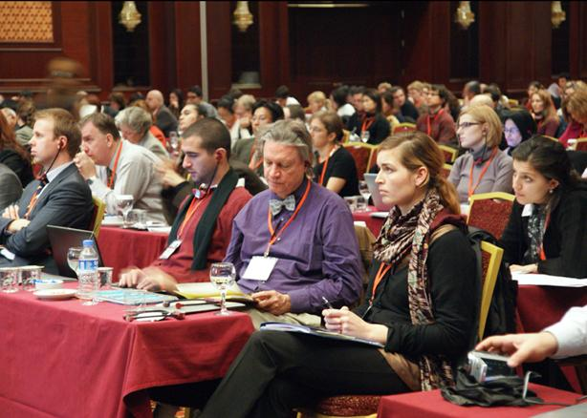
As a large, prestigious and internationally recognized conference, the ECWS helps the host city in many ways. Prospective hosts will note that the International Ecocity Conference Series is now called the Ecocity World Summit. This practice began with Ecocity 7 in San Francisco when we had approximately 2,000 participants from over 150 countries, including 220 speakers and leaders, that we felt justified and adopting the term “Summit.”
The conference brings in significant currency to the local economy through attendee’s use of the city’s lodging, dining and tour opportunities. More important is the position the city can rightfully claim in the developing history of the ecocity movement.
The conference provides an opportunity for showcasing the host city’s particular relevant contributions to an international movement with powerful offerings for solving major problems and leading toward new innovations advancing cultural and technological creativity. This in turn frequently elicits considerable local coverage in the press and some international coverage.
Academic institutions have traditionally mined the conferences for new material. On occasions, such associated positive attention has helped supportive politicians get elected.
All participants have an opportunity to witness innovations that are likely to manifest significant change in the near future. The current trend toward enhanced pedestrian centers, planting of major natural areas near and in cities, use of rooftop gardens and sky courts, advances for bicycles, the latest in solar energy technology and so on have appeared at our conferences well before the general public knew much or in some cases anything about them. Climate change was a key topic in 1990 at the first in our conference series, sixteen years before Al Gore warned the world about global warming in his movie “An Inconvenient Truth”.
In addition, the presence of the conference in a city has often helped those striving for the accomplishment of particular sustainable city goals or finite projects to gain more support. Often the Ecocity World Summit will result in a physical improvement in the city itself. For example, to prepare for the First International Ecocity Conference the city of Berkeley, California finalized a plan for a “Slow Street,” a bicycle priority street with reduced speed by reconfiguring a residential street to make it more

winding, planting trees in planters in former street-side parking places. At the time of the conference construction was nearing completion and subject of tours. The project was featured on maps provided by the conference organizers and the City of Berkeley.

Host benefits include:
- Particular technologies, policies and systems such as solar, wind, energy conservation and mixed-use building ordinances; pending and recently enacted policies promoting further development of transit and pedestrian infrastructure, more often find fresh support
- Raising the prestige of the conference’s city and host organization
- Facilitating better relations between those working on components of the city that help move it in an ecocity direction
- Receiving feedback on current plans in process locally and regionally and learning about best kindred practices from around the world
- Providing leadership opportunities for local professionals in the many fields that relate directly to ecocity design, planning, building and operation
- Providing local politicians an opportunity to put their ideas ecocity forward, and serving the public by creating an opportunity to make their ideas known to the politicians
- Facilitating new friendships, contacts and alliances.

1.4. COSTS AND FINANCES
The host city/organization has full financial responsibility for the conference, receiving all direct income and bearing all direct costs related to production and promotion and follow-up relating to the next Ecocity World Summit.
1.4.1. Costs—relative to size, location, etc.
Attendance of conferences in the Ecocity World Summit series began in the low hundreds while more recently numbers have topped 2,000 participants. With careful planning, an Ecocity World Summit conference for 1500 can likely be produced for $800,000 - 2,000,000 USD.

1.4.2. Income
Event income is typically raised from several different sources:
- Delegate fees
- Commercial sponsorship
- Institutional support such as government administrations and departments, and foundations
- Financial contribution from partners in organizing the event
- Patron donations
- Exhibition space rental

1.5. DELEGATES AND OTHER IMPORTANT ASPECTS
1.5.1. Delegate composition
Our delegates have been extremely diverse and have included:
- Private and government urban planners, architects, landscape architects and engineers
- Building, transit and bicycle industries, user groups, manufacturers and retail interests
- Climate protection and air quality experts
- Disaster recovery, mitigation and adaptation experts and survivors
- Experts in carbon sequestration practices
- Renewable energy producers and advocates
- Teachers at all levels and students in associated areas
- Local, national and international politicians who can help provide policies to facilitate ecocity building
- Members of the poor, minorities, indigenous peoples and other groups often left out of the debate
- Representatives of slums and informal communities
- Public health officials, professionals and private health organizations
- Ecotourism providers and green hoteliers
- Economists and economic experts on the means to finance and operate ecocities
- Bankers, co-op credit union officers and other financial services providers
- Practitioners of urban food production, community and individual based community gardens, commercial and municipal
- Practitioners of natural restoration work such as waterway and shoreline
- Access advocates for youth, the aged and physically impaired
- Communicators of all sorts including journalists, public relations experts, entertainers, artists, media personalities and sports heroes
- Astronauts, cosmologists, philosophers and evolutionary theorists with the larger perspective on humanity’s place on Earth and role in the universe
- A wide range of people that can best be labeled as simply the concerned public
1.5.2. Formats
Typical formats in the conference program design include:
- Plenary Sessions
- Workshops
- Breakout sessions
- Tours with discussion and debate or simply for information and experience
- Roundtable discussions and panels
- Interactive formats
- Spontaneous planning forums
Ecocity conferences are known for considerable delegate participation and examination of the ecological relationship between topics, or “cross-cutting issues.”
1.5.3. Exhibition
The applicant organizers for the next Ecocity World Summit should include an exhibition in the conference venue or nearby to be held throughout the duration of the conference. The exhibit hall allows sponsors, vendors, professional organizations and students to display information about their products, services, and ideas. The exhibit hall also provides variety and change of scene for the conference delegates. Often the exhibit hall hosts a café or refreshments area where delegates can eat and mingle. Past exhibits have included and should continue to feature the follow offerings from professionals, businesses, industry, government, academic institutions and diverse NGOs:
- New or reshaped cities, represented with designs from history both conceptual and completed.
- Transportation, energy, water, food and clean air design and projects, including actual examples of built technologies, drawings or photos of application of those technologies – all these directly to do with influencing cities toward a healthier condition
- Demonstrations of written policies facilitating the dissemination of the above technologies and associated products
- Scientific information about the Earth’s past and future condition, especially as relates to our built infrastructure
- Mapping systems and other means to grasp overall patterns of city development
1.5.4. Proceedings
Proceedings and/or results of the conference in book or video form are important to furthering the aims of the conference series. Ecocity Builders needs to know the applicant’s plan for documenting the conference. We would like to see both print and electronic records made, with an emphasis on multimedia and open data. We strongly suggest that the documentation plan include a print-on-demand conference summary book available for those who wish to purchase it.
Within one month of the close of the Summit, we require that the host make available to Ecocity Builders all papers, reports, A/V recordings, photographs and presentation decks in digitized form so that Ecocity builders can maintain and share the outcomes as part of the living archive of the Summit series.

2. APPLICATION QUESTIONS

2.1. THE ECOCITY SUMMIT QUESTIONS
Bidders for the 2019 conference are invited to reply to the questions below. You should demonstrate how your event will be unique and not only add value to the Ecocity conference series but also play an important part in raising the profile of your city for its work on eco-social urban issues.
Please answer the following questions using word processing software and email your answers in .pdf or .doc form to kirstin@ecocitybuilders.org & tina@ecocitybuilders.org.
2.1.1. Basics
- Why do you want to hold the conference? We would like to understand your interest in the Ecocity World Summit and how you think it would benefit your city, organization, region, and/or country.

- What other special reasons are there for us to choose your location for the next Ecocity World Summit? Why do you feel that your city would be a good fit for the conference series? Are there some touchstone issues, features, historical lessons, famous sons or daughters that connect you to the ecocity movement? Some special visions for the future that conferees could take home among the outstanding and influential memories of the event provided by your city?
2.1.2. Program content
- Will you propose an overall theme of the conference? Most Ecocity events have taken a theme—for example, the theme of Ecocity World Summit 2011 in Montreal, Canada was ‘Ecocities in a Northern Climate’. A theme provides an organizing principle for topics within the event and is also a selling point in itself. This theme should be mirrored in the programming and reflect current trending aspects in ecocity development.
Sometime a slogan is enough to set the tenor of the meeting. For example, at the First International Ecocity Conference we felt we were gathering together a new discipline and set of ways of living—a very broad introduction to the idea of ecocities. Over the main stage was a large banner with the reminder of why we were there: “Peace on Earth, Peace with Earth.” Introducing the ecocity idea was enough of a unifying, clarifying theme without calling it as such.
- What are the main objectives of your conference program in the context of advancing ecocities worldwide? Ecocity World Summit is an event that not only seeks to provide information but also to push forward the boundaries in bringing
people together for promoting and building ecologically healthy cities, towns and villages.
2.1.3. City context
- What ecocity-like facilities or development currently exists in the host city that would appeal to delegates? Many of our delegates and attendees have a professional interest in the ecocity conditions and amenities of the host city. Delegates not only want to hear about ecocity design and planning but also to see practical examples on guided technical visits.

- What strategies currently exist or are planned for in your city to promote and build ecocity projects and adopt ecocity policies?
2.1.4. Basics
- When do you propose to hold the conference? The date will depend on your location, climate and weather at the particular time of year, holiday calendars and the like. We are open to negotiation.

- Where do you propose to hold the conference? An ideal venue would be convenient to the city center, transport services, accommodation and tour destinations.

- How long will the conference run? Ecocity World Summit should ideally last three to five full days with plenary and workshop sessions. It has worked well in past conferences to open the sessions with a keynote speech by one or a few well known and popular presenters the evening before the first full day.

- Who are your primary bid partners?

- Who would be the lead body responsible for the conference organization and who will be the Event Director? Ecocity Builders requests organizers designate an official convener or two co-conveners for summit. The convener may also be called “Director,” “President,” or “Chair.”

- Can you provide us with a draft budget estimate for your bid? The budget should outline proposed major income sources and expenditure items, and as far as is possible be in balance. Greater proportion of costs that can be covered by sponsoring bodies and others will be seen as a positive indication of good planning. If you already have any firm offers of support, please let us know.

- Sponsors. Please let us know more about your ideas for sponsorship. What are your sponsoring aims and possibilities for this event? How important are your aims to the overall budget in terms of promoting ecocities in your city and other cities by way of the conference?

- Who is expected to be responsible for raising any sponsoring and external sources of finance? Gaining funds and sponsorship is obviously an important part of the event planning. We wish to know how you plan to address this issue. Will there be enough institutional support for the bid to make this unnecessary? If not, who will be responsible for this task?

- What strategies will you adopt to ensure good attendance at the Ecocity World Summit 2019? The event program should be engaging and innovative to encourage target groups to participate. What strategies will you put in place to ensure that this conference has a widespread appeal, both in the host country and externally? In particular, what publicity and promotion would you plan? The conference organizers should to attract delegates from both developed and developing countries. We are looking for your innovative ideas on this matter. We suggest that for the 2019 event all plans, logistics and caterings should allow for an audience of 1,000 up to 2,000.

- As an ECWS host city, how will you continue the visibility and impact of the Ecocity Movement? Can you propose a legacy project—such as establishing an “ecocity academy,” or establishing an institute or course series or certificate program or a mini office or an endowed chair—something ongoing and meaningful?

- How does your proposed ECWS theme relate to previous Summit? Bids that clearly explain how their conference theme fits with prior conference themes and moves the discussion forward are encouraged.

- What role do you envision for yourselves vis a vis future ECWS? Bids that explore what role they envision for themselves with future Summits (such as continued participation and leadership, dissemination/curation of conference outputs in a centralized global repository, commitment to building of a knowledge base such as the Ecocity Builders’ wiki) are attractive.

2.1.5. Planning and organization
- How will you ensure that relevant local NGOs, green businesses and cultural luminaries will play a full role in the organizing of the conference? It is important to us that representative citizens play a substantive part in the planning process. How will you ensure that such people are directly involved in the planning and programming?

- What arrangements would you make to ensure the full participation of Ecocity Builders in major decisions regarding conference planning? As part of the contract with the winning city, Ecocity Builders needs to be involved in key decisions regarding the event. How will you organize the planning for your event to ensure this happens efficiently and effectively?

- How would you plan for the exhibition to take place alongside the conference? All recent Ecocity series events have found it useful to plan an exhibition with participation fees for industry, government organizations, voluntary organizations, consultancies etc. The conference venue should provide space at no cost for the dispersal of information brought by delegates. The exhibition is an increasingly important aspect of the event, and one that calls for some specialist skills. How will you ensure that this can be well organized, well publicized, accessible and at a minimum self-financing?
2.1.6. Event quality
- What translation facilities will you provide for plenary and workshop sessions, and for which languages? The official Ecocity World Summit language is English, but simultaneous translation should be provided at a minimum for the host language during plenary sessions. Ideally, this service should be extended to at least the major workshop sessions as well. The ability to provide for other languages would be seen very positively. Does your chosen conference location cater to all these needs?

- What types of accommodation will you offer delegates? A variety of accommodation is required to cater to the varying budgets of the different types of delegates that attend Ecocity events. This varies from luxury to budget hotels to homestays. Can you demonstrate how your city will provide diverse accommodation types?

- What arrangements do you intend to make for students, NGOs and people from developing countries to attend? Ecocity events have a fee structure that accommodates the ability to pay and participate. In addition, it is important that the conference budget make it possible for Ecocity Builders members to attend by waiving the registration fee for 15 representatives of Ecocity Builders. We will favor bids that can include this provision.

- What social programs do you plan to organize for delegates to the conference? It is important to consider the social events as well as the core event program of presentations. These are not only important to provide time for attendees to network with each other but also should give delegates a lasting impression of your city and its heritage. It is customary to arrange social events in the evenings. In the past, these have included everything from boat rides, fireworks and dances to the more traditional receptions and dinners. In order to provide delegates with a lasting impression of your city, what do you propose for a social program?

- How convenient are the conference and accommodation sites to major transport centers such as airports, train and bus stations? All functions and events during the conference, including evening and social events, should be easily accessible by walking, cycling, or public transport. How do your venue choices reflect this aim?

- Upon selection of your bid, how long would you need before you could start work? Event planning is all about managing time and people. Once the host city is chosen the clock starts ticking toward the conference date. Therefore, we need to know that a planning team with the necessary resources to do the job effectively can be in place immediately after the final selection. There will not be time to wait very long for decision-making after the selection process is complete. We also wish to see a draft timetable of the planning stages of the conference.

- What site visits do you intend to organize around the conference date? Site visits are those made to other cities or nearby sites that can be included in the program as part of a post-conference option for delegates. These should have some ecological city relevance, but can also be for cultural or historic enrichment. While technical visits should be part of the core program, site visits should be planned as an option if they add value and interest. What site visits would you plan as part of the conference?

- What communications strategy will you employ in order to guarantee a rich delegate and speaker attendance at the conference? The host city and/or conference organizing institutions are expected to come up with a communications plan that will have to be coordinated with the ECOCITY BUILDERS communications. A well-organized and publicized call for proposals to solicit top-quality speakers, as well as wide publicity to attract quality delegates is essential to a rich program. A formal draft communications plan and budget should be supplied with the application.

3. TERMS OF REFERENCE

3.1. WRITTEN BID MATERIAL
Bidders are free to determine the format and presentation of their bid. However, your proposal should answer all the questions and conditions (Chapter 2) so that your bid can be appraised fairly. Please also bear in mind the selection criteria set out in point 3.2 below.
Language: All written material must be in English. All prices must be quoted in dollars (USD) or both USD and local currency.
Summary: So that all the bids are easily comparable, we kindly ask for a two-page summary of responses to the conditions and questions. This should be provided for both the shortlisting and final stages. The summary should be set out with:
- Bidding city name at the top of each page
- Condition/question numbers running down the left of the page with the answers inset
- Indication on which page number/s the full response to that point can be found
Your answers should include all relevant information to allow us to evaluate your bid. The quality of your answers will weigh more heavily than quantity of pages. Supplementary information on conference/hotel locations as well as city visitor attractions can be useful, but should be kept modest in size. Please bear in mind that the provisional bid material will have to be submitted electronically and should not include extensive use of graphics or photographs. For full information on requirements for the bid presentation, see section 3.6 on time tabling below.
3.2. CRITERIA FOR THE CHOICE OF VENUE
The bids will be judged on the basis of the following criteria:
- Overall quality of the bid
- Potential for inspiring and furthering the ecocity movement worldwide
- Political commitment of the City Administration
- Creative and attractive ideas
- Bids that further the aims and objectives of the IEWS
- Involvement of advantageous partners
- Proven experience of managing big projects over time
- Sound financial planning giving good value
- Bids from locations that are attractive for Ecocity Builders regarding the history and the future of the Ecocity World Summit series
- Bids proposing a legacy project, such as establishing an “ecocity academy,” or establishing an institute or course series or certificate program or a mini office or an endowed chair—something ongoing and meaningful;
- Bids that clearly explain how their conference theme fits with prior conference themes and moves the discussion forward;
- Bids that explain what role they envision for themselves with future Summits (such as participation in dissemination/curation of conference outputs in a centralized global repository, commitment to building of a knowledge base such as the Ecocity Builders’ wiki.)
- Bids that further actual policy, design, planning and building of ecocity elements
- Applicants that will commit to participating at ECWS 2019 regardless of whether or not they win the bid - in other words will commit to participating in a session, panel, exhibit, or otherwise attend.

3.3. DECISION MAKING
Ecocity Builders is the decision making body. It is guided by a panel of selected experts from academic, professional and civil society organizations with international representation including past conveners of the Ecocity World Summit who desire to remain active in the planning of future conferences. Bids are evaluated against the criteria through a ranking process. If a clear winner is not identified through the ranking, the top three bids will be further vetted by Ecocity Builders and a vote will be taken to select the winner.

3.4. CONTRACT
Once the decision on the 2019 host city is made, a contract will be promptly signed by the chosen city (or the relevant constituted body). This will set out the responsibilities and financial arrangements of both parties, which are governed by the following:
- All financial transactions are made with Ecocity Builders, which is entrusted with supporting the conference into the future. Said non-profit California corporation is known more informally as “the Keeper of the International Ecocity Conferences.”
- The general conference fee to Ecocity Builders is $90,000 USD. This fee excludes the following:
    - a. Cost of sessions in the host city with Ecocity Builders representatives to discuss and develop the main themes, concept and presenters of the conference. These meetings will be organized by the host-city and are part of the evaluation process.
    - b. Additional services of Ecocity Builders, on top of what is described in this manual, to be agreed on in the contract with the host city. For instance, the expenses for one to three-day planning visits by representatives of Ecocity Builders are expected in the normal sequence of planning. These are covered separate from the $90,000 fee by the host(s). Another example: if the host city and/or organization wishes to hire a member of Ecocity Builders to come to the host city for a period of time to help in planning, lodging, travel and pay would be in addition to the base fee of $90,000. Such additional fees would be negotiated with and paid to Ecocity Builders, which would subcontract with the individual.
- During the conference the host city will be responsible for travel costs (travel and accommodation) for the Executive Director and up to eight Ecocity Builders Staff/Board members.
During the conference (plus the days before) the host-city should provide Ecocity Builders with:
- Office space to be used by Ecocity Builders members (including Internet access, print service, whiteboard, pens, etc.)
- One meeting rooms for up to 10 people (incl. internet access, presentation media, basic catering)
3.5. FINANCIALS (INCLUDING ECOCITY BUILDERS FEE)
The general conference fee of $90,000 is payable to Ecocity Builders, Inc. This fee is for the following benefits and services that the chosen host city receives:
- Use of the name Ecocity World Summit with appropriate number in the series
- Our expertise and experience
- The conference database of names and addresses we supply
- Our work with your team during the whole planning period, based on an agreed estimate of the number of meetings
- Our work at an international level to both promote and represent the conference. Ecocity Builders will be involved in the event planning throughout the project and expects to attend meetings to help plan the event. The fee for the 2019 event will be USD 90,000. This sum will be payable in four stages, with a $2,500 non-refundable deposit due upon application. The remaining payment schedule to be decided.
All costs of bidding will be borne by the bidding cities. These include:
- Time and material costs of preparing the bidding materials. If the city is selected to be among the final shortlisted cities, the additional costs to the bidding cities will also include:
  - Travel and accommodation costs of the Executive Director and one to three Ecocity Builders representatives for a site visit during the bid process

3.6. TIMETABLE FOR PROPOSALS
The timeline for the selection of the 2019 event is as follows:
- June 2016: Publication of bid-manual. At this time, interested bodies should begin to make plans, formulate provisional answers to the Ecocity World Summit conditions and questions, and talk to possible partners. Informal discussions can and should take place between interested cities and the Executive Director's office. We will offer help and assistance equally to all bidders.
- February 2017: Deadline for proposals/bid. Your answers to the Ecocity World Summit conditions and questions and your bid are to be supplied to the ECOCITY BUILDERS office in Oakland California by this date. These submissions must be sent in electronic (e-mail) form to Ecocity Builders’ Executive Director (kirstin@ecocitybuilders.org) and as a copy to her assistant, Tina Huang (tina@ecocitybuilders.org). The answers are to be supplied in English as an attached Microsoft Word and PDF file. We also require the name, address and phone numbers of the main contact person for the bid.
- May 2017: Notification of bid winner. Public announcement will be made during the finale of Ecocity 2017 Melbourne, Australia, July 14 2017.
Bids will be forwarded to all members of Ecocity Builders. Ecocity Builders will select the city or cities by consensus of one-conference-one-vote.
- Ecocity Builders will decide on the 2019 Conference Host city and organization previous to the opening of Ecocity 12 in Melbourne.
- The winning city will be expected to announce their selection as the next host city as part of the closing ceremonies of Ecocity 12, followed by the signing of the contract with the conference organizing organization.
3.7. FINAL REMARKS
The bid process is designed to find the city best suited to host the next Ecocity World Summit. There is no set formula for how such a conference should be planned. We welcome new and exciting ideas that will further this event. We hope that the enclosed information helps you to appreciate the great potential of such a project. This potential has been recognized by the cities and organizations that have hosted the conference over the past 20 years, as well as the many international organizations we now work with in preparing the Ecocity World Summit conferences. You are hereby invited to consider this invitation, and so perhaps join the increasing list of cities where the Ecocity World Summit has been held. We look forward to receiving your bid.

Please send notification of your interest to:
Kirstin Miller, Executive Director
Ecocity Builders
339 15th Street, Suite 208
Oakland, CA 94612, USA

kirstin@ecocitybuilders.org
T + 1 510-452-9522

AND CC TO
Tina Huang, Executive Assistant
tina@ecocitybuilders.org

