Abundant Life is experienced as one hears and then puts into practice the Word of God. Jesus emphasized this point that the blessing is in the doing (practice). Jesus said, “But even more blessed are all who hear the word of God and put it into practice’’ (Luke 11:28 New Living Translation). Also, He said, ‘’Now that you know these things, God will bless you for doing them’’ (John 13:17 NLT).
The point of this book therefore, is to encourage the believer to adopt these Old Testament truths for daily living by making practical everyday decisions to walk in these covenant realities. For the believer to realize the Abundant Life (John 10:10), he must be a practitioner. Practicing the Word of God is a proven covenant technique for victorious living. I believe you are on your way to living Abundantly and fulfilling your covenant destiny.
Dr. Michael Atunrase, Sr.

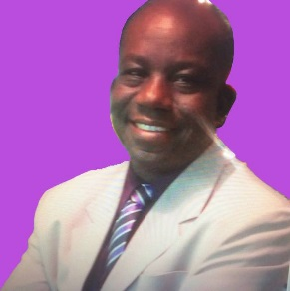
MICHAEL O. ATUNRASE, SR. Ph.D., is Senior Pastor of the Cornerstone Bible Fellowship Church, Levittown, Pennsylvania. A visionary and a missionary, he has traveled extensively, preaching and lecturing in several countries, and has studied and demonstrated proficiency in various fields such as Theology, Education, Christian Counseling, Writing, Speaking and Applied Sciences, (Biochemistry, Bacteriology & Public Health). Dr. Atunrase is author of online daily devotions, ‘Daily Refreshing’, and President of MOVE-MEN+, an International Ministry to Men. He is president of Cornerstone International Christian Ministries and Protestant Minister, for the State of New Jersey, Department of Rehabilitation and is an ordained Bishop with the AEGA Ministries, (Association of the Evangelical Gospel Assemblies, USA). He is blessed with his wife Pastor Lola and their four children.

