Website Design Brief for Shop Fronts/homepage

Prepared for:
Prepared by:
Date:
Confidential

Introduction

The Galleria By GFG invites quotes for the redesign of its public website. (please note we only require design, we currently have web developer that the client would then work with to implement the chosen designs) The website is hosted using Magento

Bids should be submitted to Martin Sturgess via email (MSturgess@goodfoodandgifts.co.uk)
We will contact you within one week of receiving the bid. The deadline for completion of the project is set for the end of may / early June.
Please address any questions to Martin Sturgess via email or alternatively contact by phone on 01234240666. In his absence please contact Stephen Briggs via email on (sjbriggs@galleriabygfg.uk)

About GFG
We are developing a unique on-line shopping mall that sells to wholesalers, trade, food-service as well as consumers. The shops in the mall are both brand and category currently specialising in gourmet, dietary, religionary and ambient long-life "meals ready to eat".
Shoppers can shop in as many shops in the Galleria by GFG as they wish but will only have ONE checkout! It is a cutting edge multi-level marketing, sales and distribution tool ideal for artisan, specialist and niche food manufacturers wanting to sell to ALL markets, consumer, wholesale, retail, food-service, trade, vending....
We handle everything from storage fulfilment and delivery! It must be one of the most competitive means of getting a product to market.
We also offer a wide range of add-on marketing services through trusted partner companies.
One of the largest wholesale buying groups will be using a portal/shop in The Galleria by GFG to fulfil the needs of its wholesale members with a wide range of "Free-from" foods, religionary and gourmet delights!
The trade launch is 1st June 2016

Target Audience
The Galleria by GFG presents a multi-level sales and marketing platform selling quality, gourmet, dietary (inc Free-From Food), religionary and ready to eat meals (esp. Ambient) to Consumers, Retail, Trade, Food service and Wholesale. All under one roof!
- Consumer – The Galleria highest margins on sales will come from its retail sector, the main focus of the website will be the sales of products from each store to the consumer. The site will offer a wide range of specialty shops all under one roof, consisting of products not generally found in supermarkets. The site also needs to include reference to a loyalty programmes and exciting promotional activity.

- Trade – (retail) Trade will be able to purchase products through the Galleria from any supply chain in the business, all at trade prices. They will be using their own domain linked to the website to access the *trade portal* however we need a visual presence for the trade portal on the main page of the site (such as a trade shop front)

- Wholesale – much like trade, wholesalers will also access their services through a separate domain. They will access their own portal and again only see prices and quantities related to wholesalers. However we do still need visual representation on the main page of the site (such as a wholesale Shop Front)

- Landmark buying group – landmark represents 68 wholesalers based in the UK. The Landmark group will also be given an exclusive portal only accessible to their buying group again with set unique prices not available to the others. We need this to also have a visual presence on the front page shop fronts.

Web requirements / Design
The main purpose of this brief is to redesign the shop fronts on the main page of the website (http://www.goodfoodandgifts.co.uk/). At current the shop fronts look outdated and plain.
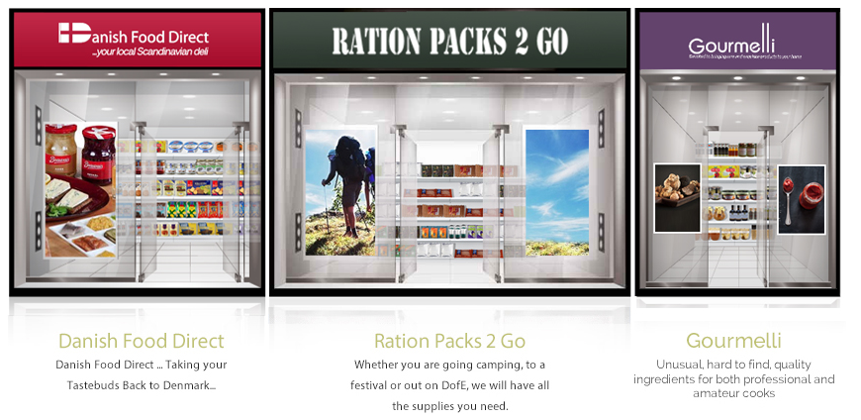

As the foundation of the concept is based on an online shopping mall we would like this to be reflected in the designs on the front page leading towards a more contemporary image, so the consumers can see a shopping mall style theme when they enter the site. We understand that this concept is rather unique from a website design aspect and we are open to a wide range of variations and ideas on how to implement shopping mall themes.
From a design perspective we are looking for a modern bespoke approach to the design of the shop fronts. The original idea we had was to give the user the feel of shopping in a modern day mall on the web, with the use of clear cut images and modern functions. The shops will each require individual branding while maintaining an overall grand image of a shopping mall
The deadline for completion of the website is set for the 1st of June 2016, any Bidder must be aware this is the final date for the total completion of the site, therefore any designs would need to be finalised to provide enough time for our developer to upload before this date.
As stated at the start of this section the main purpose for this brief is the redesign of the shop fronts before the re-launch on the 1st of June, that being said we are open to a more detailed redesign of the site such as the complete look and layout of the home pages and or individual shop pages. This includes photography, illustrations, animations and videos. This would not be required until after the launch date as the main focus at present is to update the front page and shop fronts in preparation for the 1st of June.

Website features/content
As this brief is more towards the design aspect rather than content the main feature required is the overall look and layout for the front page especially referring to the shop fronts in the previous sections. I will include along with this brief the company presenter as well as a brief design sketch to help you understand more of what I am looking for from a design point of view.
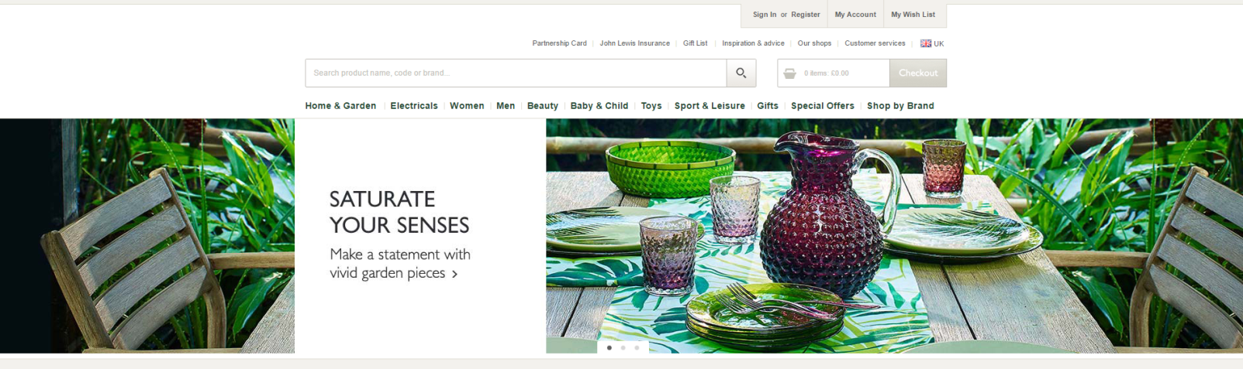
Taking a look at the flowing site you can get a better idea of the layout I was hoping for the front page http://www.johnlewis.com/

I think the logo, search bar, checkout and tabs are well located and designed followed by the very effect banner picture. The contact information and follow up links at the bottom of the page are very well placed worded and designed.
Following the large banner picture (as shown in the attached file) I was then hoping to have the new shop fronts followed with an implemented design or theme to represent a shopping mall.

Competitor websites
Forman and field are worth mentioning as a main competitor. http://www.formanandfield.com/
We like the photography on the front page, including the cycle speed of the picture. Tabs are more tailored towards the food industry. We dislike the second (centre) banner as its too busy and dark coloured. We dislike that feel of the page as if the entire page is set to the centre, unlike the John Lewis site that offers the banner and further interactions down the page across the entire width of the screen.
Marks and Spencer’s food site (http://www.marksandspencer.com/c/food-and-wine) is very well presented and the categories well organised and inventive.
Selfridges food hall (http://www.selfridges.com/GB/en/) offers a nice selection of bespoke product images again showing a more *widescreen* view of the site offering interactions across the page and not just down the centre.
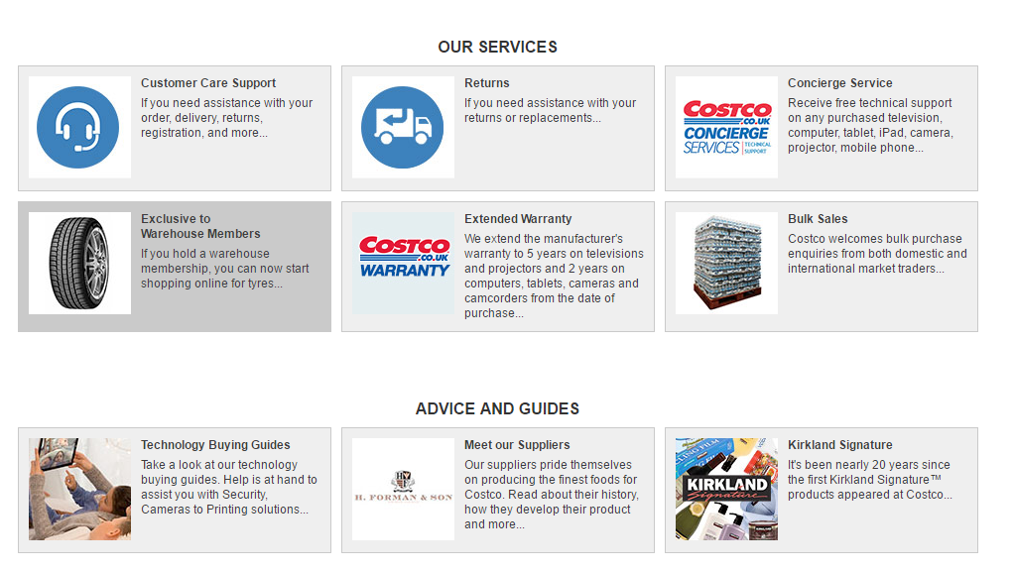
The use of pictures on the Costco site for their customer services is very appealing (on a smaller scale).

Conclusion
Thank you for viewing this brief for the Galleria by GFG if you feel you can meet our requirements and small time frames please get back to us with some ideas / examples as soon as possible.
If you require any more information or resources, such as our current photos and or contact with our web developer please get in contact.

