
Easy & affordable small batch beer labels at www.beerskins.com.au
Less than five minutes and from just $12 for a full set of custom printed labels.
Take your homebrew to another level.
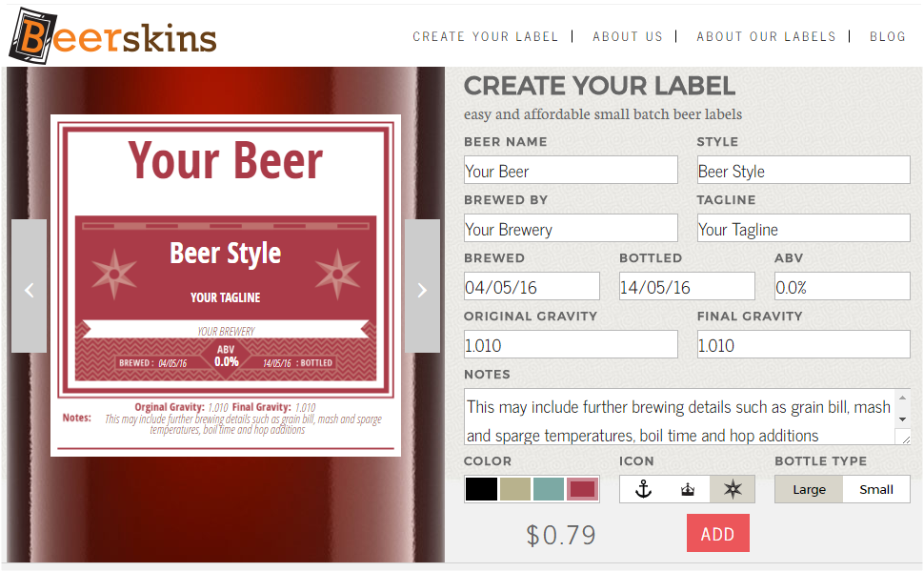
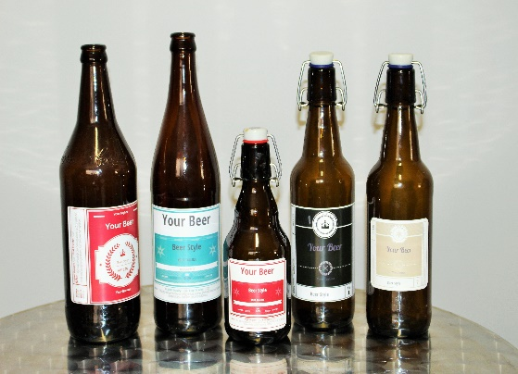
Just fill in template with details of your brew, and select from our range of designs, colours, icons and bottle size.
We print your labels in high quality LED on A4 sheets of die cut, self-adhesive labels.
Our synthetic labels are water resistant and remove cleanly from your empties without tearing and without leftover glue crud.

Try a set of Beerskins next time you lay down a batch.
www.beerskins.com.au

