PROBLEM STATEMENT
The current look and feel of The Yank Shop branding & logo is looking dated and cheap.
CLIENT PROFILE
The Yank Shop is a small business that started in 2013. The Yank Shop is a business that operates online only and offers a wide variety of items from small electronics to costumes, toys and board games, books, etc. This business initially started as an idea to sell items imported from America to facilitate purchases for Australia customers who wanted to buy modern and the latest items from the US that still hadn’t arrived to Australia, with fast and free delivery Australia wide. All items sold by The Yank Shop are genuine branded items and with very good quality.
Our website is: www.theyankshop.com.au
We also sell our items via ebay.
AIMS AND OBJECTIVES
The main objective of the rebranding is to refresh the logo and the brand in general to make it look more contemporary, a little bit more upmarket and perhaps more fun at the same time.
TARGET AUDIENCE
The target market of The Yank Shop is varied between male and female, ages in between 20 to 50, people who like to keep in contact with latest news in gadgets & toys for adults and for their children, and in general, things that can be used as gifts for a variety of age groups.
Customers are located in Australia mainly.
DELIVERABLES
We are expecting the selected designer to propose a new branding for The Yank Shop with a complete set of elements and branding guidelines including:
- A new Logo
- Backgrounds
- Colour Palettes
- A main image to be the representation of the brand and to be used in website, facebook & twitter cover, etc. See our website to see our current image.. a “Thumbs up girl”, we need a new one
- Facebook cover
- Twitter cover
- Linked-in Cover
- Header for e-mail newsletters
- Main Banner for website front page
- Stationery (Letter & business card)
- A thank you card to include with parcels sent to customers (business card size, double sided)
Please include all guidelines: fonts to be used and all colour codes (RGB & CMYK). Also the logo has to have an inverted version to be used on dark colours
SOME EXAMPLES
These are just example of some logos that we like in style and creative design. The Yank Shop logo should have both the logo and the words like in these logos below.
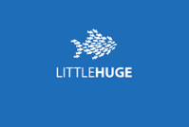
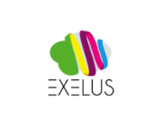
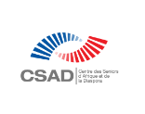

SOME OTHER GUIDANCE
- No cheap logos using cheap fonts
- All elements in general will not look too busy

