Request for Web Design mockup

Web Design Mockup

Objective:
Make a website mockup to promote a company providing services and products within the Smart City concept. There are some main applications that will be promoted but there should be an impression that the platform is open for additional applications. IoT and Smart City are buzz words that should be mentioned.
A main objective is to create an impression that the Company is an established and a serious company providing products and services for “Intelligent streetlight” as a main application within there “Smart city” platform.
So we primarily target investors, but also city officials responsible for the development of infrastructure such as outdoor lighting and EV chargers.

GENERAL
The Company Capelon has service and product platform for different Smart City applications. Basically this is IoT targeted towards Smart City Applications (mostly within traffic and infrastructure area).
This company has two main applications that should be presented but we should also display the endless possibilities for the future with a platform like this. The two main applications are Intelligent Streetlight (or Managed Streetlights) and Electrical Vehicle Charger.

We will not provide that much specific content at this point but the contester will have to add “dummy” content at different locations on the webpages. The contester must describe what type of information/text is expected at the different places on the web pages. We will provide some hints concerning content. A contester may ask related questions regarding content since it may help to provide a better understanding and thus help to make a better web mockup.
If a contester choses a video or slide show, it is important that it is described so we know the objective of the video or slide show.

Some key words
- ENVIRONMENT
- SAVE ENERGY
- REDUCE OPERATIONAL COST
- SAFETY

Overview
We see a start page and some application pages. Then each application can have their detail pages with more technical information.

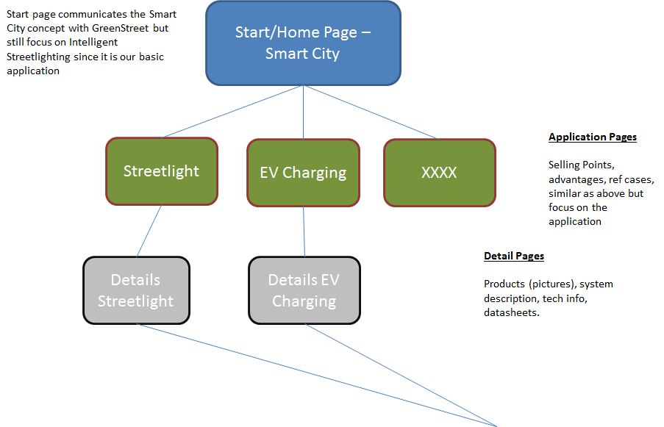

Also, for reference and suggestions the contester may take a look at the following examples that have relevant related content.
http://intelilight (dot) eu/
http://www.echelon (dot) com/applications/pl-rf-outdoor-lighting
http://www.silverspringnet (dot) com/
http://www.lighting.philips (dod) com/main/systems/connected-lighting/connected-lighting-for-smart-cities/connected-lighting-for-smart-cities.html

Home/Start Page
The start page should provide the impression about large and established company with an existing and large customer base. For that reason is ok that this start page is a bit fluffy and vague, the impression is most important.
Today Capelon has a platform/system for providing services and products for intelligent (managed) public lighting. It is called GreenStreet But instead of directly addressing the Intelligent Streetlighting business we should present a Start Page focusing on the Smart City concept. Capelon believes that the current product and service platform for “Intelligent Streetlighting” can be expanded to a “Smart City”-platform involving also other applications other than “Intelligent Streetlighting”.

GreenStreet for a Smart City…or something…

The need is to create integrated platforms that, starting from public lighting, extend services offered to citizens (public lighting remote management, video surveillance, electric vehicles charging stations etc.).

GreenStreet steps up from only being an intelligent lighting system to being an integrated platform based on Open Technologies for a Smarter City.

So the Start Page should provide the impression that Capelon is provider of services and products suitable for the “Smart City” vision. Currently this is mainly limited to the “Intelligent Streetlighting” part but as that is the base for expanding into a “Smart City” platform we will need to provide this impression here.
If you need to know about what is a Smart City? Please google. Here is a link that describes generally. https://www.youtube.com/watch?v=Br5aJa6MkBc
Or this one regarding a Smart Lamp Post: https://www.youtube.com/watch?v=7cCANCeBhGQ
The objective of the services and products are to SAVE MONEY and SAVE ENVIRONMENT by reducing energy cost and operating cost. However, when adding the “Smart City” concept to this there are services that will make the City smart which means that the people will have an easier and safer life. For example easy to find available parking space, get real time information useful for decisions, lighting scenarios providing safety, easy charging of electrical vehicles, easy available wifi hotspots etc etc.
Some buzz words: Smart City, IoT, Reduce Energy, Save Environment….
So the start page can be some pictures or a illustration of a smart city with different application or an animation..

Application Pages
On the application pages we focus in a specific application or areas within the Smart City concept. In our case we started with “Intelligent Streetlight system” so that is naturally our main application. In this level we should still mainly communicate selling points.
A system description should be a brief overview with mainly links to more detailed description (at the technical pages).

In this contest we can limit to two applications.
- Intelligent Streetlight
  - Saving Energy is one key factor but as important is a smart system that allows more efficient operations, thus reducing operational cost…the corresponding environmental savings with less outdoor operational activities, longer life length for light sources etc.

- Electrical Vehicle Charging
  - We use the fact that our Intelligent Streetlight can have power one 24/7 and then we can provide charge points from streetlights.
    - Charging of cars
    - Charging of bikes and scooters

Detail Pages
Detailed descriptions
- Pinpoint the technicality related to the services and products and elaborate the work space about them.
- Use meaningful and clear pictures of the products.
- Design should be responsive.
- Use proper heading and style format to help user easily interaction.

