
Magic TROFFER
by

LED Troffer

Advantage

• Quick Installation for each retrofit kit which only takes five minutes.

• 0-10V dimmable function help to reduce operation cost.

• 135 lumens per watt help to reduce payback period of energy saving.

• 100000 hours working time and years warranty.


E358903

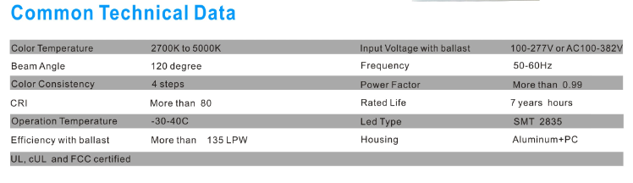
Common Technical Data

Color Tern erature 2700K to 5000K Beam Angle 120 degree

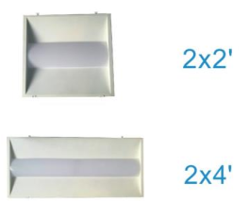
Magic Troffer 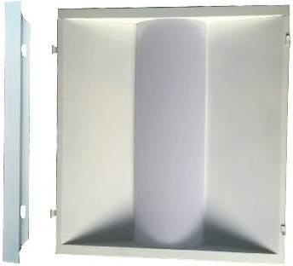 2x2' 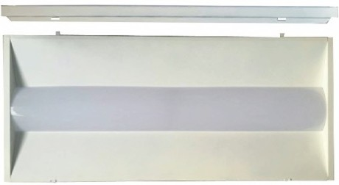 2x4'

l

Frequency 50-60Hz

Color Consistenc 4 ste s flower Factor More than 0.99

CRI |  | More than | 80 | Rated Life | 7 years hours
Operation | Temperature | -30-40C |  | Led T~ e | SMT 2835
Efficiency | with ballast | More than | 135 LPW | Housing | Aluminum+PC
L, cUL | and FCC certified
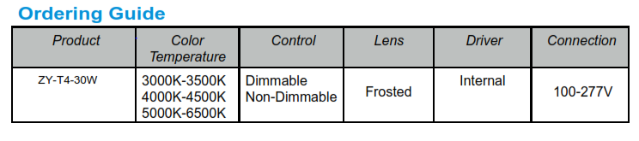

Ordering Guide

~~~~ZY~~~---'~~~R_4_IR_7~~~-'~~-2_5_W_l3_6_w_,_5o_w~ ,/...._~~~X-N_Z_IX_D_Z~~~--'

Company Code

Size

Wattage

Non Dimmable/ Dimmable

Warranty


This product has a warranty of period of 7 years from the date of purchase. The warranty is invalid in the case of improper use installation, tampering, and removal of the Q.C. date label, installation in an improper working environment or installation not according to the current edition of the National Electric Code. Should this product fail during the warranty period it will be replaced free of charge, subject to correct installation and return of the faulty unit. ALG does not accept responsibility for any installation costs associated with the replacement of this product. This warranty is in addition to the statutory rights in your country of purchase. ALG reserves the right to alter specifications without prior notice.
Product Specification

Product Number | Wattage | Color | Voltage | Lu mens | Working Hours | CRI
2x2 Troffer Retrofit Kit Door

ZY-T4-25W XNZ | 25 | 3000K | AC 100-277V or AC 1 00-382V | 3300 | 7 years | 80
ZY-T4-25W XNZ | 25 | 3500K | AC 100-277V or AC 1 00-382V | 3300 | 7 years | 80
ZY-T4-25W XNZ | 25 | 4000K | AC 100-277V or AC 1 00-382V | 3300 | 7 years | 80
ZY-T4-25W XNZ | 25 | 5000K | AC 100-277V or AC 1 00-382V | 3300 | 7 years | 80
ZY-T4-25W XDZ | 25 | 3000K | AC 100-277V or AC 1 00-382V | 3300 | 7 years | 80
ZY-T4-25W XDZ | 25 | 3500K | AC 100-277V or AC 1 00-382V | 3300 | 7 years | 80
ZY-T4-25W XDZ | 25 | 4000K | AC 100-277V or AC 1 00-382V | 3300 | 7 years | 80
ZY-T4-25W XDZ | 25 | 5000K | AC 100-277V or AC 1 00-382V | 3300 | 7 years | 80
ZY-T4-36W XNZ | 36 | 3000K | AC 100-277V or AC 1 00-382V | 5000 | 7 years | 80
ZY-T4-36W XNZ | 36 | 3500K | AC 100-277V or AC 1 00-382V | 5000 | 7 years | 80
ZY-T4-36W XNZ | 36 | 4000K | AC 100-277V or AC 1 00-382V | 5000 | 7 years | 80
ZY-T4-36W XNZ | 36 | 5000K | AC 100-277V or AC 1 00-382V | 5000 | 7 years | 80
ZY-T4-36W XDZ | 36 | 3000K | AC 100-277V or AC 1 00-382V | 5000 | 7 years | 80
ZY-T4-36W XDZ | 36 | 3500K | AC 100-277V or AC 1 00-382V | 5000 | 7 years | 80
ZY-T4-36W XDZ | 36 | 4000K | AC 100-277V or AC 1 00-382V | 5000 | 7 years | 80
ZY-T4-36W XDZ | 36 | 5000K | AC 100-277V or AC 1 00-382V | 5000 | 7 years | 80
2x4 Troffer Retrofit Kit Door

ZY-T7-36W XNZ | 36 | 3000K | AC 100-277V or AC 1 00-382V | 5000 | 7 years | 80
ZY-T7-36W XNZ | 36 | 3500K | AC 100-277V or AC 1 00-382V | 5000 | 7 years | 80
ZY-T7-36W XNZ | 36 | 4000K | AC 100-277V or AC 1 00-382V | 5000 | 7 years | 80
ZY-T7-36W XNZ | 36 | 5000K | AC 100-277V or AC 1 00-382V | 5000 | 7 years | 80
ZY-T7-36W XDZ | 36 | 3000K | AC 100-277V or AC 1 00-382V | 5000 | 7 years | 80
ZY-T7-36W XDZ | 36 | 3500K | AC 100-277V or AC 1 00-382V | 5000 | 7 years | 80
ZY-T7-36W XDZ | 36 | 4000K | AC 100-277V or AC 1 00-382V | 5000 | 7 years | 80
ZY-T7-36W XDZ | 36 | 5000K | AC 100-277V or AC 1 00-382V | 5000 | 7 years | 80
ZY-T7-50W XNZ | 50 | 3000K | AC 100-277V or AC 1 00-382V | 6880 | 7 years | 80
ZY-T7-50W XNZ | 50 | 3500K | AC 100-277V or AC 1 00-382V | 6900 | 7 years | 80
ZY-T7-50W XNZ | 50 | 4000K | AC 100-277V or AC 1 00-382V | 7000 | 7 years | 80
ZY-T7-50W XNZ | 50 | 5000K | AC 100-277V or AC 1 00-382V | 7000 | 7 years | 80
ZY-T7-50W XDZ | 50 | 3000K | AC 100-277V or AC 1 00-382V | 6880 | 7 years | 80
ZY-T7-50W XDZ | 50 | 3500K | AC 100-277V or AC 1 00-382V | 6900 | 7 years | 80
ZY-T7-50W XDZ | 50 | 4000K | AC 100-277V or AC 1 00-382V | 7000 | 7 years | 80
ZY-T7-50W XDZ | 50 | 5000K | AC 100-277V or AC 1 00-382V | 7000 | 7 years | 80

