DESIGN BRIEF: ednr muesli labels
Muesli label design requirements:
5 x products
Each requires a front and a back label (= 10 labels in total)
- Dimension guide:
  - front 60 x 125 (can be slightly larger and/or slightly different dimensions)
  - back 105 x 148 (can be slightly larger and/or slightly different dimensions)
(I’m not planning to change my kraft paper bags with window – as per image below)
Labels must be cohesive, but also differentiated through use of different colours for example
Barcodes must not be smaller than 37.29mm x 25.93mm
Font is not pre-determined, and is flexible.
Examples of styles I like:
http://bareblends.com.au/store/

http://www.alibaba.com/product-detail/Zip-Lock-Stand-up-Pouches-Kraft_1898080026.html?spm=a2700.7724838.0.0.76PyAG

http://www.alibaba.com/product-detail/2015-stand-up-pouch-bag-with_60348168312.html?spm=a2700.7724838.0.0.jzkCZM

http://www.alibaba.com/product-detail/2015-custom-printing-natural-white-kraft_60371155983.html?spm=a2700.7724838.0.0.0Sz9NB

http://www.alibaba.com/product-detail/Kraft-paper-stand-up-pouch-with_60379659009.html?spm=a2700.7724838.0.0.CTb5Pr
examples of competitor’s product labelling:
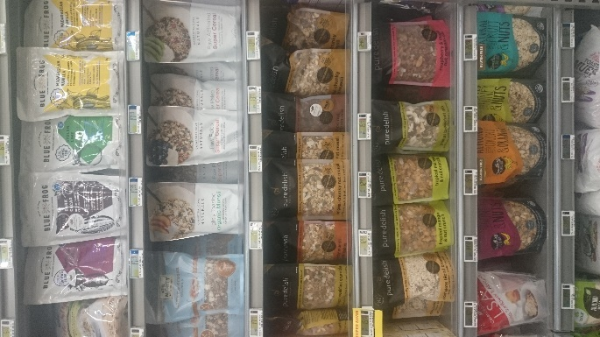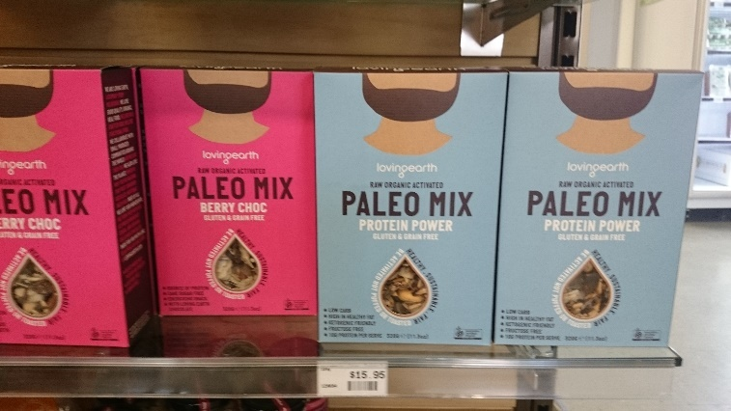
And competitor’s products also at:
http://hashtaggranola.com.au/shop/
http://www.bantingfood.com.au/
http://byronbaymuesli.com.au/
http://foragecereal.com/products/
https://www.farmerjo.com.au/products/paleo-granola

Current packaging for ednr muesli
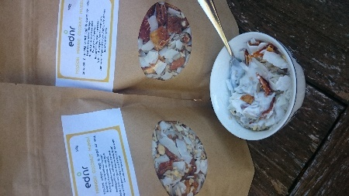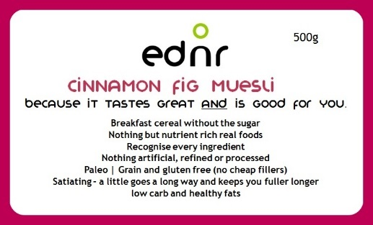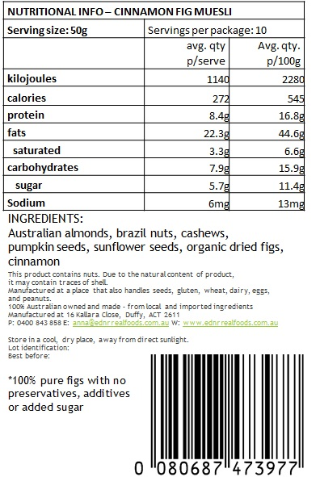
Also, at http://ednrrealfoods.com.au/food/muesli/

Information to be included on each new label is below.

Chunky toasted muesli
500g

simple. authentic. natural.

because it tastes great AND is good for you!

paleo
fruit free and low carb
full of healthy natural fats (79% nuts)
no grains, gluten, refined sugar, additives, preservatives or trans-fats
nothing puffed, beaten, rolled, or high-temp heated into shape (=nutrients remain intact in ednr products)
just nutrient rich, real, whole foods – recognise every ingredient
a little goes a long way and keeps you fuller longer

versatile
home-made
local (ACT)

Crafted by an integrative health coach with a certificate in sports nutrition
We donate 5% of all our profits to Care Australia, providing food and water to those in need, across the world.

BACK:
Ingredients: walnuts, Australian almonds, pecans, pumpkin seeds, fair trade organic coconut flakes, fair trade organic virgin coconut oil
Lightly toasted. Chunky and crunchy.

NUTRITIONAL INFO – CHUNKY TOASTED MUESLI
Serving size: 50g | Servings per package: 10
 | avg. qty p/serve | Avg. qty. p/100g
kilojoules | 1420kj | 2840kj
calories | 339 cal | 679 cal
protein | 7.3g | 14.5g
fats | 32.8g | 65.7g
saturated | 9.2g | 18.3g
carbohydrates | 2.9g | 5.8g
sugar | 1.8g | 3.6g
sodium | 4mg | 7mg

This product contains nuts. Due to the natural content of product, it may contain traces of shell.
Manufactured at a place that also handles seeds, gluten, wheat, dairy, eggs, and peanuts.
100% Australian owned and made – from local and imported ingredients
Manufactured at 16 Kallara Close, Duffy, ACT 2611
P: 0400 843 858 E: anna@ednrrealfoods.com.au W: www.ednrrealfoods.com.au
Store in a cool, dry place, away from direct sunlight.
Lot identification:
Best before:

ednr products are ideal for:
- The health conscious
fuel your day with nutritional goodness
- Bushwalkers and outdoor enthusiasts
energy dense = minimal weight to carry
- Endurance Athletes
low carb/healthy natural fats and protein
Healthy living. Healthy training. Healthy racing.

Raw muesli crumble
500g
simple. authentic. natural.

because it tastes great AND is good for you!

paleo
fruit free and low carb
full of healthy natural fats (86% nuts)
no grains, gluten, refined sugar, additives, preservatives or trans-fats
nothing puffed, beaten, rolled, or high-temp heated into shape (=nutrients remain intact in ednr products)
just nutrient rich, real, whole foods – recognise every ingredient
a little goes a long way and keeps you fuller longer

versatile
home-made
local (ACT)

Crafted by an integrative health coach with a certificate in sports nutrition
We donate 5% of all our profits to Care Australia, providing food and water to those in need, across the world.

BACK:
Ingredients: walnuts, Australian almonds, pecans, pumpkin seeds, fair trade organic coconut flakes
A perfect bircher base or dessert topping.

NUTRITIONAL INFO – RAW MUESLI CRUMBLE
Serving size: 50g | Servings per package: 10
 | avg. qty p/serve | Avg. qty. p/100g
kilojoules | 1350kj | 2710kj
calories | 325 cal | 648 cal
protein | 7.8g | 15.5g
fats | 30.8g | 61.6g
saturated | 5.8g | 11.6g
carbohydrates | 3.0g | 6.0g
sugar | 1.9g | 3.8g
Sodium | 4mg | 7mg

ednr products are ideal for:
- The health conscious
fuel your day with nutritional goodness
- Bushwalkers and outdoor enthusiasts
energy dense = minimal weight to carry
- Endurance Athletes
low carb/healthy natural fats and protein
Healthy living. Healthy training. Healthy racing.

This product contains nuts. Due to the natural content of product, it may contain traces of shell.
Manufactured at a place that also handles seeds, gluten, wheat, dairy, eggs, and peanuts.
100% Australian owned and made – from local and imported ingredients
Manufactured at 16 Kallara Close, Duffy, ACT 2611
P: 0400 843 858 E: anna@ednrrealfoods.com.au W: www.ednrrealfoods.com.au
Store in a cool, dry place, away from direct sunlight.
Lot identification:
Best before:

Choc hazelnut muesli
500g
simple. authentic. natural.

because it tastes great AND is good for you!

paleo
fruit free and low carb
full of healthy natural fats (60% nuts)
no grains, gluten, refined sugar, additives, preservatives or trans-fats
nothing puffed, beaten, rolled, or high-temp heated into shape (=nutrients remain intact in ednr products)
just nutrient rich, real, whole foods – recognise every ingredient
a little goes a long way and keeps you fuller longer

versatile
home-made
local (ACT)

Crafted by an integrative health coach with a certificate in sports nutrition
We donate 5% of all our profits to Care Australia, providing food and water to those in need, across the world.

BACK:
Ingredients: hazelnuts, pecans, Australian almonds, fair trade organic coconut flakes, local raw honey, raw fair trade organic cacao powder, vanilla essence
Enjoy the chocolate milk at the bottom of your bowl!

NUTRITIONAL INFO – CHOC HAZELNUT MUESLI
Serving size: 50g | Servings per package: 10
 | avg. qty p/serve | Avg. qty. p/100g
kilojoules | 1429.19 | 2858.02
calories | 341.77 | 683.46
protein | 5.45 | 10.90
fats | 23.40 | 46.80
saturated | 4.77 | 9.53
carbohydrates | 15.52 | 31.05
sugar | 9.66 | 19.32
Sodium | 3.26 | 6.51

ednr products are ideal for:
- The health conscious
fuel your day with nutritional goodness
- Bushwalkers and outdoor enthusiasts
energy dense = minimal weight to carry
- Endurance Athletes
low carb/healthy natural fats and protein
Healthy living. Healthy training. Healthy racing.

This product contains nuts. Due to the natural content of product, it may contain traces of shell.
Manufactured at a place that also handles seeds, gluten, wheat, dairy, eggs, and peanuts.
100% Australian owned and made – from local and imported ingredients
Manufactured at 16 Kallara Close, Duffy, ACT 2611
P: 0400 843 858 E: anna@ednrrealfoods.com.au W: www.ednrrealfoods.com.au
Store in a cool, dry place, away from direct sunlight.
Lot identification:
Best before:

Tropical mango coconut muesli
500g
simple. authentic. natural.

because it tastes great AND is good for you!

paleo
low carb and healthy natural fats (40% nuts)
no grains, gluten, refined sugar, additives, preservatives or trans-fats
nothing puffed, beaten, rolled, or high-temp heated into shape (=nutrients remain intact in ednr products)
just nutrient rich, real, whole foods – recognise every ingredient
a little goes a long way and keeps you fuller longer

versatile
home-made
local (ACT)

Crafted by an integrative health coach with a certificate in sports nutrition
We donate 5% of all our profits to Care Australia, providing food and water to those in need, across the world.

BACK:
Ingredients: Australian almonds, cashews, organic dried mango*, fair trade organic shredded coconut and sunflower seeds
*100% dried fruit. No preservatives, additives or added sugar
Mango and coconut – best of friends!

NUTRITIONAL INFO – TROPICAL MANGO COCONUT MUESLI
Serving size: 50g | Servings per package: 10
 | avg. qty p/serve | Avg. qty. p/100g
kilojoules | 1130 | 2270
calories | 270 | 543
protein | 7.0g | 14.1g
fats | 22.1g | 44.2g
saturated | 6.9g | 13.8g
carbohydrates | 8.9g | 17.9g
sugar | 7.5g | 15g
Sodium | 4mg | 7mg

This product contains nuts. Due to the natural content of product, it may contain traces of shell.
Manufactured at a place that also handles seeds, gluten, wheat, dairy, eggs, and peanuts.
100% Australian owned and made – from local and imported ingredients
Manufactured at 16 Kallara Close, Duffy, ACT 2611
P: 0400 843 858 E: anna@ednrrealfoods.com.au W: www.ednrrealfoods.com.au
Store in a cool, dry place, away from direct sunlight.
Lot identification:
Best before:

ednr products are ideal for:
- The health conscious
fuel your day with nutritional goodness
- Bushwalkers and outdoor enthusiasts
energy dense = minimal weight to carry
- Endurance Athletes
low carb/healthy natural fats and protein
Healthy living. Healthy training. Healthy racing.
Cinnamon fig muesli
500g
simple. authentic. natural.

because it tastes great AND is good for you!

paleo
low carb and healthy natural fats (50% nuts)
no grains, gluten, refined sugar, additives, preservatives or trans-fats
nothing puffed, beaten, rolled, or high-temp heated into shape (=nutrients remain intact in ednr products)
just nutrient rich, real, whole foods – recognise every ingredient
a little goes a long way and keeps you fuller longer

versatile
home-made
local (ACT)

Crafted by an integrative health coach with a certificate in sports nutrition
We donate 5% of all our profits to Care Australia, providing food and water to those in need, across the world.

BACK:
Ingredients: Australian almonds, brazil nuts, cashews, organic dried figs*, pumpkin seeds, sunflower seeds and cinnamon
*100% dried fruit. No preservatives, additives or added sugar
An earthy and warm flavour.

NUTRITIONAL INFO – CINNAMON FIG MUESLI
Serving size: 50g | Servings per package: 10
 | avg. qty p/serve | Avg. qty. p/100g
kilojoules | 1140 | 2280
calories | 272 | 545
protein | 8.4g | 16.8g
fats | 22.3g | 44.6g
saturated | 3.3g | 6.6g
carbohydrates | 7.9g | 15.9g
sugar | 5.7g | 11.4g
Sodium | 6mg | 13mg

This product contains nuts. Due to the natural content of product, it may contain traces of shell.
Manufactured at a place that also handles seeds, gluten, wheat, dairy, eggs, and peanuts.
100% Australian owned and made – from local and imported ingredients
Manufactured at 16 Kallara Close, Duffy, ACT 2611
P: 0400 843 858 E: anna@ednrrealfoods.com.au W: www.ednrrealfoods.com.au
Store in a cool, dry place, away from direct sunlight.
Lot identification:
Best before:

ednr products are ideal for:
- The health conscious
fuel your day with nutritional goodness
- Bushwalkers and outdoor enthusiasts
energy dense = minimal weight to carry
- Endurance Athletes
low carb/healthy natural fats and protein
Healthy living. Healthy training. Healthy racing.

