YSAR (Youth Search and Rescue) is an organisation that is going places.
Originally YSAR was established in a city/province of New Zealand called ‘Tauranga’ and due to its success, it is now going to grow to become a national (or potentially international) organisation.
As such, it requires a logo that will grow with it.
We want a future-proofed logo that can be used as follows in this brand hierarchy:
YSAR (umbrella brand) – eventually a global brand
YSAR New Zealand
YSAR Tauranga
YSAR Waikato
YSAR Auckland
The strapline is: Training Future Leaders
Ideally the word Youth Search and Rescue will be the logo but smaller than the initials YSAR.
Key words to consider when designing are: positive youth, energy, mountains, Outdoors, Rescue, searching, STEM (Science, Technology, Engineering and Mathematics), innovation, and leading edge technology
Not to look like: Scouts, not to be contained in a circle as YSAR represents out of the box thinking.
From a cultural DNA perspective, the leaders state that they “believe passionately in our youth to meet the needs of the changing Search and Rescue and Emergency Management environment. They would like an identity that the youth can feel good about.”
Ideas that they like:
Eagle Tech Group, Hawkeye, Aeronavics, Auck Waikato Uni Engineering depts drone, Nanotech electronic textile opportunity in SAR and EM.
Note that the logo will be used on the website, in print material and it will be screened onto high vis vests and garments something that the youth will be proud to etc
Number of colours: no preference. We could have one logo with colour as the differentiator between the levels or areas of the organisation e.g. as they have done with this logo structure:
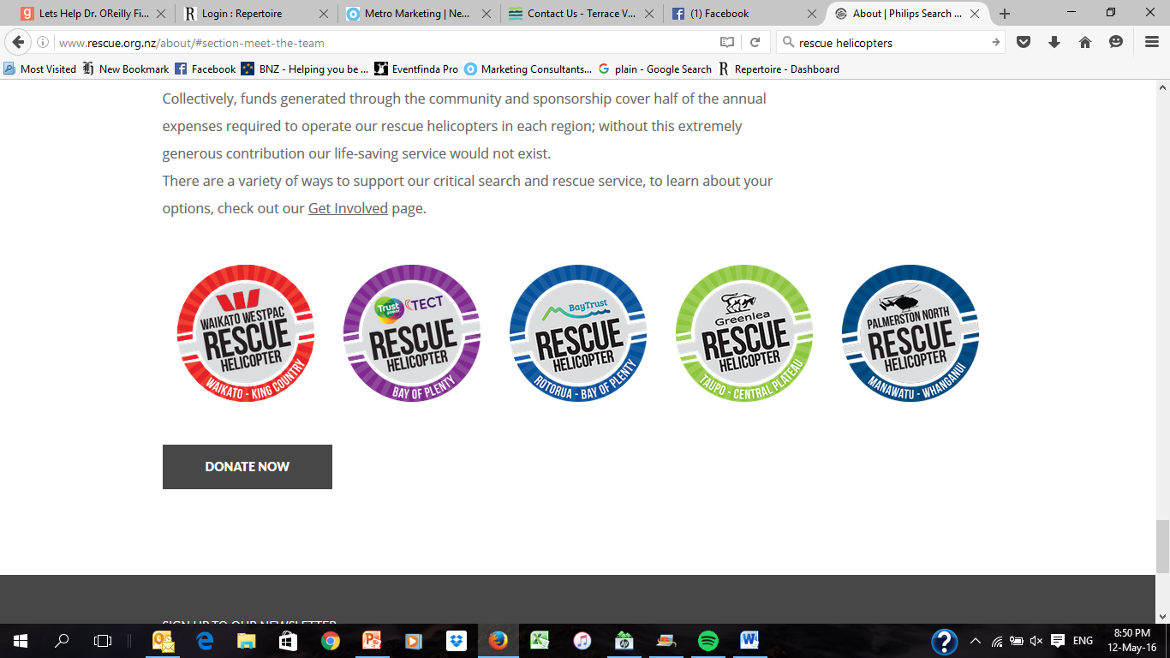
INITIAL THOUGHTS FROM CLIENT
One option = tidying up existing logo on www.ysartauranga.co.nz although there a concern with how busy it is.

- Maybe a mountain in the background?
- Two or more people shows collaboration
- Changing fonts

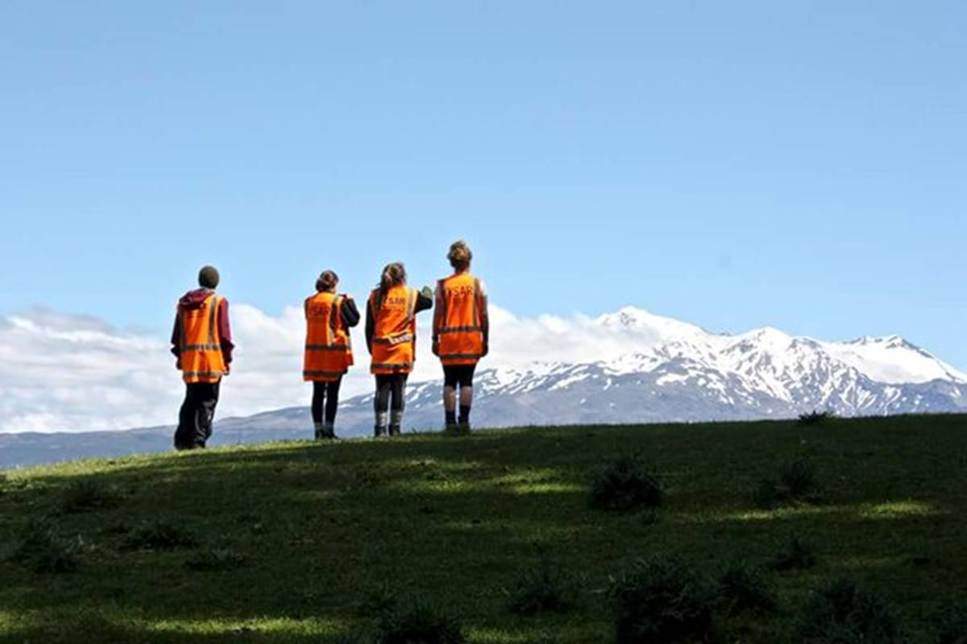

Other logos that the client likes – note that none of these have borders which the client likes.
