SAMPLE…

We’re Specialize In

● International Shipping (Air / Sea) ● Transportation / Haulage
● Consolidation – NVOCC ● Warehousing
● Project Management ● Packing
● Supply Chain Management ● Marine Insurance
● Tax Exemption Consultancy ● Distribution
● Custom Brokerage ● Door to Door

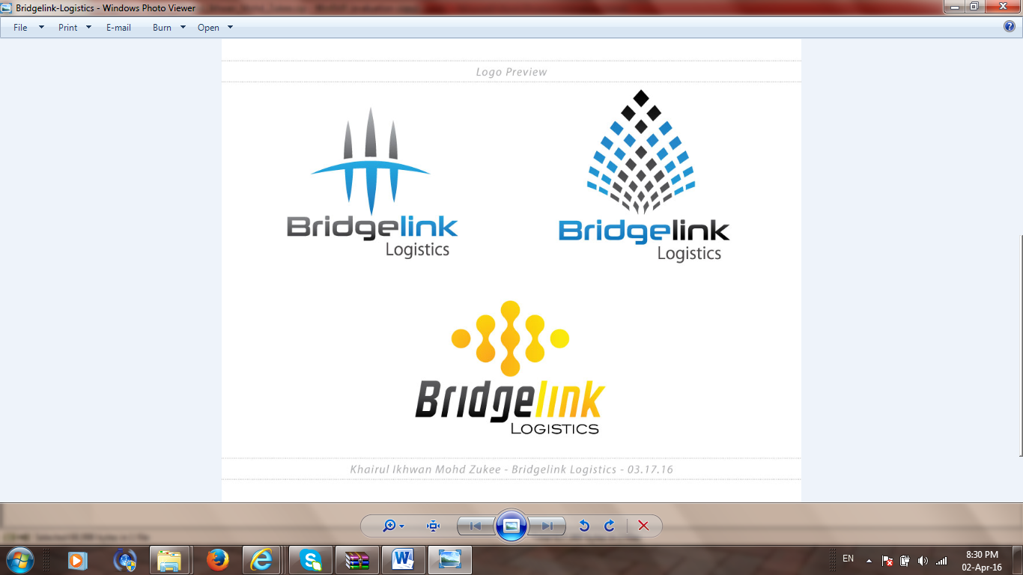

BRIDGELINK LOGISTICS SDN. BHD. (1179501-U)
No. 21A, 1st Floor,
Jalan Bayu Tinggi 1A,
Batu Unjur Taipan 2, Tel : (603) 3319 4722 / 4822
41200 Klang, Fax : (603) 3319 4922
Selangor Darul Ehsan, Email : khairul.ikhwan@bridgelink.com.my
Malaysia. Website : www.bridgelink.com.my

Khairul Ikhwan
Managing Director
+6012-963 0666

ONE STOP LOGISTICS SOLUTIONS

ONE STOP LOGISTICS SOLUTIONS

