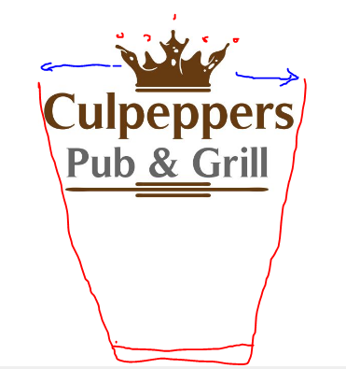

Can you add the outline of a Pint glass on the outside (similar to the red), widen the crown and add the splash drops to the crown.

