Inner Wellness Conference

Saturday August 20th 2016
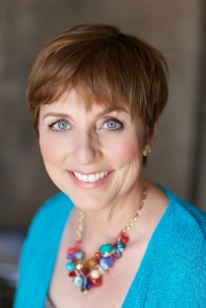  9:00 – 10:45 | Wild Hairs – Embarking Upon the Spiritual Life  Everyone is searching for love, joy and peace – aren’t we? Yet love, joy and peace is already our natural state of being. So how did we come to forget this fundamental Truth? Why are we searching for what we already are? The answers to these questions are rather simple and obvious, but only after we come to understand the nature of the human ego. For too long, the human ego has taken us on a wild goose chase.  It could take an entire lifetime of study, to fully grasp the magnitude of the nature of awakening. In this discussion you will receive a very simple to understand explanation of the journey humanity is undertaking, from conception to enlightenment – and how you can assess where you are on your own journey and keys to unlocking your love, joy and peace.  Facilitator: Laurette DeJulian  A modern day spiritual facilitator, Laurette DeJulian, takes a fresh and fun approach to redefining spirituality for everyone. Laurette's own spiritual awakening propelled her to share what is possible, when one truly commits to transformation. True transformation requires a deep understanding of our mind. Hidden deep within our mind-made stories lies, in waiting, the truth of who we are. Laurette is an ordained minister, author, certified clinical hypnotherapist, ministerial counselor, workshop facilitator, speaker and medical intuitive. Her simple techniques and practical tools have helped to transform many lives.
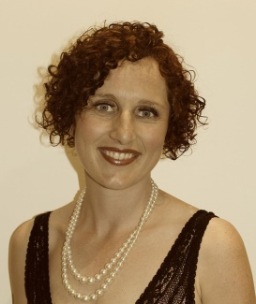  11:00 – 12:45 | Conscious Connection & Living Life Fully  We live in a world where most people feel disconnected or ‘out of synch’ with friends, loved ones and the daily experiences we share with one another. This workshop is designed to offer you a framework for LIVING more consciously, intimately and with greater connection, presence and depth – to ourselves and others. The more we feel connected to ourselves, the more connected we will feel with others. In a time where more and more people are feeling isolated in a busy urban existence, tantric practices can foster love, connection and fulfillment. Come & explore simple, facilitated exercises that deepen a heart-felt, authentic and feeling space.  Facilitator: Lulu Marie  With a background in laughter-yoga, tantra, coaching, psychology, and life-modelling, Lulu Marie brings authenticity, accessibility, warmth and humour to all she does. She is a nurturing leader and passionate advocate for human beings loving every aspect of themselves - the light and the dark, finding new expansive edges and living life fully. She has facilitated Conscious Connection workshops for women, 7 week Dancing Eros journeys, and Sacred Sexuality Temple Eros rituals, and an immersive weekend feminine sexual archetype retreat. Lulu is passionate about sharing accessible and powerful practices to cultivate self-connection, intimacy and love.
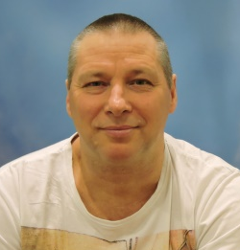  Peter Fernie  1:30 – 3:15 | The Slow Breath to Freedom  Stress is is one of the number one causes of leading diseases today. The connection between Mind and Body has long since been established by both science and spirituality. This session will guide you through simple meditations, self-inquiry, mindful eating and movement. You will find these tools extremely useful to releasing the stress valve, improving your relationships and managing your day to day life in a more enjoyable, present way.  Using his highly intuitive skills and the “Heart Awaking Process” Peter will help you experience your divine nature and harness your individual power – enabling you to live a life in harmony and peace.  Working largely through breathing, focusing and self-inquiry techniques Peter has discovered we can all be transformed. These approaches help people break through old limiting patterns of behaviour, helping them to make healthy and positive change in their lives.  Facilitator: Peter Fernie  Peter has over 35 years of experience in meditation, healing and martial arts.  Peter is extremely compassionate and non-judgemental – having suffered and healed many personal challenges common to us all – and works to help you discover your own true happiness and meaning in life
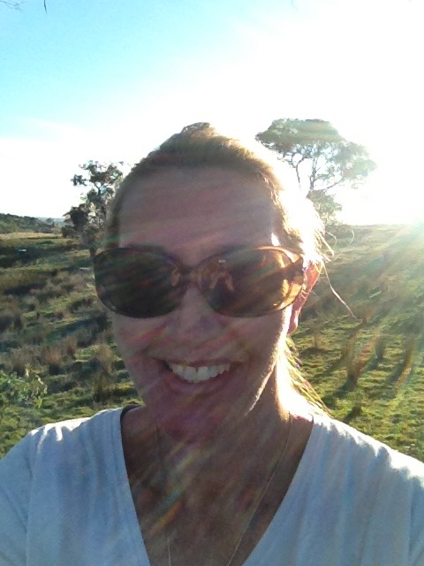  Cheryl Wilkie  3:30 – 5pm | Learning to SHINE  In a world where too often we feel less than our bright, shiny best we can all afford to bring out more of our own natural light to shine for ourselves and others. In this session, Cheryl will guide you through ways to connect with your inner SHINE and not only use that to brighten yourself, but to shine your light on others to share in warmth and love that improves all things.  Facilitator: Cheryl Wilkie  A loving mum, devoted wife and shining light on her community, Cheryl Wilkie shares her wealth of knowledge that you can implement into your everyday life. Showing you how to make your inner light shine brighter. Which can transcend in all areas of your life. Cheryl has spent the last 20 years absorbing many aspects of “Spirituality” from her personal journey as a Manager in a five star Hotel to meeting The Dalai Lama. Gaining knowledge in Angel Intuitive, Numerology, Tarot, Pranic Healing and Mindfulness. Cheryl loves to share her “toolbox” with you so that you may also bring more joy into your life and those around you. Shine bright XX
 | MC: Tim Moon

