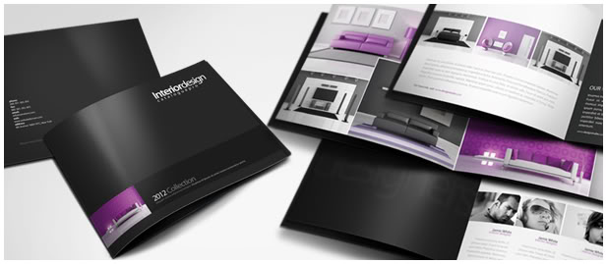
Make cover page similar to this.
- Submit two cover pages: one with AINONGPlastics logo with the “AINONGPlastics” text to the side of icon, on top right of page, and one with AINONGPlastics text below icon in the middle of the page
  - I uploaded both icons in the brief
- Use “2015Collection” on bottom banner, and you can remove the picture on the bottom left and use the whole bottom row for the banner section
- Use a shiny silver or silver gradient for the background color, and black or transparent black for the bottom banner
  - You can use green, white, or grey accents for the font at the bottom
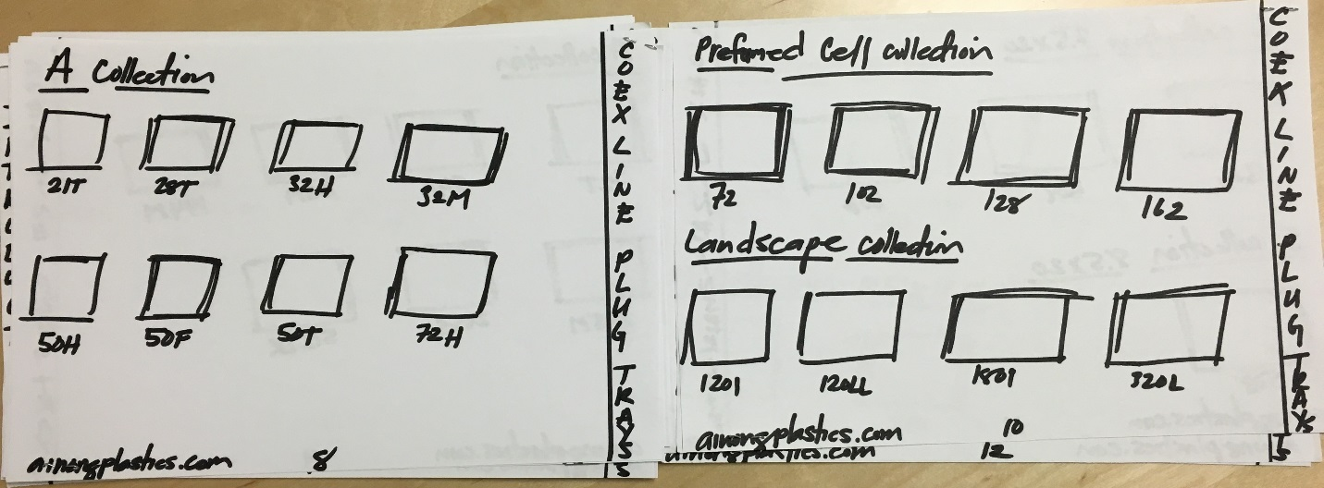
Use this layout for the product templates.
- For the left hand side, make sure the category column marker is on the left edge instead of the right edge as shown in the photo
- Please put in specs information neatly below the boxes (where photo of product goes in)
  - The specs to use are: Product Code, Tray Dimensions, Weight, and Loading Quantities
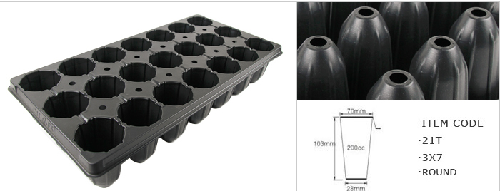
Use this photo for the product photo for the template above
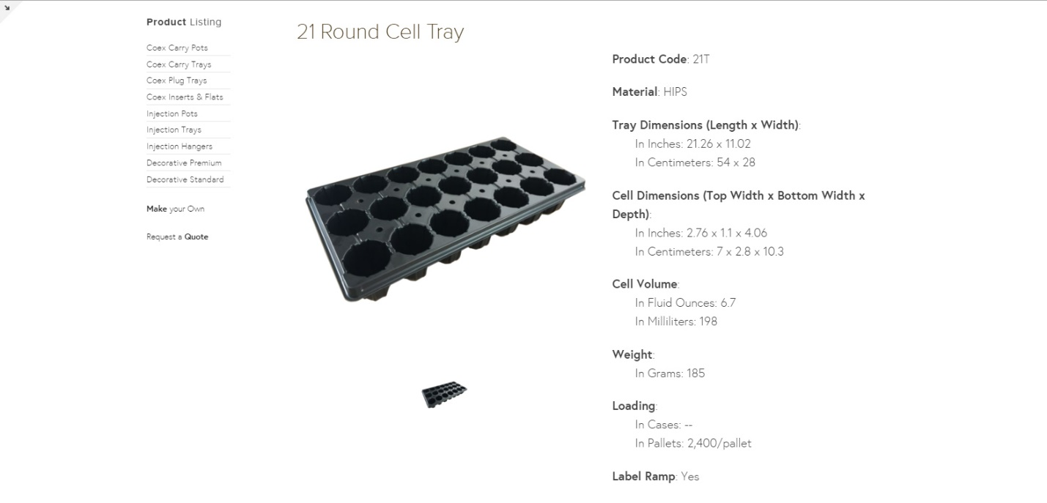
Use the specs from here that were requested for the product templates

