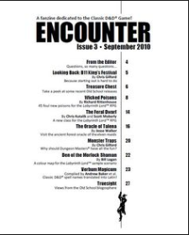
Potential layout for table of contents

Looking for landscape design layout 11x8.5

For coex pot listing looking to do a chart similar to Apple’s iPhone comparison chart on their website

